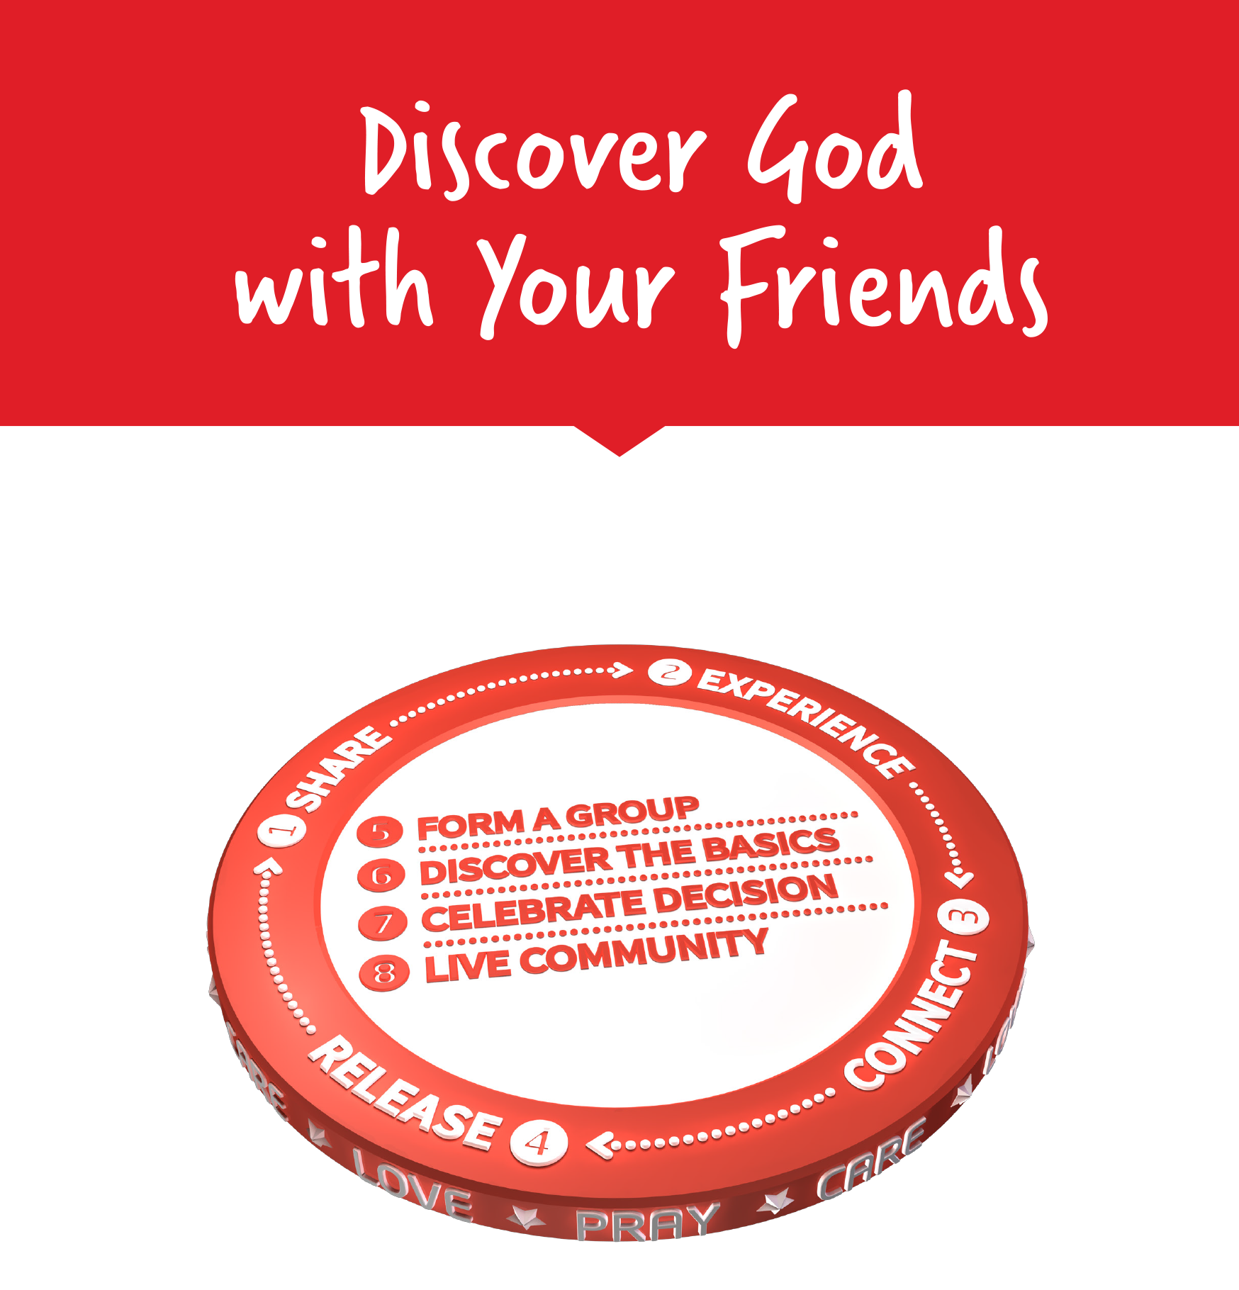

Facilitators Guide
Module 1 – Introduction and Love

Module 1: Introduction and Love


Module 1 Objectives
During this module participants will:
- Understand the structure and purpose of MyFriends Lifestyle training and the need to share Jesus in our everyday lives.
- Understand the commitment they’re making in taking part.

- To be able to explain God’s love for all His people.

Tools
As a facilitator you will need the following tools:
- Laptop or digital device
- Access to the participant materials – you will share these on a screen or on zoom (there are PowerPoint slides if this suits your teaching style better)
- TV or Data Show to present materials on.
- Flipchart stand, paper and markers.
- Room set up in a friendly and collaborative style – we suggest setting up in a “bistro” manner so that groups can sit round smaller tables which works well for group discussions.
- Virtual – please use a tool like Zoom. Please ensure that your Breakout Room setting has been switched on and the chat and annotate function has been enabled.
- Catering: whilst this is an optional extra, catering does help people get to know each other when having a cuppa and a biscuit or muffin! If you are running evening sessions, it’s good to have something for those that have come straight from work.
- PDFs are available for each module if you have participants that don’t have access to the digital materials.

Facilitator Guide: Module 1 Introduction and Love

Introduction (10 mins)
Welcome to MyFriends – this is more than a program; I like to think of it as a lifestyle to help people build relationships with God.

Open in a short prayer giving the course and time to God.


Ask the group to introduce themselves - if this is a group that doesn’t know each other well – you might like to use an icebreaker from the Icebreaker section here.

MyFriends is a tried and tested way to live like Jesus and share His message like he did. MyFriends was initially developed in Switzerland and adapted for Australia to help everyday Christians live like Jesus and share His message.
The MyFriends approach is based on Jesus’s life and how he started this amazing movement– bringing us back into a relationship with each other and God.
Now introduce yourself and share a little of your testimony (2mins max.)
Lets play our MyFriends Introduction video that explains what the MyFriends Lifestyle is all about.


Play the video ‘Introduction to the MyFriends Lifestyle https://vimeo.com/showcase/10517460/video/841109818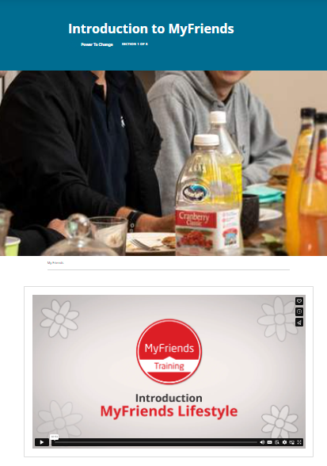
(Click Full screen – bottom right)

Participant Materials overview (5 mins)
To make the course easier and more environmentally friendly we have put the content online.
If you haven’t done that, please go to

Movementbuilders.org.au – and register for an account (top left-hand corner)
Display Movement Builders site www.movementbuilders.org.au
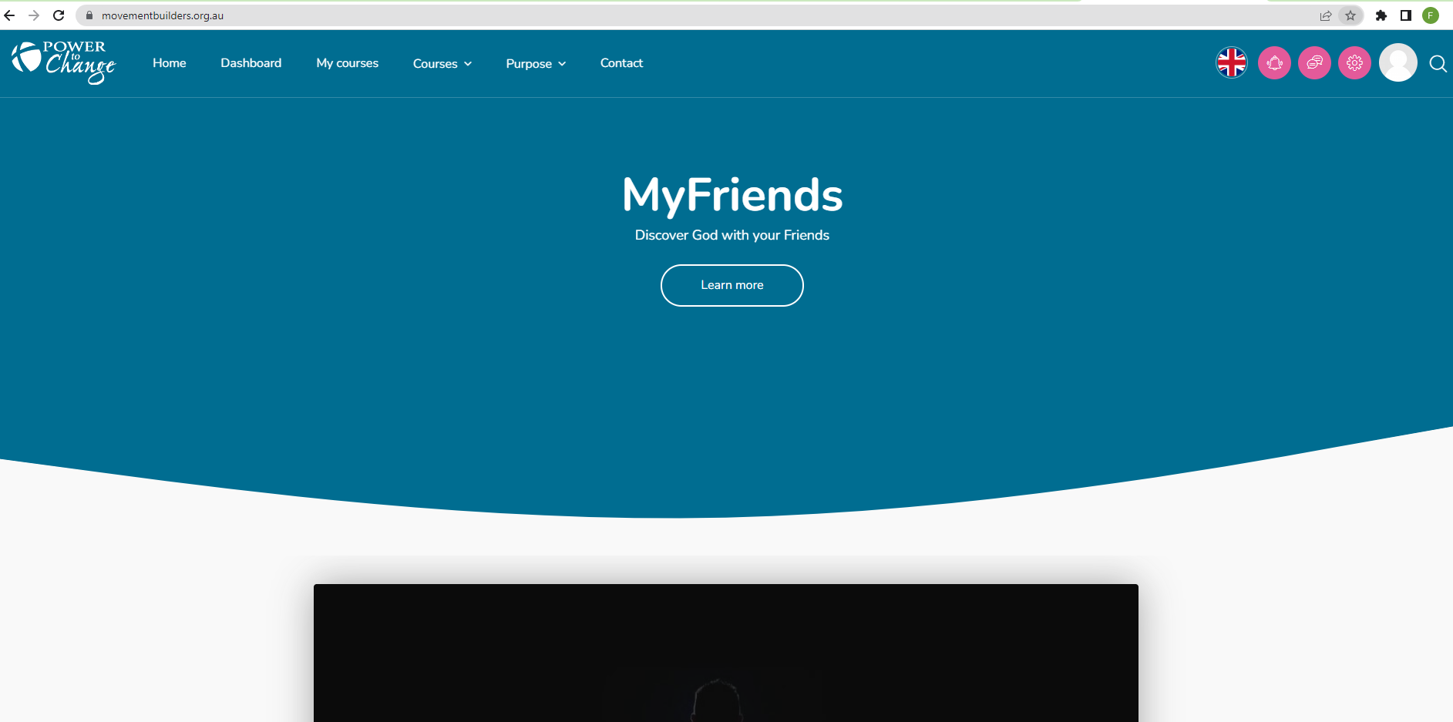
- Explain the basic navigation.
- Logging on
- Your course
- My Courses – click preview of course to access your content.
- Click on course content to show how to launch each module.
To find your materials for today go to MyFriends and find our course cohort “Course Name”.
To navigate through our modules, you click on them as we go.
These modules aren’t e-learning – they are designed to be done in our course so don’t be tempted to skip ahead!
Also, these modules also “trigger” a mid-week nudge which will send you an email with questions to reflect on and a link to our Lifestyle module that is linked to the topic we are covering.
The digital materials will work on a laptop, tablet, and smart phone – they are designed to resize depending on your device.
If you are using a mobile device and would like to access the materials through an app – go to your app store – search for Moodle – download and open it. You will be asked for the domain name – MovementBuilders.org.au and your username and password. Using the Moodle app you will get a better user experience on a mobile device, and you can access your course offline too.

If you don’t want to bring your device to our sessions every module has a “Resources” section with a PDF version of the module if you want to print it out and bring a hard copy. The choice is yours.

Display your Course
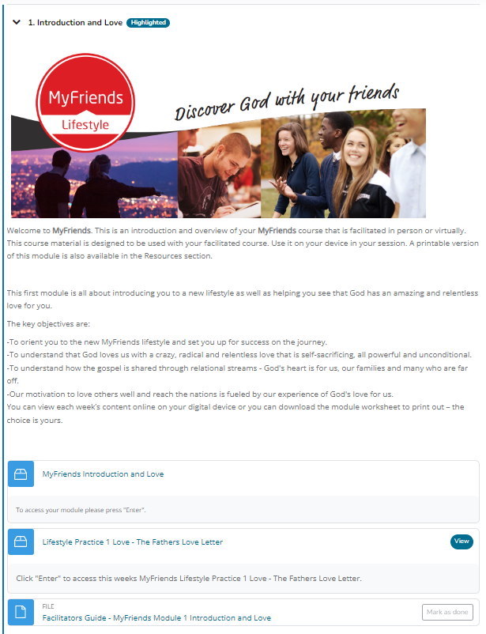

There are two parts to each of our modules.
- The course content that we will go through each week.
- The Lifestyle Practice that complements the week's module and helps us implement the learning in our own lives. Today’s module is about God’s Love, so this week’s Lifestyle Practice is Knowing the Fathers Heart. This is a topic in your weekly module.
The Lifestyle Practice is there for you to do between sessions – “Home Play”!
The leader’s notes / Facilitator Guides are available if you want to follow the leaders’ notes – you might like to lead this course with a different group later.
Check everyone has access to the course.

The Challenge (15 mins)
Society has changed – in the last 50 years there has been a lot of change. Church was a foundation of community, in 1966 – 88% of Australians identified as being Christian – in the 2021 Census only 43.9% identified as Christians.
Ask someone in the group to read out the challenge section.
“Aussies are interested in spiritual things, but not often interested in going to church. So how will they get to know Jesus?”
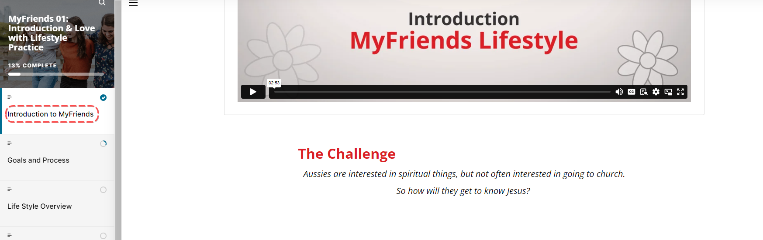

Activity: What does this mean?
In pairs take a minute to discuss the implications of this.
Ask the group to come back together and share their ideas.

At the turn of the century – mission was perceived to be outside of Australia – people went to be missionaries. Today in Australia over 50% of Australians don’t know Jesus or His message.
Mark Greene from the London Institute of Contemporary Christianity found that.
“Globally 98% of Christians are neither envisioned nor equipped for mission in 95% of their waking lives. But, just imagine if they were ….”
What would it look like if Christians saw themselves being missionaries in their communities? In the diagram we can see that many of our social spaces in life are outside of the church. We know and have relationships with those that don’t know God.
Take a moment to think about your social groups – your connections – the social spaces in your life.
We believe that God has sent you into those spaces to reveal Jesus’ life and invite your friends to connect with His story wherever they are.
Activity – ask for a volunteer to share their different social groups and create a diagram of it.

Think about your friends who don’t know Jesus yet– how do they view Christians and Churches.
Rather than asking “How can I bring people to church?” Why not ask “how can I help people experience Jesus where they are and discover God in their own community?”

Our Motivation (2 mins)
Ask someone in the group to read Acts 2:39 aloud.
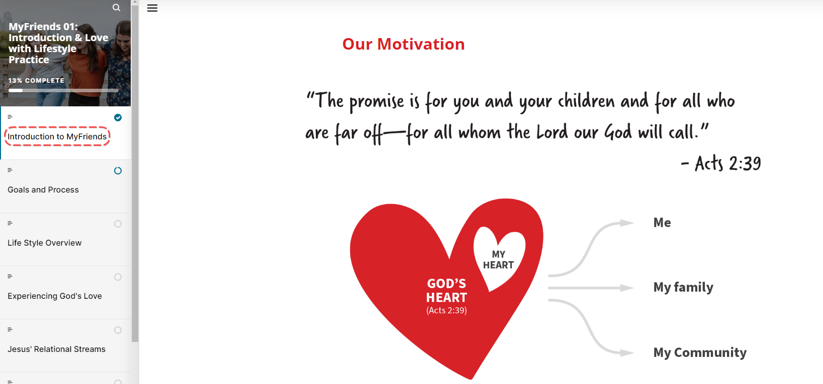
God’s heart is for me, my family and my community to be in relationship with Him. So, our motivation in all of this is to have God’s heart for others.

Our Prayer for You (5 mins)
It’s exciting to think what might unfold over the next 9 weeks as we do this together. Not just in ourselves but in our friends, family and community too.

Ask someone to read aloud the 3 prayer points indicated by red arrows.
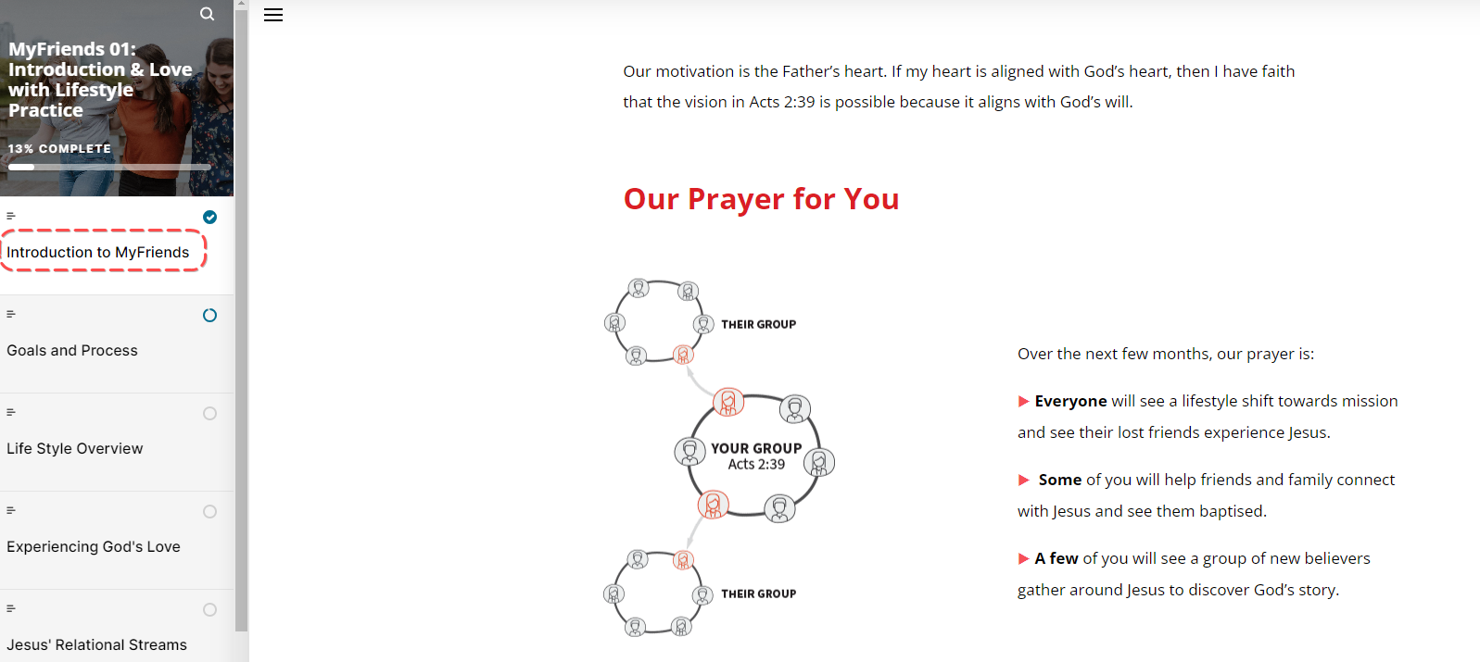
Briefly share with your group your own experience of MyFriends and if either of these three things happened for you!

Goals, Processes and MyFriends Lifestyle (7 minutes)
MyFriends is not a program but a lifestyle that seeks to follow Jesus’s model of disciple making.
The goal is to learn how to love, pray, and care for people, help them experience and know Jesus personally, and from Bible Discovery groups with people in our social circles.
We do this in a learning community that provides accountability and support.
The MyFriends Lifestyle is typically practiced over several months. The content is split between Training and Lifestyle Practice sessions.

Play ‘MyFriends- Key Concept: Lifestyle Overview’
https://vimeo.com/showcase/10517460/video/841141945
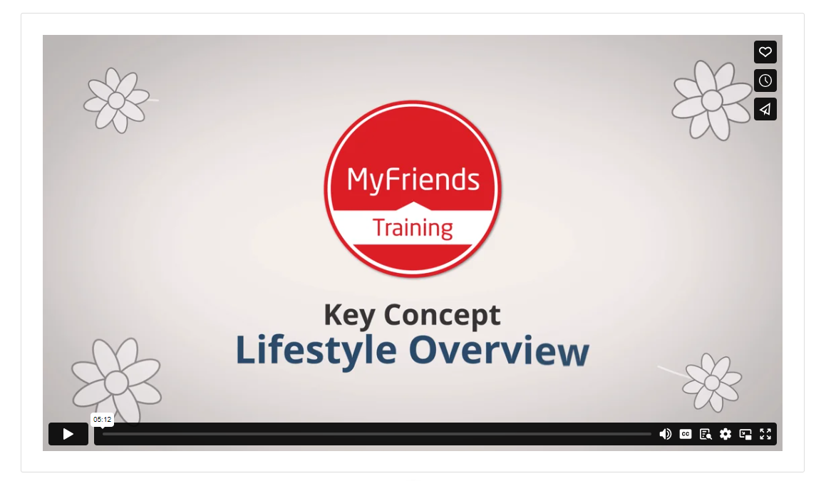
(Click bottom right to play in full screen)
There are 5 distinctive of the MyFriends Lifestyle Training
- Jesus’ life is our focus as we practice His way of love, mission and community.
- Time: Training and Lifestyle Practice takes place over several months to shape new habits which lead to a lifestyle of mission
- Simplicity – MyFriends uses a simple framework of tools, language and practices to make it easy for people to share with others.
- Movement DNA: MyFriends uses a DNA of disciple making that leads to forming and multiplying groups of new believers.
- Community: Learning with people you know who follow Jesus and reaching the people you know who are far from Jesus

These distinctives help us to adopt a mission lifestyle and see those in our networks and beyond, come to know and follow Jesus.
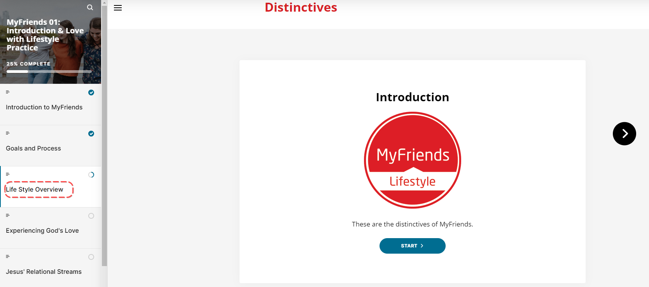
MyFriends content is split into two parts – Training and Lifestyle Practice.
The training is what we are doing now!
Lifestyle Practice goes alongside these training sessions and is a chance for us to grow together as we learn mission lifestyle principles and implement them with a supportive community.
Each of these Lifestyle Practices have their own reflection topic built into each week.
Show where this is in the materials.
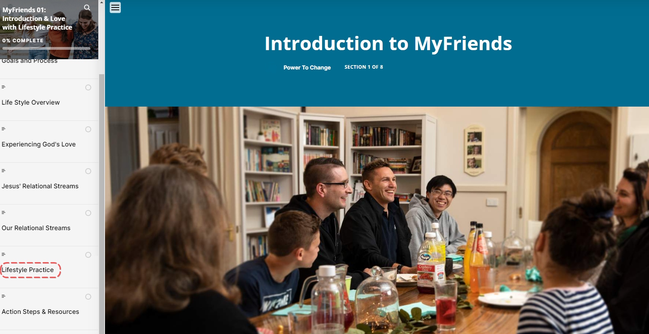
After we have done our training session – I will send you an email or message through the messaging app group – to prompt you to do the MyFriends Lifestyle practice at a time that works for you before our next session.

Learning in Community
We have the opportunity to shape our community by going ‘all in’ with this training! Let’s set up a social media group to keep in touch throughout the week so we can pray for each other and celebrate what is being done as well as keep each other accountable for our actions.
Activity: Take some time to ensure that everyone can access this group and understands its purpose. Share your own stories of how you used it when you went through the training if that is helpful.

Your Commitment
It’s important we remember that MyFriends is NOT a program, it’s a lifestyle we learn by practicing principles we see modelled in the life of Jesus.

To make sure we get the most out of it we really need to commit to being here every week – for our own sake but also for the sake of this group who we will journey with.

Spend time making sure everyone has:
-Downloaded the “power to change Moodle app” from the app store.
-Downloaded the myfriends.network app by pinning it to their home screen.

-Visited and bookmarked the MyFriends video pages

Break for a quick cup of tea and a stretch before we move to Experiencing God’s Love

Experiencing God’s Love
Welcome back from the break. Now that the introduction is finished it’s time to kick off our official first training session which is all about Love!
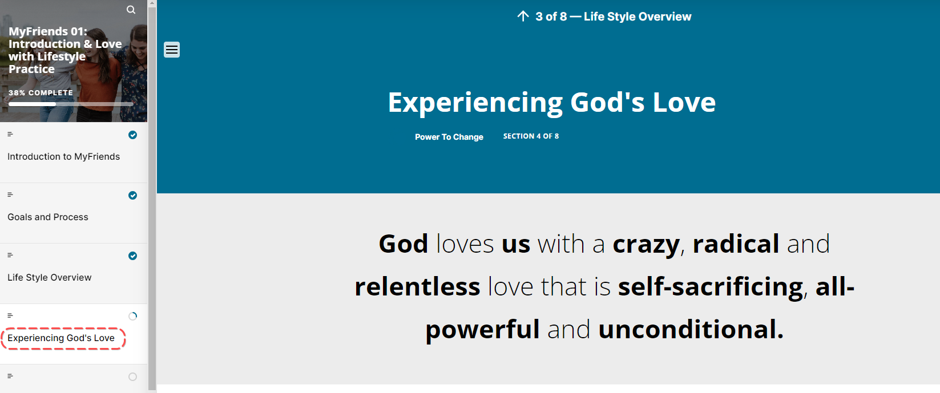
God loves us with a crazy, radical and relentless love that is self-sacrificing, all-powerful and unconditional.
You might want to share something about how you have felt God’s love in your life.

Play the video ‘MyFriends – Key Concept: Love’.
https://vimeo.com/showcase/10517460/video/841111142

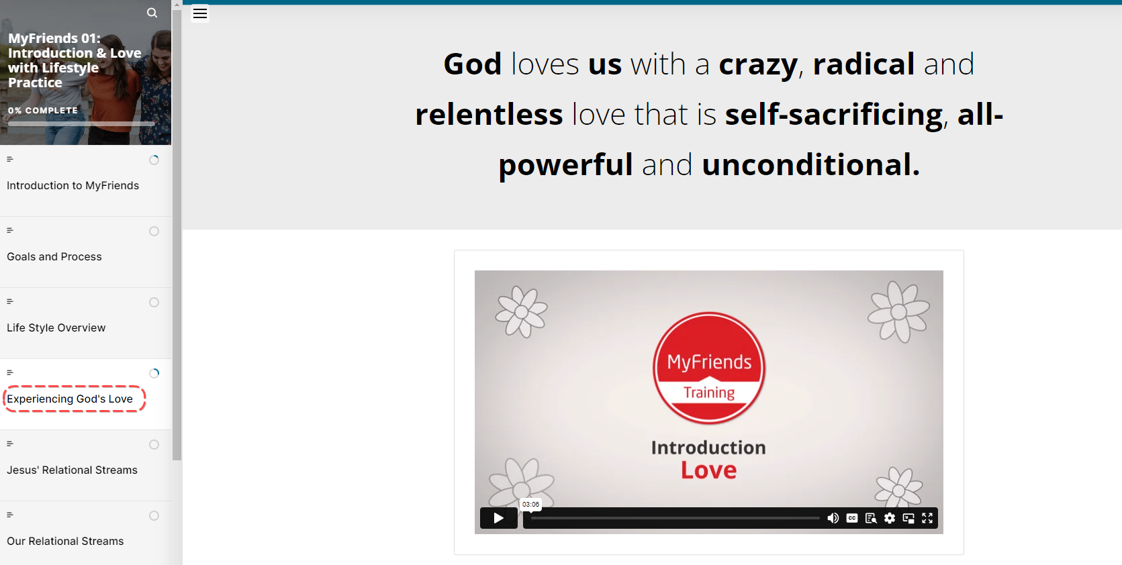
Let’s look at the bible as see what scripture says about God’s love.
Activity: Ask someone to read 1 John 4:9-19
Ask the group to spend a few minutes responding to the 3 questions listed.
- What stands out to you in this passage?
- What do you learn about God or people?
- What principle of mission did you discover that you can apply today?
Go through each question, asking participants to share their responses.

Discover Jesus Relationships
We’re going to look now at Jesus’ relationships and see what we can learn from them. As we’re reading this next passage from John, let’s try to map out the relationships we can identify.
Ask a participant to read John 1:35 – 46

As they’re reading, jot down on the white board the names of people as they come up. Once the reading is finished ask people to contribute by connecting people and describing their relationship until you have a relationship map drawn. Have a look at the relationship map on the Movement Builders Training Hub and discuss any differences and the similarities!
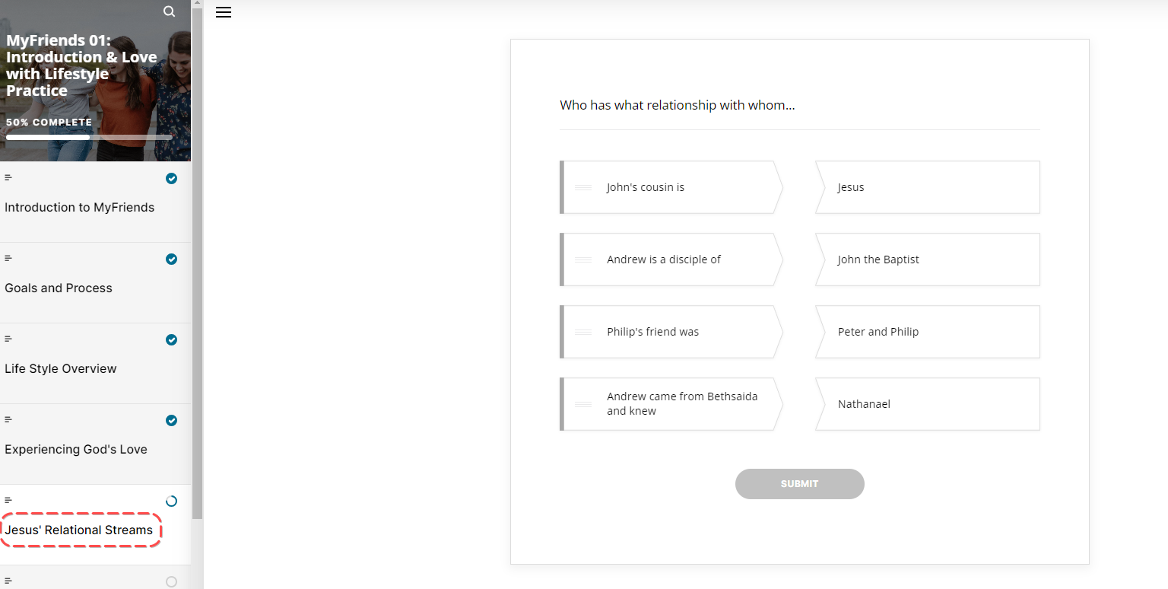

Get everyone to individually have a go at the connecting activity.

Our Relational Streams
Play the video introducing the Daisy Chain Key Concept of identifying our relational streams.
https://vimeo.com/showcase/10517460/video/841145798

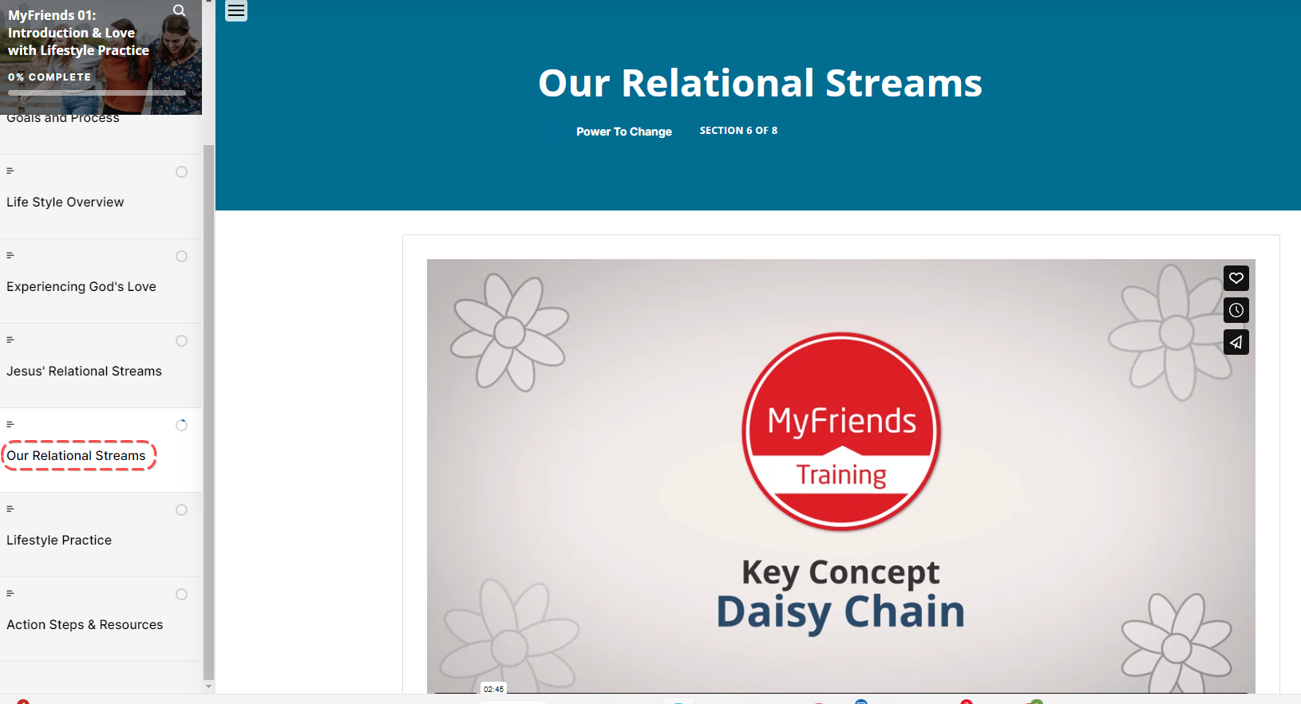

Hand out the printed copies of the daisy chain. MyFriends - Daisy Chain Sheet (movementbuilders.org.au)
Model for the group how to fill out the daisy chain, showing them your different social groups on each petal and the different people that are part of those groups.


Have a go at filling out this daisy for yourself. Write down the different social groups on each petal and then people you know from each social group who don’t have a relationship with Jesus.

Lifestyle Practice – The Fathers Heart

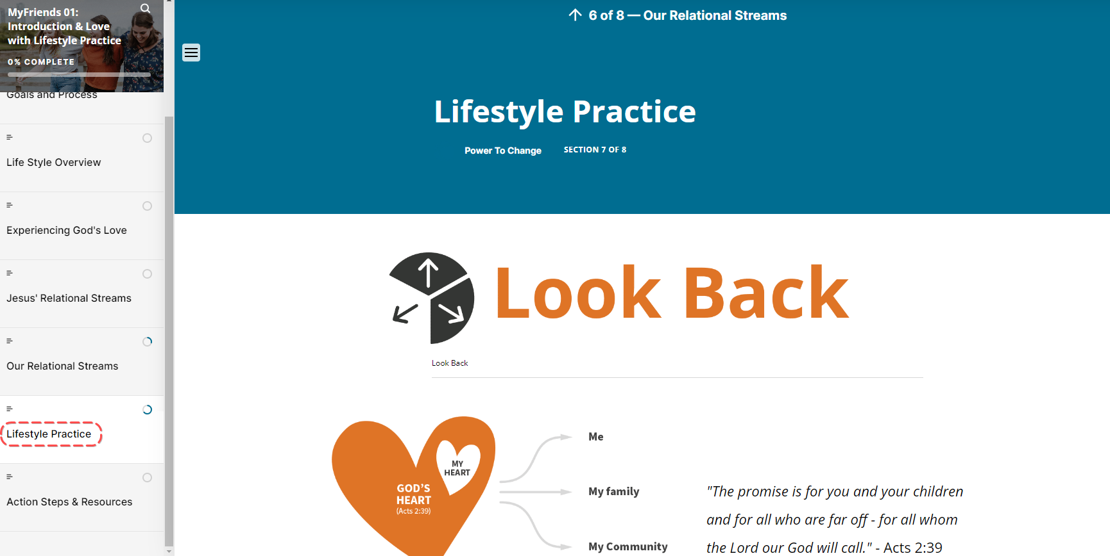

Over the next week find some time to think about and maybe review what we have learned today. Each week there is a section of your materials that is called “Lifestyle Practice” which will take you between 10 to 30 minutes to do. You can do in on your own or if you are close to someone in the group – this is a great thing to do together.
First we look back over the weeks content and think about what stood out for you. Over the last week how did you experience God at work in and through your life? What did you learn about God, yourself and others over the week?
Secondly we look UP and will look at some scripture that is relevant to the week and ask some simple questions to help you think about it a bit more deeply.
Then we ask you to look forward and apply what you have learned to your life.
This week our MyFriends Lifestyle Practice is about Love and The Fathers Heart.
End in a short prayer. You might like to ask a participant to pray or simply pray that each member of the course experiences and recognises God’s love in their lives this week.

Week 1 Facilitator Follow up.

Set up your social media group
- Set up your Social Media group – WhatsApp and Facebook Groups are the most common types of groups. Invite all your group to join.
- In the first few weeks you will need to drive the usage of the group before it becomes self-sustaining
- Some suggested posts that you could use are:
  - Say “Hi” to everyone in the group.
  - Send a link to the course content – if you go to the page for the “scorm” package this is a unique URL to that particular module. Ask a question like – What part of the module “Introduction and Love” did you like the best – Here is a link to the module if you would like to review it again. Link
  - Our “home play” this week was to think about the Fathers Love – here is a link to the module – link. What bible verse stood out to you in “The Fathers Love Letter” video.
  - How are you going with your daisy chain? What are your social places (each of your daisy petals)? Are there any people that don’t know Jesus yet in each of these places?
  - Looking forward to seeing you in our next session. The link to the content is (link) and the zoom link is (link)

Facilitator email MyFriends Module 1 - Introduction and Love
To Attendees:
Subject – MyFriends: Week 1 Introduction and Love
Hi everyone,
It was great to meet you all this week.
MovementBuilders.org.au training centre has all your content in.
- Create a free MovementBuilders.org.au account.
  - Go to www.movementbuilders.org.au
  - Click Login / Register at the top right-hand corner and then “Sign Up!” and fill in the registration form. We will email you a confirmation email – please confirm your registration.
- Go to your course and access your materials.
  - Go to “Course link” (Put in your course link)
  - Use this Free Student Enrolment Code “PTCMyFriends23” if you haven’t already enrolled.
  - If you have already enrolled go to “My Courses” on the top toolbar
This week’s course materials can be found on this link (Put in your course link)
The Lifestyle Practice can be found on this link (Put in your course link) (the video is great)

Who is on your daisy chain? Where are your social spaces? The gym, work, outreach group etc… Who doesn’t know Jesus yet in these spaces? Write them on your daisy chains’ petals.

Using a Mobile Device?
We recommend you access your course using the Moodle App from your App Store (Moodle is the software we are using). After you have installed Moodle, you will be asked for:
- The domain name – movementbuilders.org.au
- Then your “username” and “password”
If you do have any technical issues, please contact Fiona.Dunn@powertochange.org.au.

We are looking forward to seeing you next week.

Blessings,

