

Facilitators Guide
Module 2 - Pray

Module 2: Pray


Module 2 Objectives
This module is about Prayer to help people to understand that Jesus’ life modelled prayer and explore prayer for people, places and peace. Participants will spend time asking God who specifically to pray for from their daisy chains and commit to doing it!
During this module participants will:
- Jesus modelled a life of prayer that is dependent on the Father, and we must follow the same pattern as we seek to live like Him
- There can be no disciple making movement before there is a prayer movement.
- Jesus sought the Lord for wisdom on missional alliance and strategy.


Tools
As a facilitator you will need the following tools:
- Laptop or digital device
- Access to the participant materials – you will share these on a screen or on zoom (there are PowerPoint slides if this suits your teaching style better)
- TV or Data Show to present materials on.
- Flipchart stand, paper and markers.
- Room set up in a friendly and collaborative style – we suggest setting up in a “bistro” manner so that groups can sit round smaller tables which works well for group discussions.
- Virtual – please use a tool like Zoom. Please ensure that your Breakout Room setting has been switched on and the chat and annotate function has been enabled.
- Catering: whilst this is an optional extra, catering does help people get to know each other when having a cuppa and a biscuit or muffin! If you are running evening sessions, it’s good to have something for those that have come straight from work.
- PDFs are available for each module if you have participants that don’t have access to the digital materials.

Facilitator Guide: Module 2 : Prayer

Introduction (10 mins)
Welcome everyone back for week 2! Spend some time sharing stories from the week or doing an ice breaker (link here) if you feel that your group is still in the early stages of formation.


Open in a short prayer giving the course and time to God.


Quick Introduction if the group doesn’t know each other well – review of the MyFriends Lifestyle
- Name
- How have you experienced God this week?
- What did you learn about God, yourself or others?
      - Just one point.
  - How did you go with the Lifestyle Practice? The Fathers’ Love Letter
  - What stood out for you in the Video?
  - Did you notice the Holy Spirit Prompting you to do things this week?

This session is all about prayer. We’ll be looking at how Jesus modelled a life of prayer that is dependent on God and how we must follow the same pattern as we seek to live like him. We will also look at just how important prayer is for any disciple making movement and how Jesus sought the Lord for wisdom on missional alliance and strategy.

Pray – Jesus’ Prayer Life

Play the video ‘MyFriends – Pray”.
https://vimeo.com/showcase/10517460/video/841112912
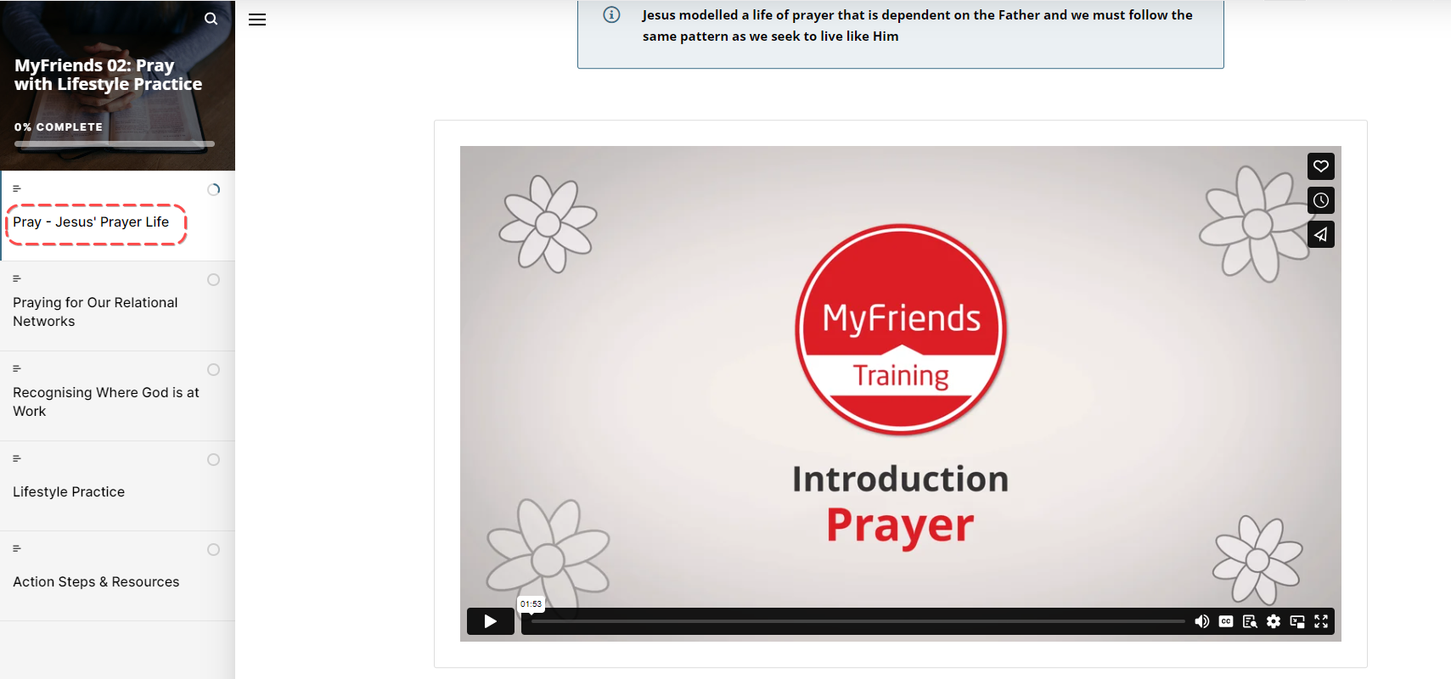


Activity: Reading the bible – Split into smaller groups and assign 2 or 3 passages to each group.
Ask the group to spend a few minutes reading their passages and responding to the 3 questions listed.
- What stands out to you in this passage?
- What do you learn about God or people?

- What principle of mission did you discover that you can apply today?
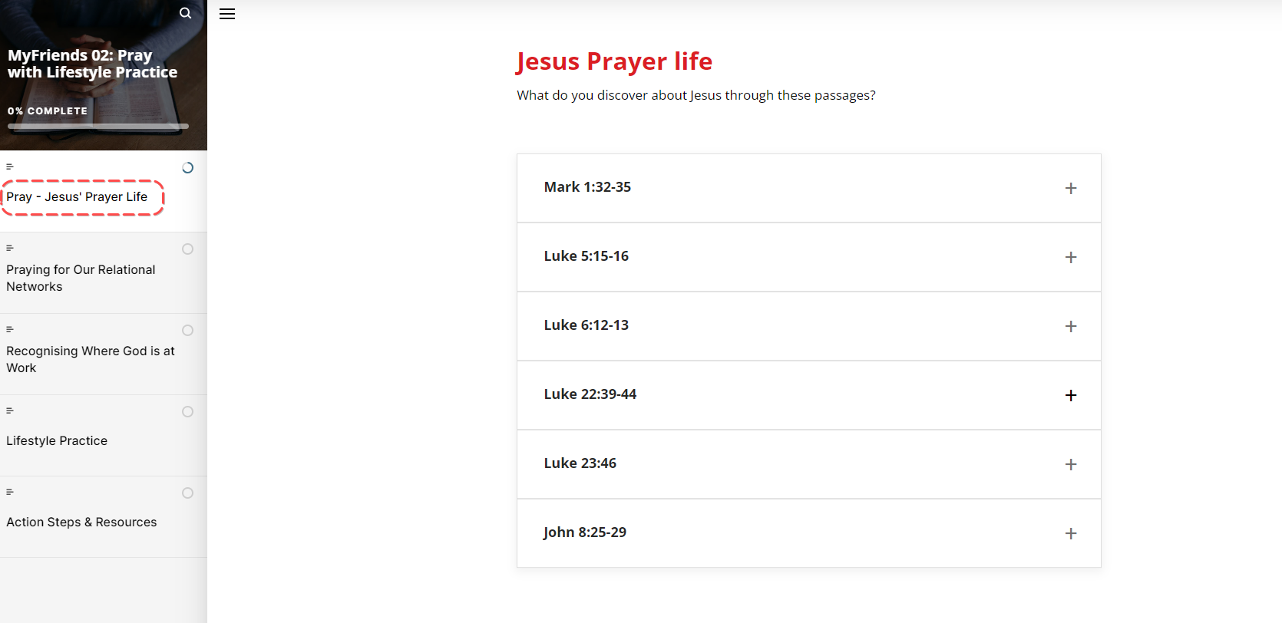
In our materials you can click the “+ “ to get the bible passage – or look it up 😊

Ask participants to spend a few minutes reflecting on the questions listed in this section. Encourage them to write down their answers. Once you think most have finished, get them to share their responses in pairs.

Praying for Our Relational Networks
Read the quote
“No movement has been started or sustained without focused, faithful, and fervent prayer.”

Ask a participant to read the different ways we are intentional in prayer.
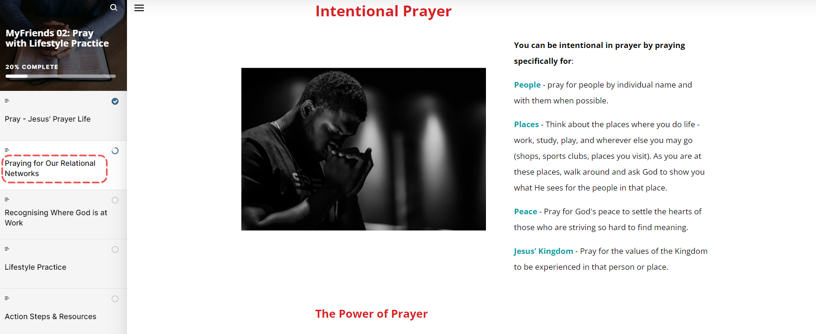
What does that mean for us?
Watch ‘MyFriends – The Power of Prayer’
https://vimeo.com/355918619
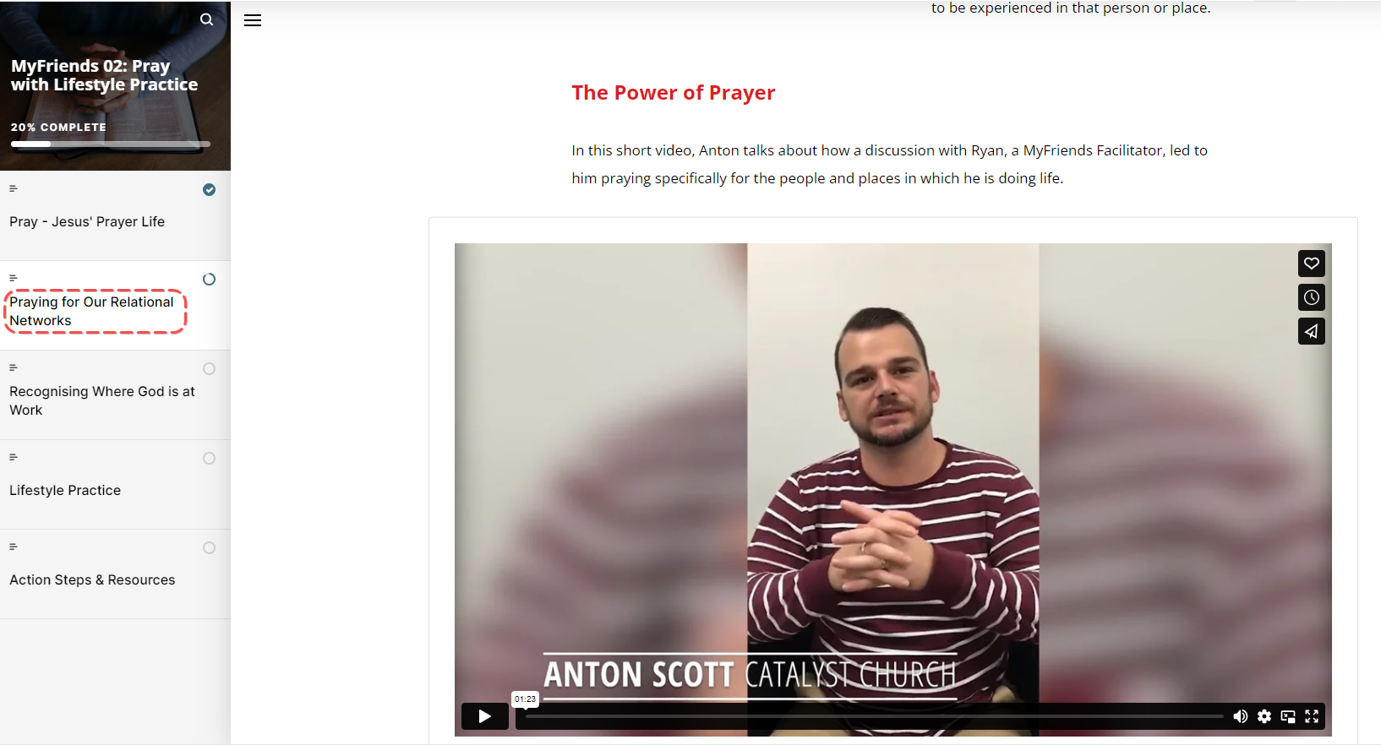
Recognising Where God is at work
Jesus often took time out to seek the Father's will as He decided where and with whom to spend time with. Prioritising time with the Father in prayer is essential for aligning ourselves with His purposes and plans for people in our social circles.
Challenge: Ask everyone to pull out their daisy chains from last week – how did everyone go at remembering to pray for the people listed during the week?
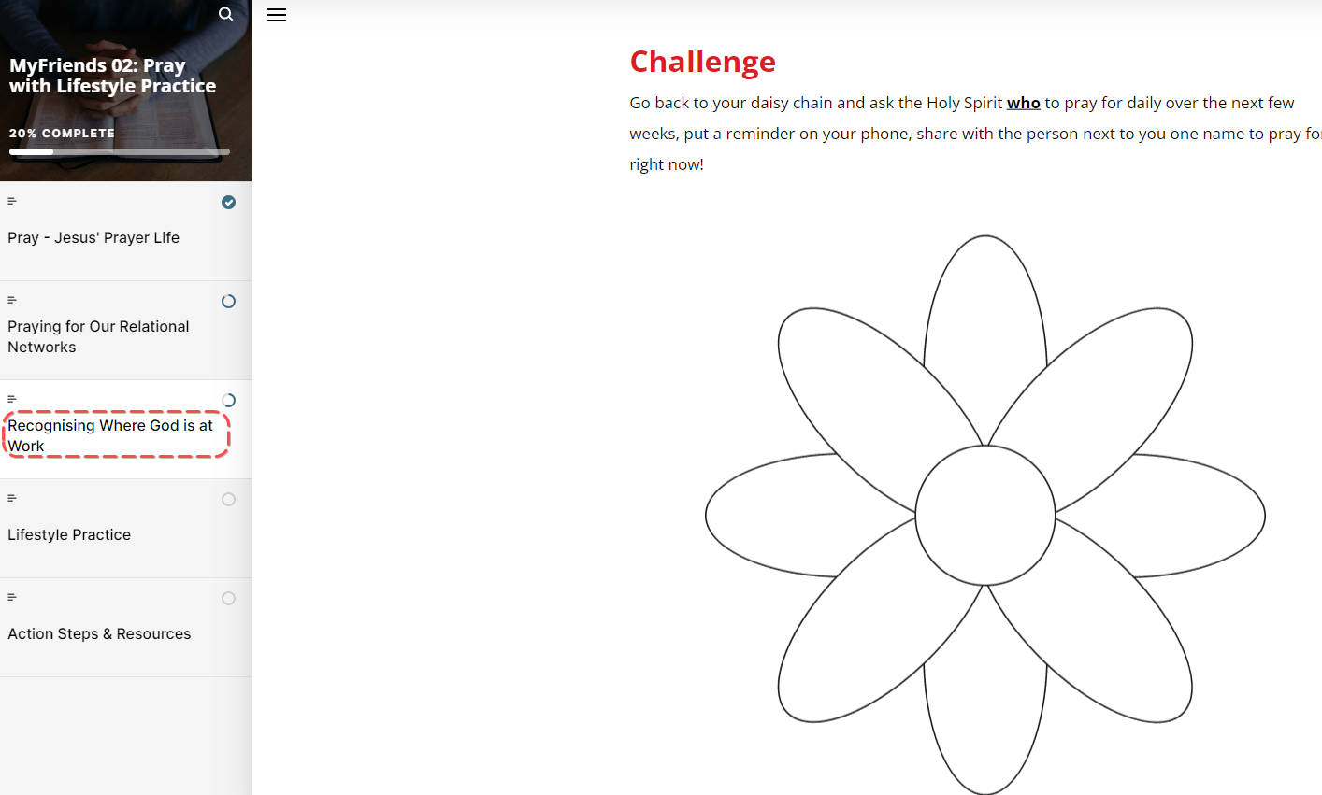
Spend time now asking the Holy Spirit WHO to pray for daily over the next few weeks and underline them on your daisy chain. Encourage people to set daily reminders on their phone so they remember to pray. Then share with the person next to them one name off their daisy chain and pray for them!

Be Intentional about praying for:
- The People – pray for people using their names and with them where possible
- Places – the places on your daisy chain where you do life and meet people
- Peace – pray for God’s peace in the hearts of those that are striving hard to find meaning – that God’s Holy Spirit works in them
- Jesus Kingdom - pray for the values of the Kingdom to be experienced in that person or place

Explain that it’s good to stick the daisy chain in a place in their home where they will see it regularly – cupboard door, bathroom mirror etc.

Explain the Lifestyle Practice for the coming week
The MyFriends Lifestyle Practice this week is: Hearing God’s Voice
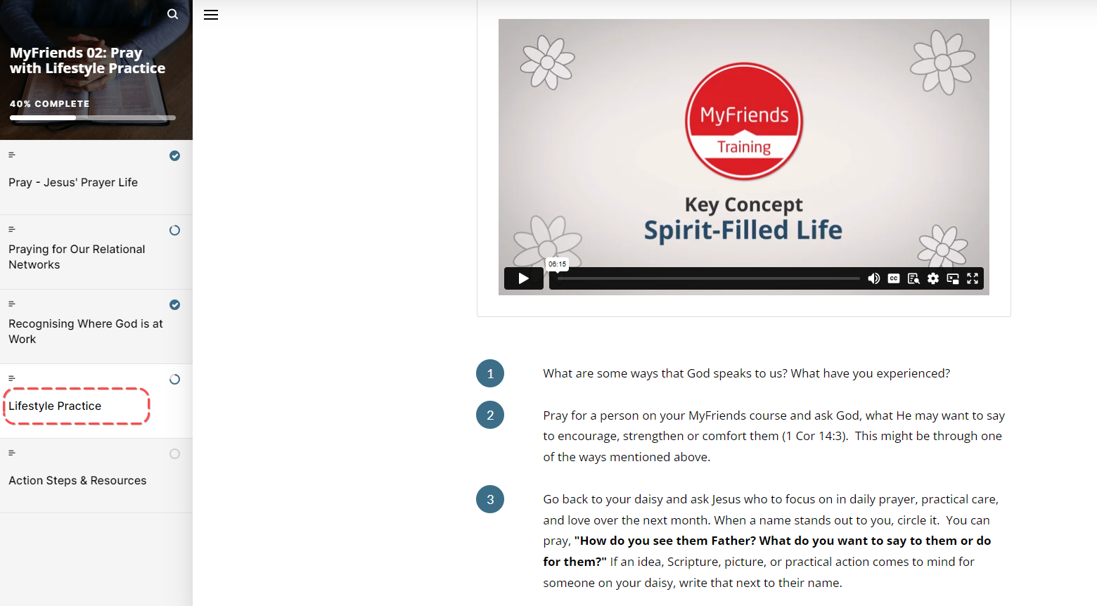
- Look back over the week
  - How have you experienced God at work and through your life?
  - What did you learn about God, yourself, or others this week?
- Look Up
  - Read John 10:3-5 and watch the Spirit-Filled Life Video
  - What are some ways that God speaks to us?
  - Pray for your course members
  - Pray for those on your Daisy Chain
- Look Forward
  - What is the Holy Spirit prompting you to do in developing a lifestyle of love and mission? Is the Holy Spirit prompting you to do something specific with a person on your daisy chain?
  - What practical next steps do you need to take?

Spend some time praying for each other in smaller groups. Include prayers for those on their daisy chain!

Week 2 Facilitator Follow up.

Social Media follow up
- Put a short prayer in your social media group after your session
  - Dear Lord, I thank you for encouraging this amazing group of people to attend MyFriends. Lord help them pray for their friends on their daisy chain. Amen
  - Role model praying for your friends on your daisy chain – e.g. Lord I ask you to help XXXX with XXX challenge in their life – Amen
  - Send a link to the course content – if you go to the page for the “scorm” package this is a unique URL to that particular module. Ask a question like – What part of the module “Prayer” did you like the best – Here is a link to the module if you would like to review it again. Link
  - Our “home play” this week was to think about the Hearing God’s Voice here is a link to the module – link. What stood out to you?
  - How are you going with your daisy chain? Who are you praying for?
  - Looking forward to seeing you in our next session. The link to the content is (link) and the zoom link is (link)

Facilitator email MyFriends Module 2 - Prayer
To Attendees:
Subject: MyFriends: Week 2 Prayer


Dear Name
This week in the MyFriends programme we looked at prayer.
Jesus modelled a lift of prayer that is dependent on the Father, and we must follow the same pattern as we seek to live like Him.

Reflect on the content of this week’s MyFriends session:
- Reflect on Jesus' prayer life. What is one change you feel like you would like to make to your prayer life? How will you implement that?
- Who are you praying for on your daisy chain? Share this on your social messenger group.
- Sometime in the next week, while you are out of the house, ask God to show you what He sees for the people in the place you are in.
- Please review this week’s Lifestyle Practice: Hearing God’s Voice (link to the module in moodle)

We look forward to seeing you at your next session.
Blessings,

