

Facilitators Guide
Module 3 - Care

Module 3: Care


Module 3 Objectives
The fourth module is about the Holy Spirit and how we live out the Spirit filled life.

The key objectives are:
- To describe who is the Holy Spirit and what are His purposes and passions.
- To be able to explain the role that the Holy Spirit plays in the trinity and in our lives.
- To recognise how Jesus modelled the Spirit filled life and desires us to be surrendered to the Holy Spirit.
- To be able to express why it is important for our friends to have a proper perspective on the Holy Spirit and be empowered and led by the Spirit.


Tools
As a facilitator you will need the following tools you used in previous sessions.

Facilitator Guide: Module 3 Care

Introduction (10 mins)
Welcome everyone back for week 3! Spend some time sharing stories from the week particularly focusing on how participants went praying for people on their daisy chains.


Open in a short prayer giving the course and time to God.


Ask how everyone went praying for people on their daisy chain.
Did they notice God working in their lives or in the lives of their friends?
Anything else that the group wants to share with each other.
Anything from the Social Media group that you want to make a comment on.
Note: You may like to continue with the icebreakers until the group knows each other well.

This session is all about caring for people in your world. The main aims of this session are to understand the different ways to care for people (physical, social, emotional and mental) and to see people as God does, not as projects! We also hope to introduce some tools and brainstorm practical and feasible ideas to help us get started.

Elements of Care

Play ‘My Friends – Care’
https://vimeo.com/showcase/10517460/video/841113959 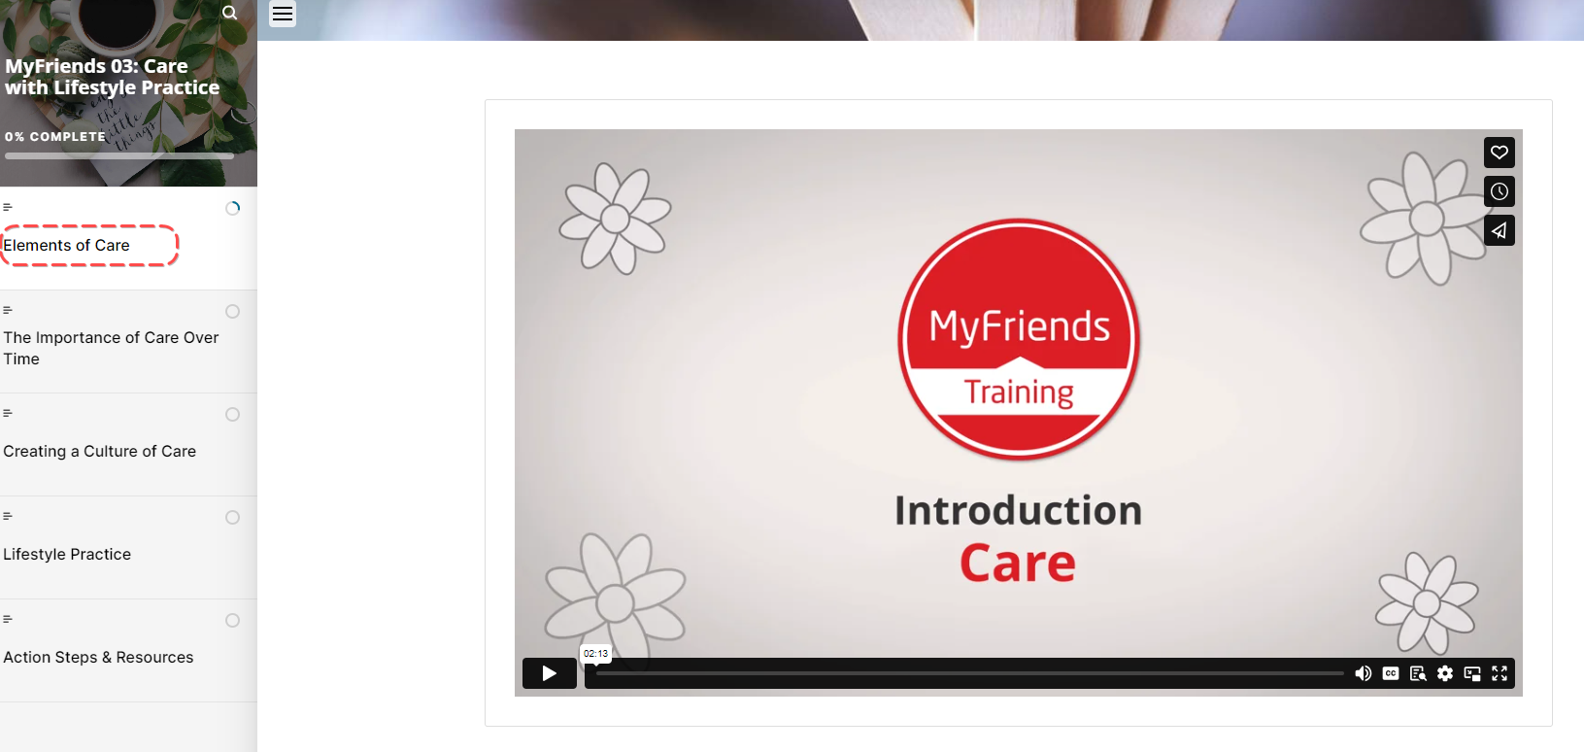

(Click Full screen – bottom right)


Activity: Ask a participant to read Mark 12:30-31 aloud
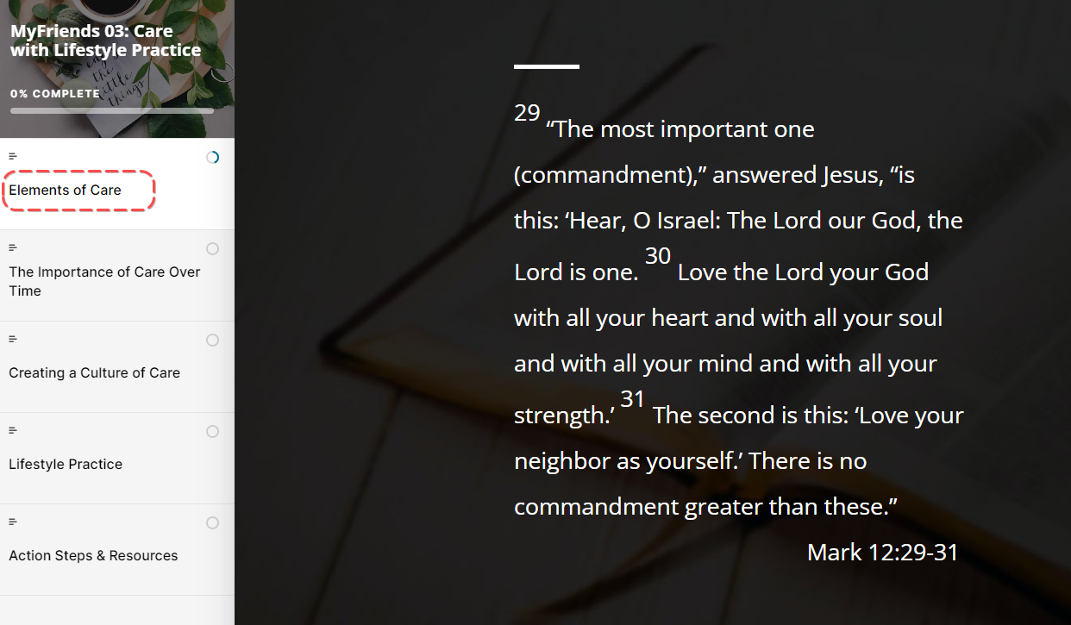

What are the elements of Care?
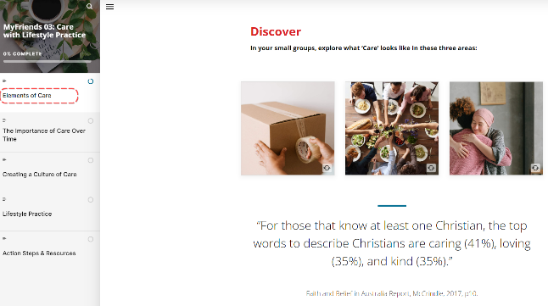
- Physical
- Social
- Emotional or Mental

“For those that know at least one Christian, the top words to describe Christians are caring (41%), loving (35%), and kind (35%).”
Faith and Belief in Australia Report, McCrindle, 2017, p10.

Share your thoughts on this report.

The Importance of Care Over Time

Activity: In small groups explore what care looks like.
What examples can you think of for each of these?
Share your ideas back to the group
We are asked to love each other authentically – not make people our “project” - but to see them as God sees them.
Read – 1 Thessalonians 2:8
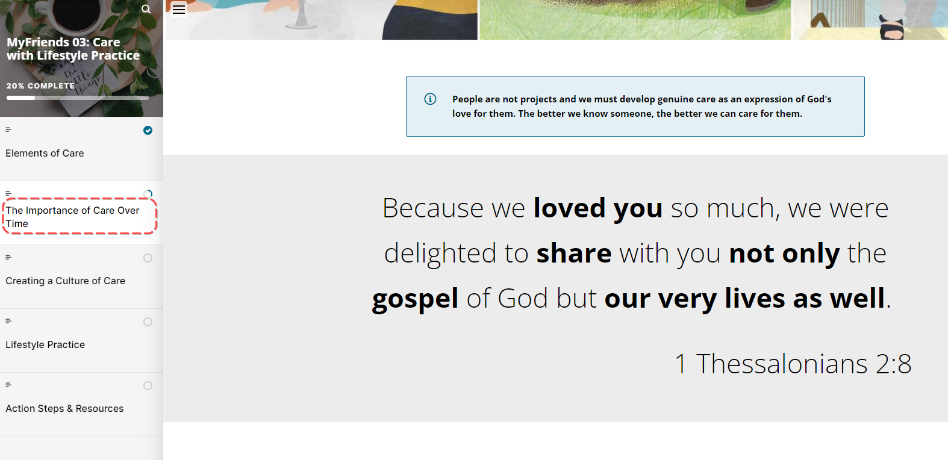
What does this mean to you?

Imagine if Christians were not primarily known for their stances on various issues, but rather as people who love others and could be counted on to care for people.
What would this look like? 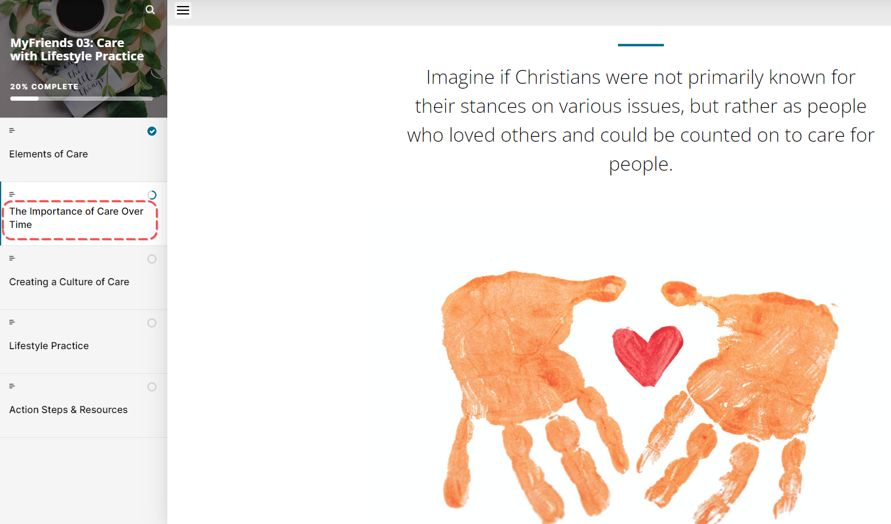

We don't get to define if we are a loving person or not. That will be determined by others over time. To love well, we need to get close to people to learn their needs and love them on their terms in a way that is best for them; not in the way that is most convenient for us. We must follow the example of Jesus who gave up the pleasures of Heaven to come down to earth to serve and give His life for those who were distant from God.

Activity: In pairs take 5 mins to discuss the following Questions

- What stops us from caring well for others?
- What changes can you make to embrace a lifestyle of caring well for others?

Creating a Culture of Care
Ask someone to read Mother Theresa’s quote aloud
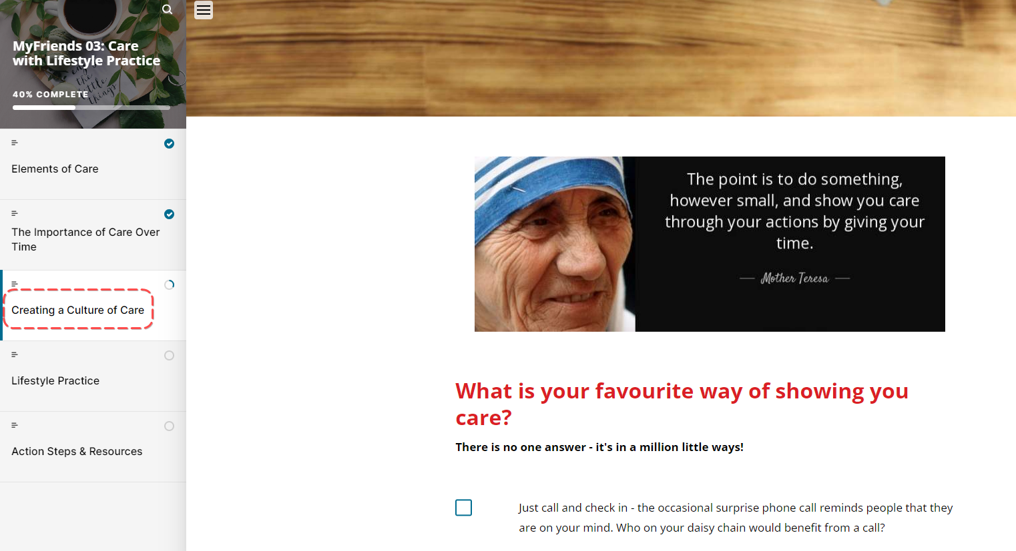

There are a million different ways to show that you care for a friend. Take a moment to think about the ways you show you care.

Challenge: Get participants to write down their answer to this question. “What can you do personally or within your community to practically care for people in your daisy chain this week?”

Once they have written them down, ask people to share their ideas to inspire others. If people are stuck, get them to brainstorm ways that people have cared for them in the past or read the list on moodle.

Play ‘Food Truck Church – External Use’
food truck churches Original - YouTube
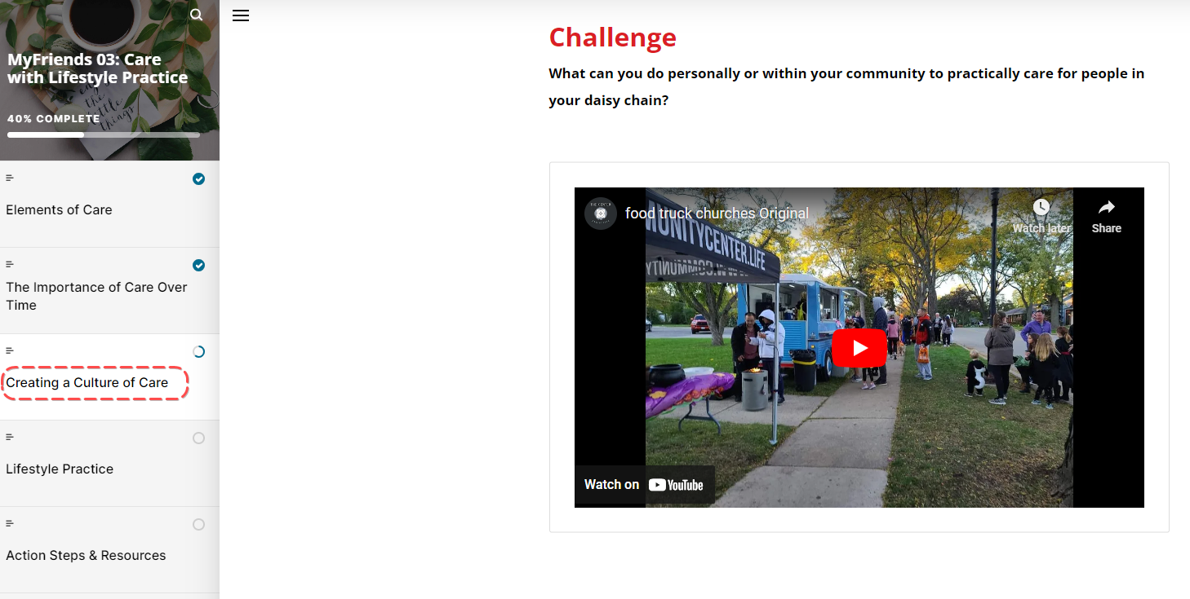

Ask your group
“What are your reactions to this video?
What do you see as the strengths and potential pitfalls of “food truck” church?
How would a food truck style church help with caring for others?”

Discover – Brainstorm together as a group what care looks like under the three categories of physical, social, emotional / mental. If you like, draw them up on a whiteboard and record people’s ideas underneath.

Lifestyle Practice – Sent Like Jesus

Explain the Lifestyle Practice for the coming week
Explain the Lifestyle practice for the coming week – Sent Like Jesus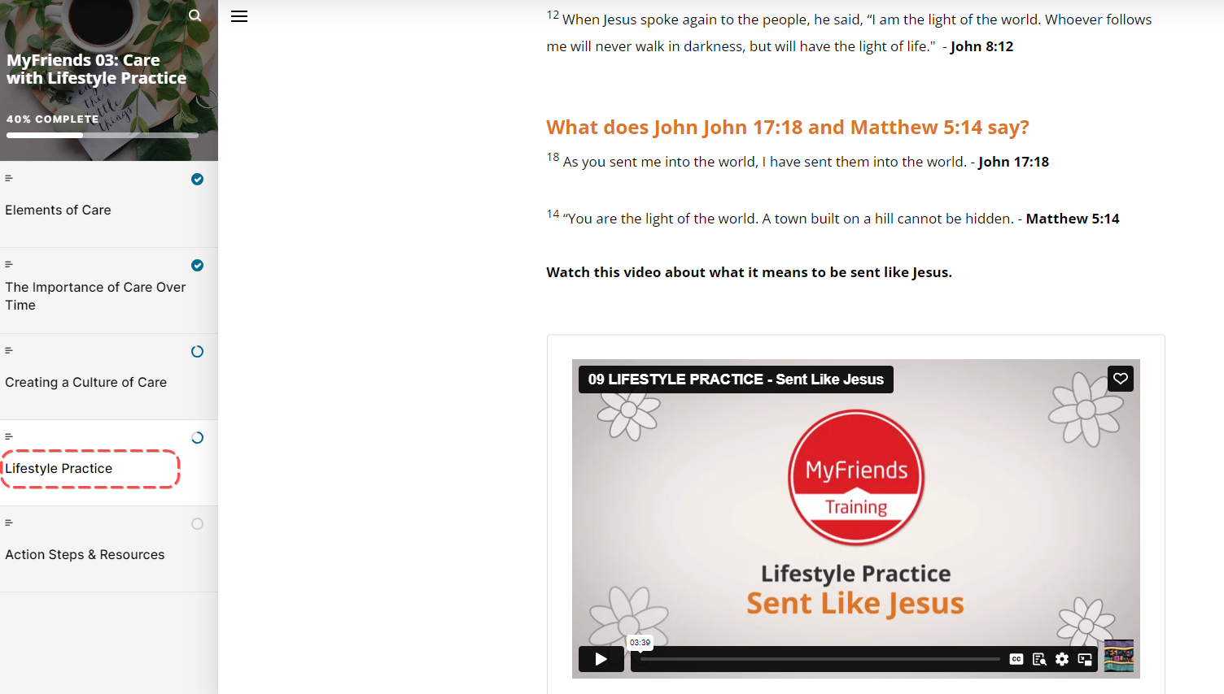
This week take time to go through Lifestyle Practice – Sent Like Jesus
Peace be with you! As the Father has sent me, I am sending you”. Jesus
https://vimeo.com/showcase/10517460/video/843807412

- Look back over the week
  - How have you experienced God at work and through your life?
  - What did you learn about God, yourself, or others this week?
- Look Up
  - Read John 3:16, John 8:12, John 17:18, Matt 5:14
  - What does it mean to say that we are sent as Jesus was sent?
  - How will an attitude of “sentness” influence your priorities and actions on a daily basis?
- Look Forward
  - What specific and practical changes do you need to make in your life to be 'sent' like Jesus?
  - What will these changes cost you?
  - Who on your daisy chain is the Holy Spirit prompting you to care for in a practical way this week?
  - What practical next steps do you need to take?
Pray for each other and ask the Holy Spirit to prompt and inspire everyone this week as they seek to care for those on their daisy chains.

If time is running short you might like to use the prayer in the content: “Father, give me your heart, lead me by your Spirit, use me where you have sent me and with whom you have shown me today.”

Week 3 Facilitator Follow up.

Social Media follow up
- Put a short prayer in your social media group after your session
  - Dear Lord, I thank you for encouraging this amazing group of people to attend MyFriends. Lord help them pray and care for their friends on their daisy chain. Amen
  - Role model praying and caring for your friends on your daisy chain – e.g. Lord I ask you to be with me while I “XXX Caring action” for my friend
  - Send a link to the course content – if you go to the page for the “scorm” package this is a unique URL to that particular module. Ask a question like – What part of the module “Care” did you like the best – Here is a link to the module if you would like to review it again. Link
  - Our “home play” this week was to think about the “How we are sent like Jesus” here is a link to the module – link. What stood out to you?
  - How are you going with your daisy chain? Who are you praying and caring for?
  - Share how you are caring for people on your Daisy Chain. Can you care for 3 people this week – this might be an encouraging text, phone call, catch up for a cuppa etc…. share what you have done.
  - Looking forward to seeing you in our next session. The link to the content is (link) and the zoom link is (link)

Facilitator email MyFriends Module 3 – Care
To Attendees:
Subject: MyFriends: Week 3 Care

Dear Name
This week in the MyFriends programme we looked at how we care for others.
Imagine if Christians were not primarily known for their stances on various issues, but rather as people who loved others and could be counted on to care for people.
Reflect on the content of this week’s MyFriends session:
- Seek the Holy Spirit in how He wants you to practically love, pray and care for those on your daisy chain.
- Take some time to practically care for someone on your daisy chain this week. Share this on your social messenger group.
- Think about how you can start a new relationship with someone in one of your communities and take a step to say 'hi' and care well for them.
- Please review this week’s Lifestyle Practice: Sent Like Jesus (link to the module in moodle) - Link

We look forward to seeing you at your next session.
Blessings,

