

Facilitators Guide
Module 4 – Holy Spirit

Module 4: Holy Spirit


Module 4 Objectives

Key Objective: To understand that Jesus modelled a life dependent on the Spirit and that everything we do, including love, pray and care, needs to be done by relying on the Holy Spirit.
Participants will have a look at the ‘God tools’ app which is a great resource for learning more about the Holy Spirit. Make sure you have downloaded it before the session and are familiar with how it works.
The key objectives are:
- To describe who is the Holy Spirit and what are His purposes and passions.
- To be able to explain the role that the Holy Spirit plays in the trinity and in our lives.
- To recognise how Jesus modelled the Spirit filled life and desires us to be surrendered to the Holy Spirit.
- To be able to express why it is important for our friends to have a proper perspective on the Holy Spirit and be empowered and led by the Spirit.


Tools
As a facilitator you will need the tools that you used in previous weeks.

Facilitator Guide: Module 4 Holy Spirit

Introduction (10 mins)
Welcome everyone to week 4! Share stories from the week with a particular focus on how people went caring for people on their daisy chains.

Questions you could ask are:
- How have you experienced God this week?
- What does it mean to you to be “sent” like Jesus?
- What specific and practical changes do you need to make in your life to be 'sent' like Jesus?
- What happened when you prayed for people on your daisy chain?
- How did you hear God’s Voice this week?


Open in a short prayer giving the course and time to God.

Who is the Holy Spirit?
This week is all about the Holy Spirit! The main aims for this session are to describe who the Holy Spirit is and what His purposes and passions are as well as the role He plays in the trinity and our lives. We will also explore how Jesus modelled the Spirit filled life and desires us to be surrendered to the Holy Spirit and explain why it’s important for our friends to understand the Holy Spirit and be empowered and led by Him!


Video: Play the video ‘Introduction – Holy Spirit”
https://vimeo.com/showcase/10517460/video/841115230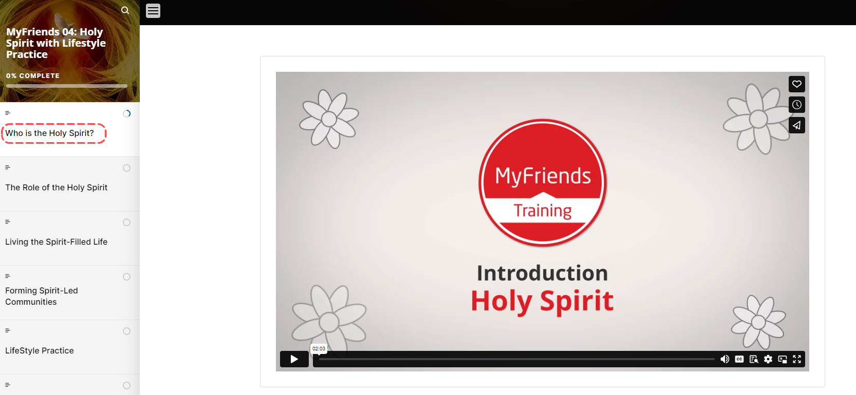

Activity: On a whiteboard write the heading ‘Holy Spirit’ and then brainstorm as a group who He is and what He does. Write everyone’s response and ideas on the board and keep it visible for the duration of the session.


Bible Reading
Let’s open the Bible and see what God has to say about the role of the Holy Spirit.
Ask someone to read John 14:15-27 and then ask someone else to read it a second time.
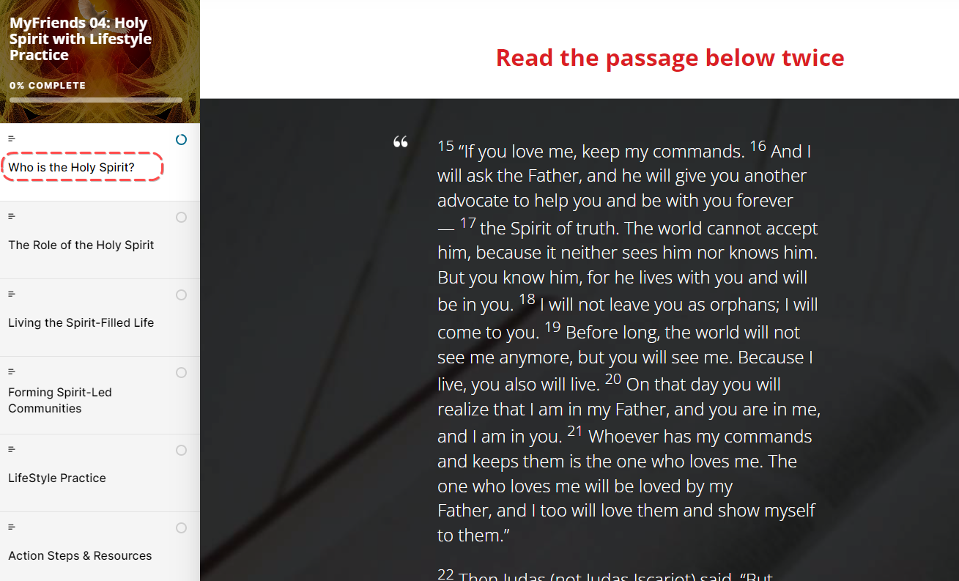
Ask participants to answer these questions individually and then share them as a group
- What stands out to you in this passage?
- What did you learn about the Spirit of God and people?
- What principle of mission did you discover that you can apply today

The Role of the Holy Spirit
“The Bible refers to God’s Spirit as the wind or breath of God. From the beginning of God’s story to the end, the Holy Spirit is breathing life into humanity.”

In the bible the Holy Spirit is constant in Jesus’s life from conception through to him being raised by the spirit. Let’s see what scripture says about this.
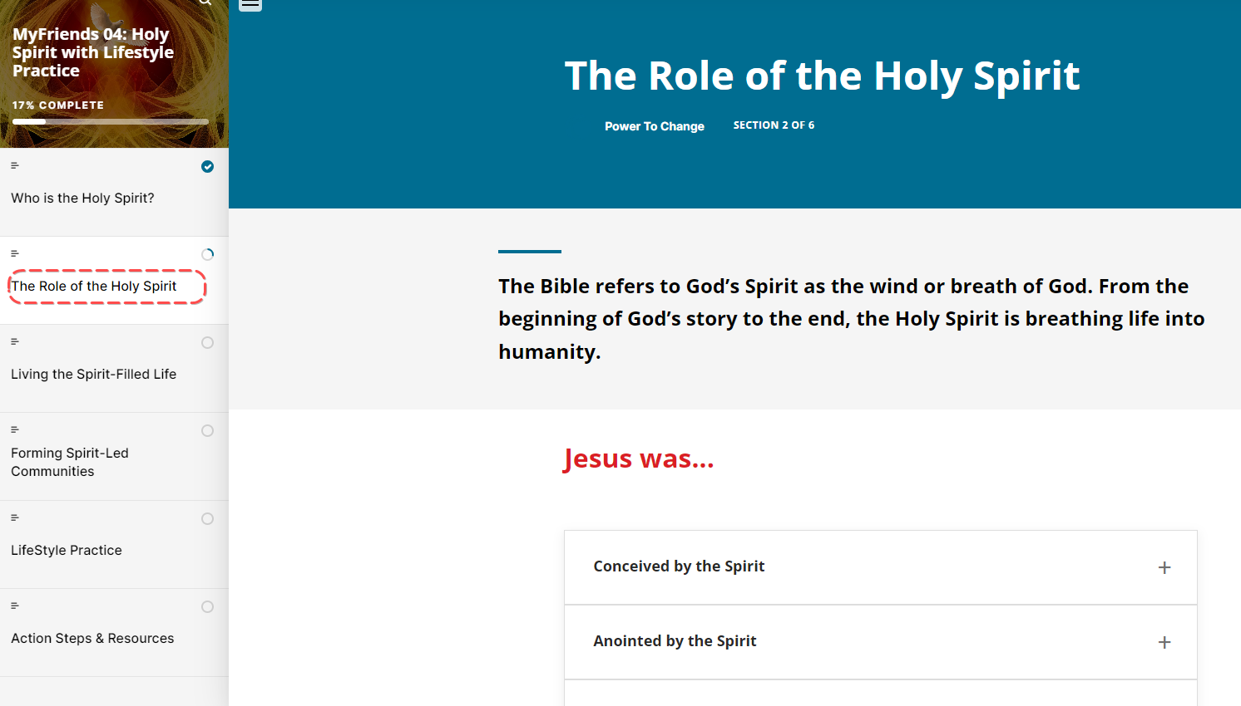

Break into groups of 2 or 3 and divide the passages between the groups. Ask each group to answer the question “What do we learn about the Holy Spirit from this passage” for each passage they are given.

Go around and share responses for each passage. Add to the whiteboard brainstorm you created at the start if new information emerges.

How have you experienced the Holy Spirit working in your life?
What are the dangers of trying to love, pray and care for people in our own strength without relying on the Holy Spirit?

Break - take a 5 minute break if the group needs it.
Living the Spirit Filled Life
Video Let’s watch a video about living a Spirit Filled life with Earl Roberts
https://vimeo.com/showcase/10517460/video/841147560 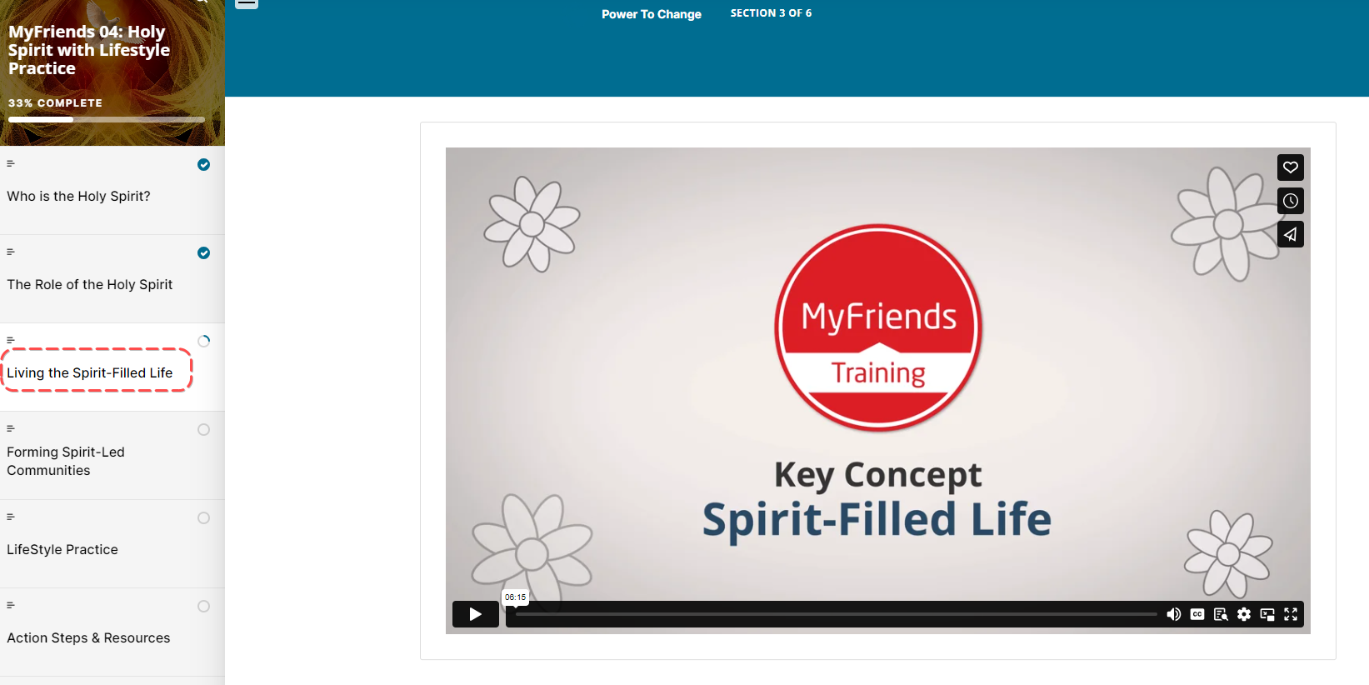
Let’s take a few minutes to do some Spiritual Breathing – and let God’s Holy Spirit work within us.

Spiritual breathing (exhaling the impure and inhaling the pure) is an exercise in faith that enables you to continue to experience God's love and forgiveness.
- Exhale — Confess your sin — agree with God concerning your sin and thank Him for His forgiveness of it, according to 1 John 1:9 and Hebrews 10:1-25. Confession involves repentance — a change in attitude and action.
- Inhale — Surrender the control of your life to Christ and appropriate (receive) the fullness of the Holy Spirit by faith. Trust that He now directs and empowers you according to the command of Ephesians 5:18 and the promise of 1 John 5:14-15.

Holy Spirit Surrender Prayer
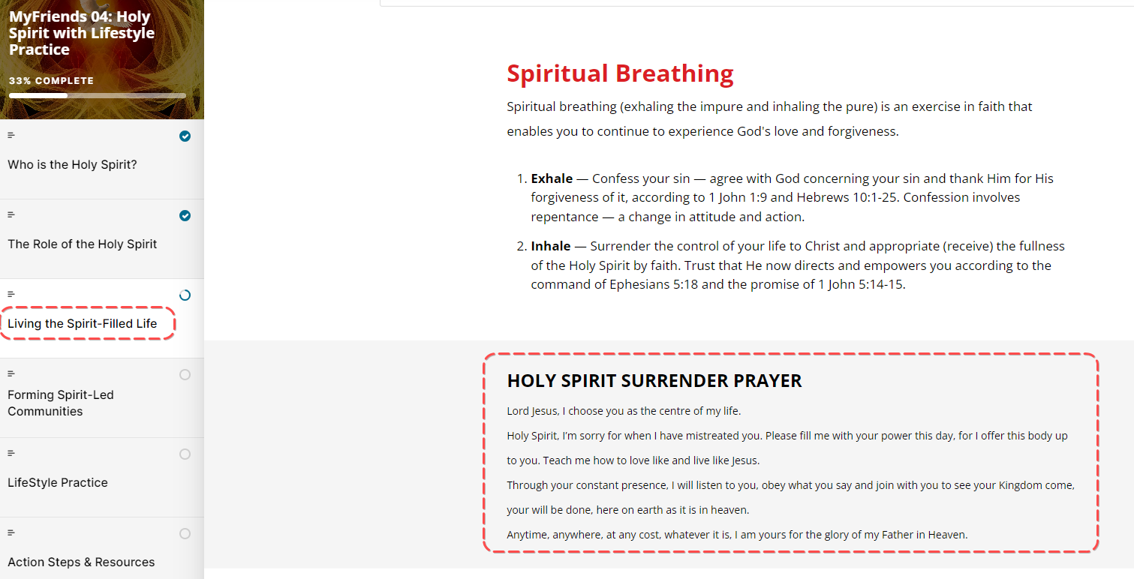

Maybe you have never surrendered your life to the Holy Spirit before? If you’re comfortable, you’re welcome to join me as I pray this prayer of surrender aloud. Whether it’s the first time or the millionth time that you have done this, let’s read it aloud and surrender to the Holy Spirit again.

Read the prayer aloud slowly.

HOLY SPIRIT SURRENDER PRAYER
Lord Jesus, I choose you as the centre of my life.
Holy Spirit, I’m sorry for when I have mistreated you. Please fill me with your power this day, for I offer this body up to you. Teach me how to love like and live like Jesus.
Through your constant presence, I will listen to you, obey what you say and join with you to see your Kingdom come, your will be done, here on earth as it is in heaven.
Anytime, anywhere, at any cost, whatever it is, I am yours for the glory of my Father in Heaven.

Forming Spirit-Led Communities
The Holy Spirit is working in the lives of people you know to draw them to Jesus. The Holy Spirit wants to express the love of the Father through you so they can experience Jesus and connect with Him personally. The daily act of love, pray and care is the first step in this process.

Let’s go back to our daisy chains again. This time, pause to ask the Holy Spirit who He is highlighting for you to love, pray and care for this week. Make sure you underline that person’s name and take a moment to pray for that person now.
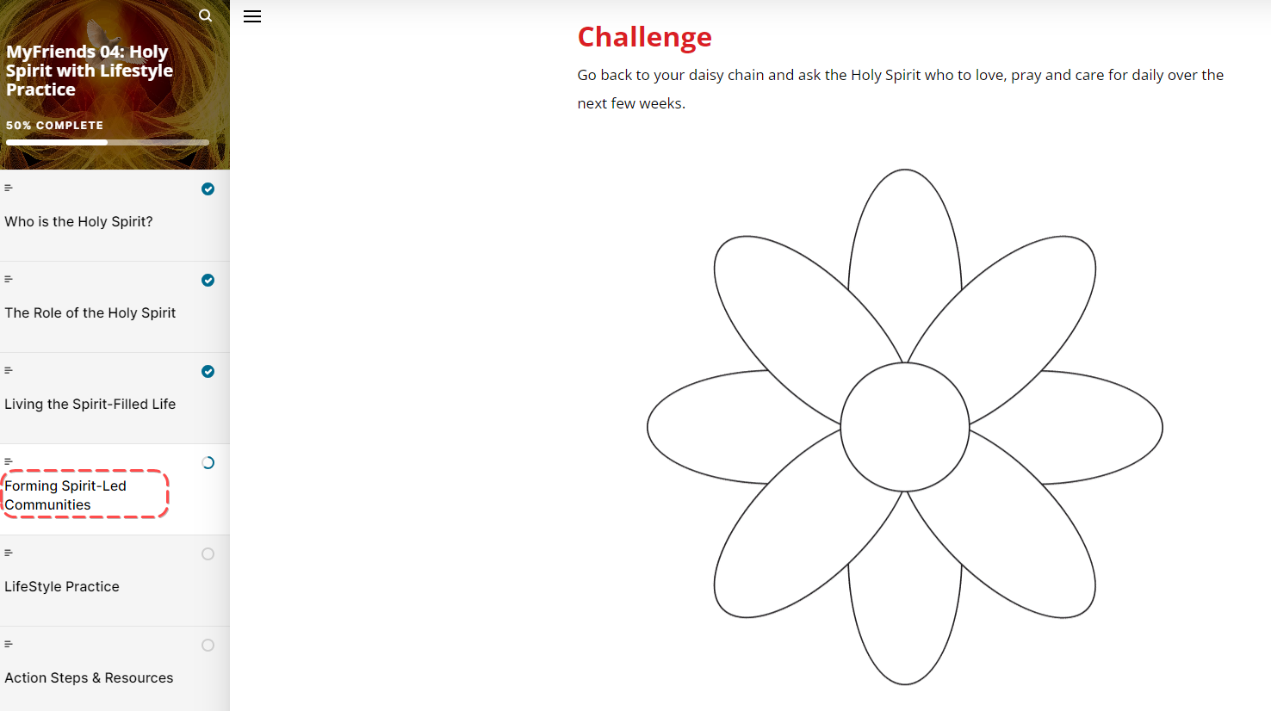
Like Jesus, we can live by, be led by, and keep in step with the Holy Spirit as we seek to obey the Father (Galatians 5:16-26).

Explain the Lifestyle Practice for the coming week
Explain the Lifestyle practice for the coming week
Look back over the week – how did you experience God? What did you learn and how does the Holy Spirit impact your life?


Read Satisfied

Look forward and Breath, walk in step with the Holy Spirit, review your Daisy Chain and think of some practical steps that the Holy Spirit is prompting you to do.
Closing Prayer
Pray for each other and ask the Holy Spirit to prompt and inspire everyone this week as they seek to care for those on their daisy chains.

Week 4 Facilitator Follow up.

Social Media follow up
- Put a short prayer in your social media group after your session
  - Dear Lord, I thank you for encouraging this amazing group of people to attend MyFriends. Lord help them pray and care for their friends on their daisy chain. Amen
  - Role model praying and caring for your friends on your daisy chain – e.g. Lord I ask you to be with me while I “XXX Caring action” for my friend
  - Send a link to the course content – if you go to the page for the “scorm” package this is a unique URL to that particular module. Ask a question like – What part of the module “Care” did you like the best – Here is a link to the module if you would like to review it again. Link
  - Our “home play” this week was to think about the “Holy Spirit” here is a link to the module – link. What stood out to you?
  - What stood out to you in Satisfied from God Tools (link)? Satisfied? Demo - GodTools (godtoolsapp.com)
  - Share how the Holy Spirit has worked in your life and ask them to share how He has been working in their lives
  - How are you going with your daisy chain? Who are you praying and caring for?
  - Looking forward to seeing you in our next session. The link to the content is (link) and the zoom link is (link)

Facilitator email MyFriends Module 4 - Holy Spirit
To Attendees:
Subject: MyFriends: Week 4 Holy Spirit


Dear @@USER:username@@,
This week in the MyFriends programme we looked at the importance of the Holy Spirit and how we live out a Spirit filled life.
Reflect on the content of this week’s MyFriends session:
- Download the God Tools app and read through 'Satisfied?'. Do you need to take some time to get right with God, breathe spiritually, and invite the Holy Spirit to control your life?
- Take some time to observe those around you. How is the Holy Spirit at work in their lives? Is there a step of faith the Holy Spirit is wanting you to take?
- Go back to your daisy chain and ask the Holy Spirit who to love, pray and care for daily over the next week.
- Please review this week’s Lifestyle Practice: Holy Spirit (link to the module in moodle)

We look forward to seeing you at your next session.
Blessings,
MyFriends Team

