

Facilitators Guide
Module 5 – Share and Experience

Module 5: Share and Experience


Module 5 Objectives
This fifth module is about Sharing and how we can share our experiences of God with others and how we can help our friends Experience God in their lives.

The key objectives are:
- To recognise that the first step to helping people experience Jesus is to help show them how we experience Jesus.
- Help our friends build bridges in their life that connect to the spiritual - it's about them; not us!
- To be able to enable others to experience Jesus before they fully understand who He is - this launches them on a path of further investigating Jesus (heart before head).
- Practice a short prayer for someone to help them experience Jesus.


Tools
As a facilitator you will need the tools that you used in previous weeks.

Facilitator Guide: Module 5

Introduction (10 mins)
Welcome everyone to week 5! Share stories from the week with a particular focus on how people went caring for people on their daisy chains.

Questions you could ask are:
- How have you experienced God this week?
- How did you experience the Holy Spirit this week?
- What stood out for you in Satisfied?
- What happened when you prayed and cared for people on your daisy chain?
- How did you hear God’s Voice this week?

Open in a short prayer giving the course and time to God.

Welcome everyone to week 5! This week you will cover two topics – share and experience. Explain to the group that you will have to move through the content quite quickly.
Spend some time sharing stories from the week – particularly focusing on how participants have experienced the Holy Spirit.
Sharing our Experience with Others
Our first module in this session is called Share and is all about how we share our experience of Jesus with our friends. We will explore our own experiences of Jesus and practice casually sharing what God has done in our lives. We will look at how to build bridges in our friends lives to help them connect with the spiritual.


Video: Play the video ‘Introduction - Share.
https://vimeo.com/showcase/10517460/video/841116359
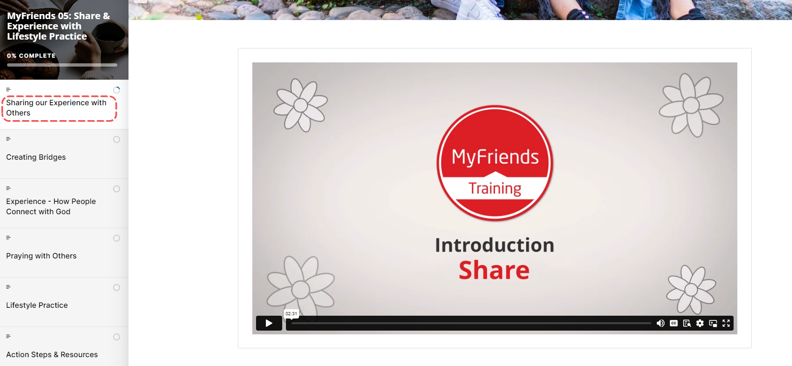
What is your reaction to the type of sharing described in the video?
Have a brief discussion as a group. Share a story about how you have experienced Jesus work in your life.
What are some ways that a relationship with God practically helps you in every day life?
Share with someone in your group in pairs.


Read John 4:27-30, 39-42 – Read it twice
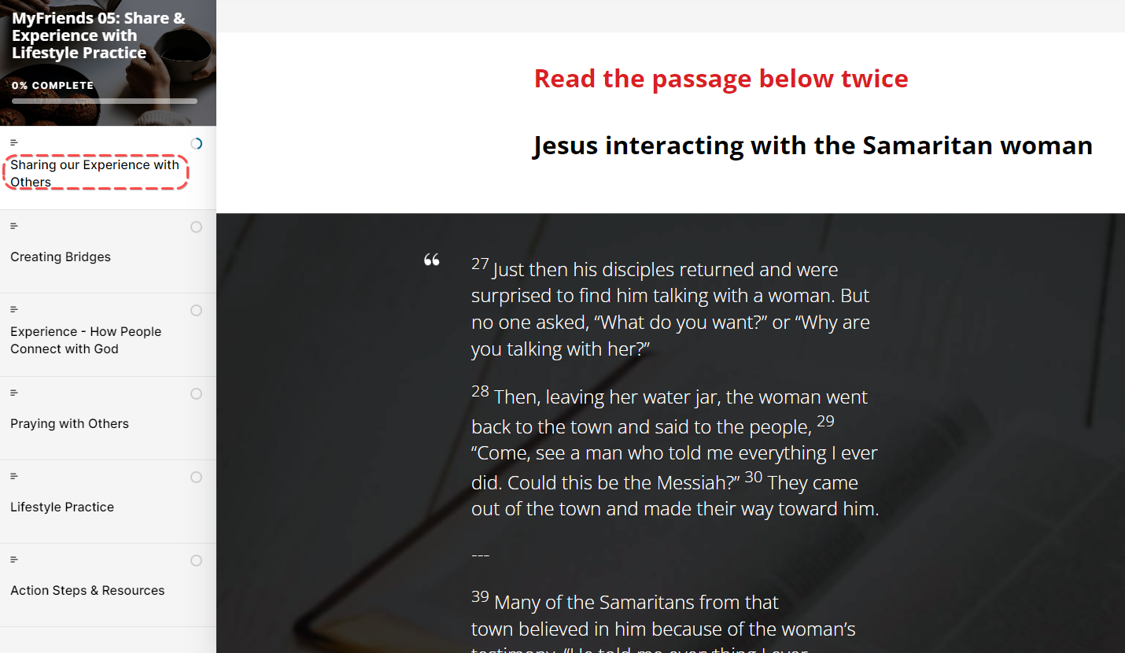
- What stands out to you in this passage?
- What do you learn about God or people?
- What principles of mission did you discover that you can apply today?

We don't want our friends to just know facts about Jesus but to begin a relationship with Him. When we share short stories about how Jesus impacts our everyday life, it helps our friends learn what a relationship with Jesus is like.

Three forms of witness
- Sharing how you experience Jesus in daily life (everyday witness).
- My story (personal testimony).
- Jesus' story (gospel presentation).

In the MyFriends Lifestyle, SHARE refers to opportunities that we have to communicate our experience of Jesus with our friends. This is the first form of witnessing listed above and can lead to opportunities to share the gospel in more detail in future conversations. We will unpack this more in EXPERIENCE and CONNECT.

Creating Bridges
We’re going to spend some time now writing down our own experience of Jesus. It does not have to be your whole testimony or conversion experience but can be a short story of how you’ve experienced Him in everyday life.

If participants are finding this hard, sit with them and ask them what’s the biggest difference they would say Jesus has made in their lives. See if you can identify a particular moment when that person has experienced Jesus.

Now with the person sitting next to you, share in 30 secs an experience of Jesus that you’ve had. It can be the one you’ve written down or another one altogether!
Set a timer and let people know when 30 seconds is up! Invite them to swap over who is sharing and set the timer for 30 seconds again.
Have a look at what the McCrindle report said – “Conversations with people are the biggest prompt for Australians to think about spiritual or religious things…More than half of Australians (55%) talk about spirituality or religion (often or occasionally)when they gather with friends. Generation Z is the most comfortable of all generations talking (often/occasionally) about spirituality or religion (65%).”
What do you think when you hear research like this?

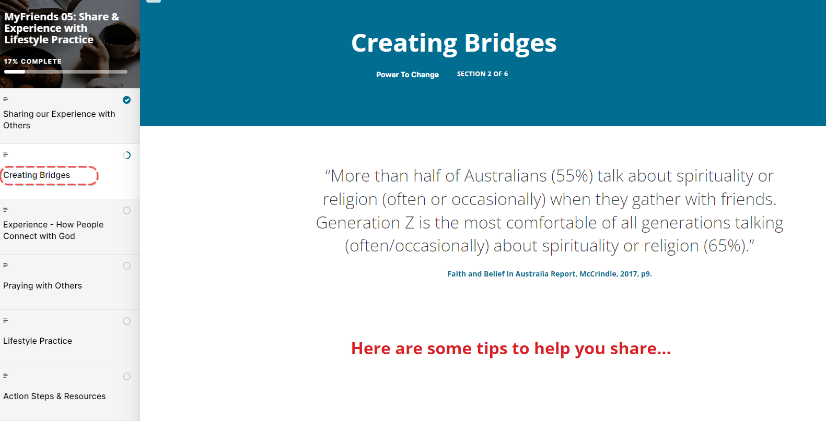
Tips for sharing your story
- Share your everyday experiences of Jesus
  - Sharing your everyday experiences of Jesus is a key way for people to get to know Jesus. It is best to keep your story short (max 30 seconds). Short stories are easy to listen to and engage with.
- Share your feelings
  - Share your feelings: Being vulnerable and authentic is important for people to connect with your story.
  - For example: “I was really scared of an exam. A friend prayed for me and asked Jesus to help me feel calm. I went into the exam and felt peaceful and focused. It was amazing!”
- Take Context into account
  - Take context into account: Share stories that have something in common with the listener’s experiences and which they will find easy to identify with. Telling a father about how God helped you in your relationship with your children will communicate better than if you tell the same story to a teenager who doesn’t have kids.
- Be honest, real and personal
  - Be honest, real and personal: It’s not about impressing people. You can be honest about your weaknesses and difficulties. People need to know that God can help us in our brokenness. Your listener will find it easier to be honest and more open to prayer if you are.
  - For example: “I was driving the other day and someone cut me off. I got really angry. Instead of driving aggressively I asked Jesus to help calm me down and I let it go.”
- It’s about them not us
  - Learn to help our friends build bridges in their life that connect to the spiritual - it's about them; not us!
- Don’t use Christian lingo
  - The Christian subculture has a lot of language that is very foreign to those outside the church. It's best to use everyday language that our friends use in their regular vocabulary.
  - For example: Discipleship = mentoring; fellowship = gathering with friends, etc.

Our role is to create a bridge for our friends to know God, how He works in our lives and Jesus’ story – so that they can make a decision to learn more …

Experience How people connect with God
Play Video: Introduction – Experience
https://vimeo.com/showcase/10517460/video/841117825
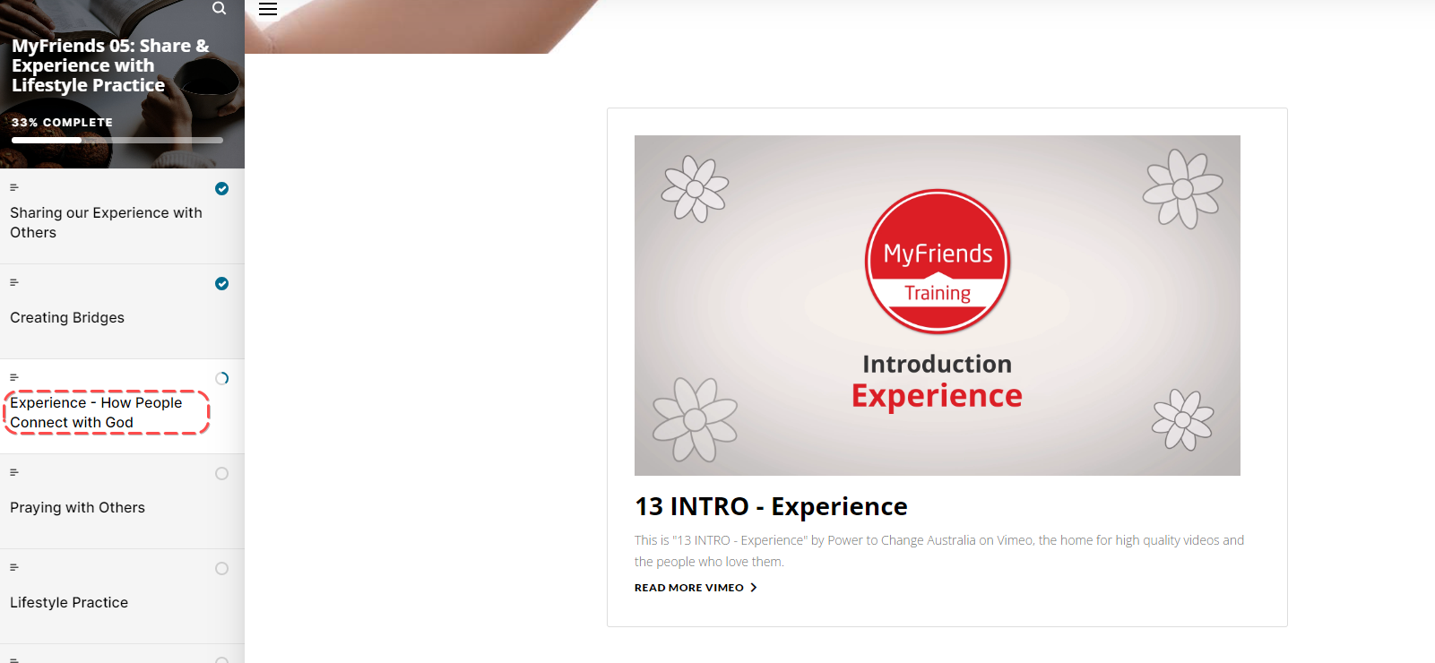
Most people’s understanding of God comes from an experience of meeting Him in their time of need. This is true in the bible too with Hagar. You are the God that sees me. Gen 16:13
What about you?
How have you experienced God in significant ways where God has show you a bit more about who He is?
Think of a close relationship you have - what experiences have led to that level of close intimacy? Why do you think these experiences have had that effect on your relationship?
Heart before head
While people need to understand intellectually who Jesus is to have a personal relationship with him, the activating event in their lives that engages their interest is often through an experience of Jesus - this launches them on a path of further investigation. An experience of Jesus could be through practical love, prayer, or care in their life.

Praying with Others
So how do we help people experience Jesus? One way is to learn how to pray with someone. Rather than just telling them we’re going to pray for them, actually taking the time to pray with them in the moment.

If you have a personal experience of praying with someone, now would be a great time to share it!
Let’s read the tips together
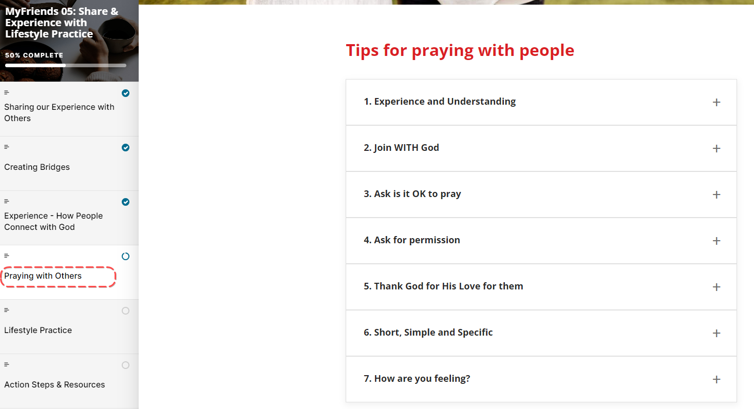
Go around the room, reading one tip each and pausing on any tip in which you have first hand experience, to share your story!

Discuss with the group ‘How can you overcome the fear barrier of praying out loud with someone?’

I think one of the biggest barriers is the fear that nothing will happen when we pray. But there are two things people will always experience when you pray – they will know you have a personal relationship with God and they will feel Jesus’ love through your prayer. So be bold! Amazing things happen when we pray with people.

Challenge We’re now going to look at our daisy chain again and ask the Holy Spirit who to love, pray and care for daily over the next few weeks. Specifically ask God to help you identify opportunities where you can share your 30 second story of how you have experienced Jesus in everyday life.

Ask the group if anyone felt the Holy Spirit prompt them as to who to share their 30 second testimony or pray with this week.

Our challenge this week is to share it with one person! Let’s share in our chat how we’ve gone and encourage each other to be brave!

Lifestyle Practice – Person of Peace
Explain the Lifestyle practice for the coming week.

Read: During the week read Matt 10:11-14 and Luke 9:1-5 and watch the video “Person of Peace” - https://vimeo.com/showcase/10517460/video/841216476
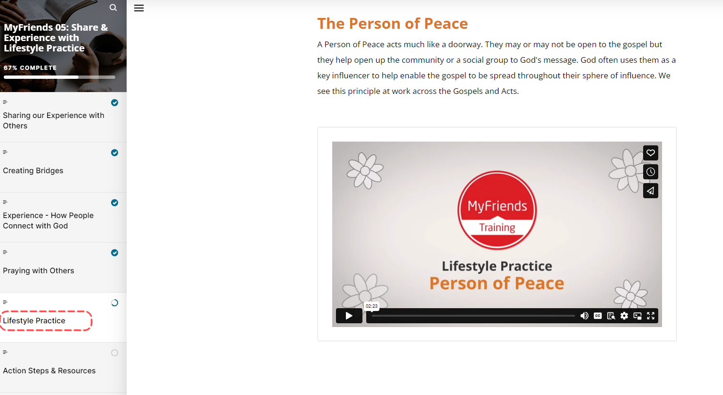
Discover who Jesus wants us to intentionally spend time with.
Look over your Daisy Wheel – and ask the Holy Spirit to help you identify who would fall into the Green, orange or Red category ….. and what your next steps are.

Closing Prayer

Spend some time praying as a group for opportunities to pray with others this week.

Week 5 Facilitator Follow up.

Social Media follow up
- Put a short prayer in your social media group after your session
  - Dear Lord, I thank you for encouraging this amazing group of people to attend MyFriends. Lord help them pray with and care for their friends on their daisy chain. Place a Person of Peace in their social places. Amen
  - Role model praying with and caring for your friends on your daisy chain – e.g. Lord I ask you to be with me while I “XXX Caring action” for my friend
  - Send a link to the course content – if you go to the page for the “scorm” package this is a unique URL to that particular module. Ask a question like – What part of the module “Share and Experience” did you like the best – Here is a link to the module if you would like to review it again. Link
  - Share on our private social group where God has worked in your life – have a practice here in a safe space before sharing it with someone on your daisy chain.
  - Share how God has worked in your life this week and who you have shared it with.
  - Our “home play” this week was to think about the “Person of Peace” here is a link to the module – link. What stood out to you?
  - Who is a person of peace in your social places? How can you engage with them?
  - Have you looked at your daisy chain and identified who is “Green” and spiritually open to discover more about God’s story? What are you going to do?
  - How are you going with your daisy chain? Who are you praying with and caring for?
  - Looking forward to seeing you in our next session. The link to the content is (link) and the zoom link is (link)

Facilitator email MyFriends Module 5 – Share and Experience

Dear @@USER:username@@,
This week in the MyFriends programme we looked at how we can share our experiences of God with others and how we can help our friends experience God in their lives.
Reflect on the content of this week’s MyFriends session:
- Reflect on how you have experienced God this week
- Share with someone on your daisy chain how you have experienced God in everyday life – a short 30 second story.
- Complete this week's form to help you be accountable for implementing your MyFriends actions. Your responses will be emailed to you and your church results will be aggregated so you can celebrate together.
  - MyFriends: Experience - How are you going? - Google Forms
- Please review this week’s Lifestyle Practice: Person of Peace (link to the module in moodle) Discover God with Your Friends: Person of Peace (movementbuilders.org.au)

We look forward to seeing you at your next session.
Blessings,
MyFriends Team

