

Facilitators Guide
Module 6 – Connect

Module 6: Connect


Module 6 Objectives
This fifth module is about Sharing and how we can share our experiences of God with others and how we can help our friends Experience God in their lives.

The key objectives are:
- To recognise that the first step to helping people experience Jesus is to help show them how we experience Jesus.
- Help our friends build bridges in their life that connect to the spiritual - it's about them; not us!
- To be able to enable others to experience Jesus before they fully understand who He is - this launches them on a path of further investigating Jesus (heart before head).
- Practice a short prayer for someone to help them experience Jesus.


Tools
As a facilitator you will need the tools that you used in previous weeks.

Facilitator Guide: Module 6: Connect

Introduction (10 mins)
Welcome everyone to week 6. Share stories from the week with a particular focus on how people went caring for people on their daisy chains.

Questions you could ask are:
- How have you experienced God this week?
- What is challenging you about MyFriends training and lifestyle?
- What do we discover about who Jesus wants us to intentionally spend time with?
- Who on your daisy chain had a red, orange or green light?
- What is the next step you need to take with the person of peace?

Discuss how people have identified how to know where people are – red, orange or green?
  - What happened when you prayed and cared for people on your daisy chain?
  - How did you hear God’s Voice this week?


Open in a short prayer giving the course and time to God.

This module is all about understanding how to connect our friends with Jesus after they have had an experience of Jesus.
We will look at how to gauge where your friends are at in their spiritual development and how to explore the message of Jesus in a simple way.
Spend some time sharing stories from the week – particularly focusing on how participants have experienced the Holy Spirit.

Connect the Experience to God
Can we remember what the 3 forms of witness were that we looked at last week?
Write them up on a whiteboard. Prompt if necessary!
- Sharing how you experience Jesus in daily life (everyday witness)
- My Story (personal testimony)
- Jesus’ story (gospel presentation)


Play Video: Introduction Connect
https://vimeo.com/showcase/10517460/video/841119015
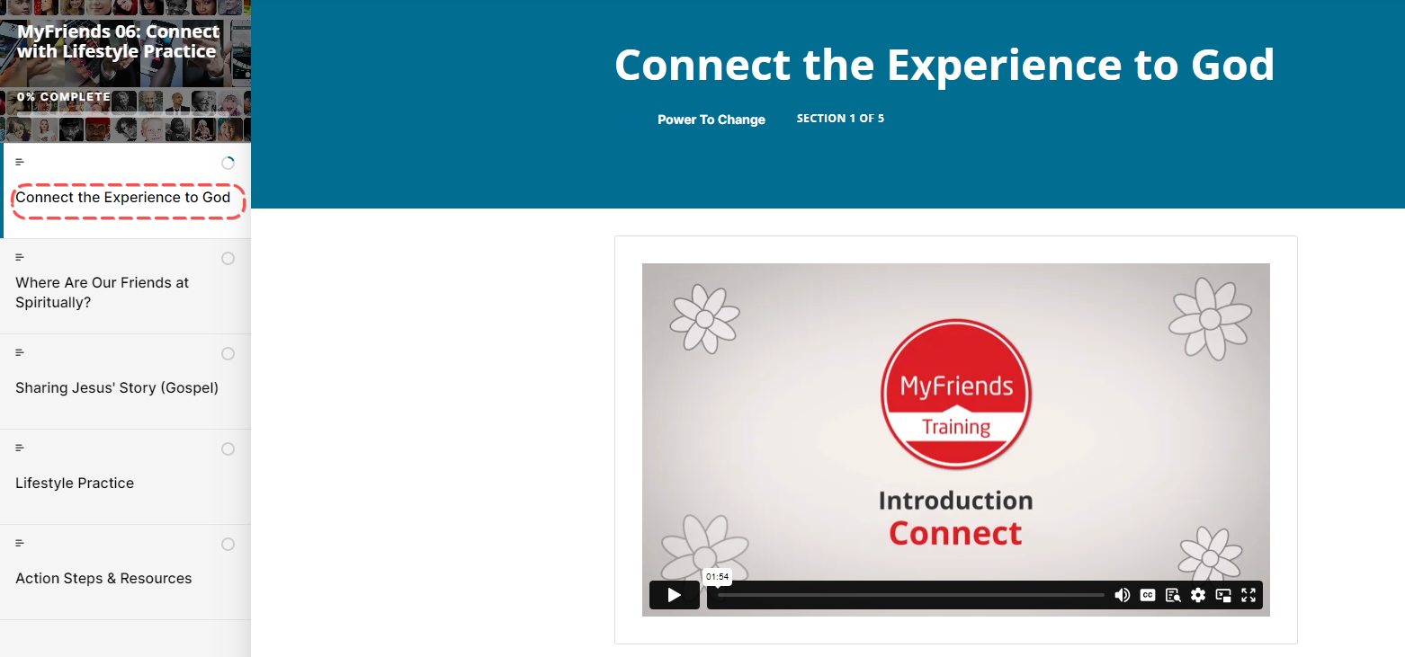


Activity: Ask a participant to read Acts 17:16-32
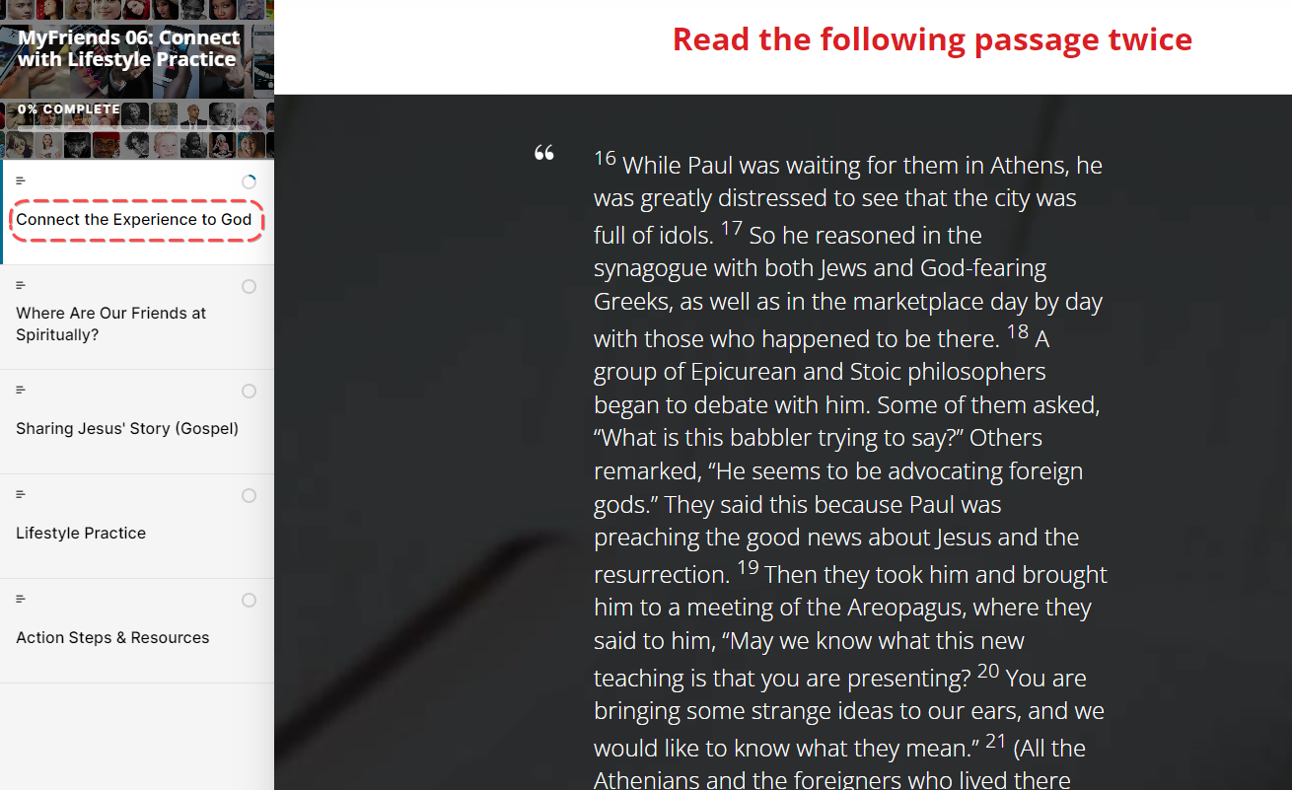


Then ask someone else to read it again (a different translation is often helpful!)
Then ask someone to retell the story – help them out if they get stuck!
Get participants to individually answer the 3 questions –
- What stands out to you from this passage?
- What do you learn about God or people?
- What principle of mission did you discover that you can apply today?

After they’ve had a few minutes to jot down their answers, ask for volunteers to share their responses with the group.

Challenge: Ask a participant to read the section titled ‘Challenge’.
“A witness in a court of law makes a statement about what they see, hear, or experience. Being a witness is not just about your own story - it’s being a witness to what God is doing in someone else’s life, right in front of your eyes… and pointing that out so they can see it!
Optional – Image- what do you see?
How do you share your interpretation of the image?
What does this mean for your witnessing God at work in someone's life?

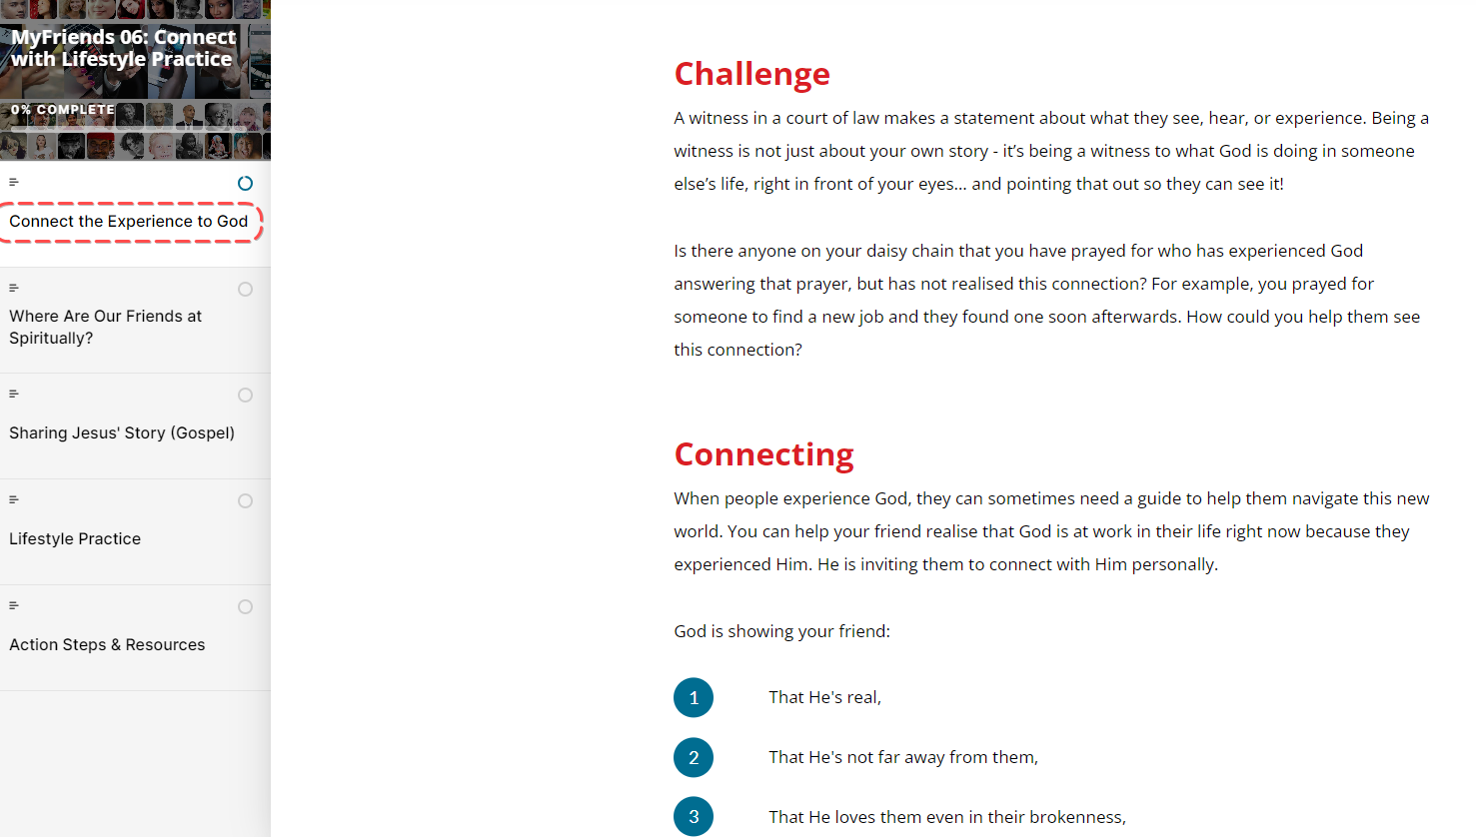

Ask anyone to share who can identify someone on their daisy who has had an answer to prayer but hasn’t realised it is God. Share about someone on your own daisy too if appropriate!

You can help your friend realise that God is at work in their life right now because they experienced Him. He is inviting them to connect with Him personally. Have a look at what God is showing your friend right now:

Ask someone to read from Moodle the list of ‘What God is showing your friend.
- That He's real,
- That He's not far away from them,
- That He loves them even in their brokenness,
- That He wants to start a friendship with them.

It’s so important to be listening to the Holy Spirit when you are talking to your friends and making connections for them to Jesus – He might be asking you to pray out loud with your friend, to share your testimony or even to ask them if they would like to have a friendship with God that is personal and life changing?

Where are our Friends Spiritually?

Faith Journey
As our friends have experiences of Jesus, it's important to think about where they are spiritually and what the next step is for them. For instance, someone hostile to faith is probably not open to reading the Bible but might be happy to talk with a Christian who is seeking to love, pray, and care for them. On the other hand, if someone is a spiritual seeker, then it might be best to share how Jesus has changed your life. The goal is to help people take their next spiritual step forward towards faith in Jesus and become a disciplemaker.
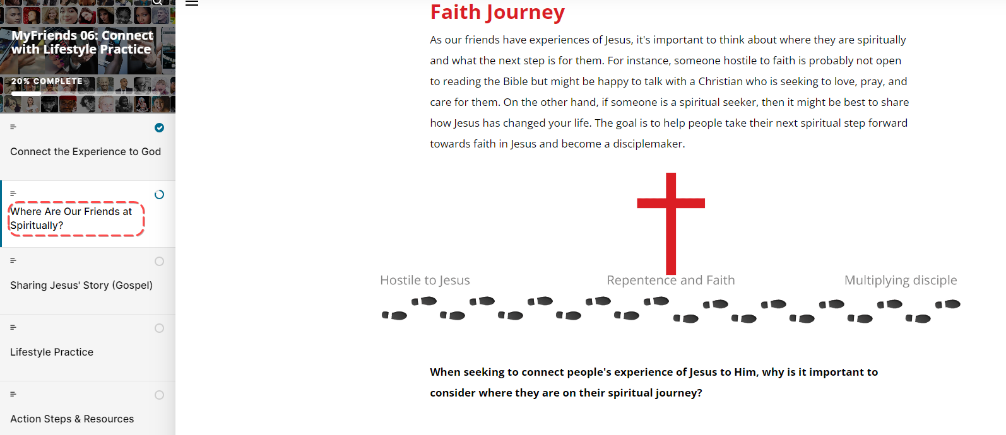

When seeking to connect peoples experience of Jesus to Him, why is it important to consider where they are on their spiritual journey?

Activity Take a moment to think about people on your daisy chain… Where are they at?
Sharing Jesus’ Story (Gospel)
Ok so the third way we talked about witnessing to our friends is by sharing Jesus’s story or the gospel. There are many ways to do this, some of you will already have some awesome tools you may have used before to help share the gospel with others. MyFriends has chosen ‘The Four’ as a short and simple way of sharing the gospel with others.

Play Video Key Concept The Four
https://vimeo.com/showcase/10517460/video/841151829 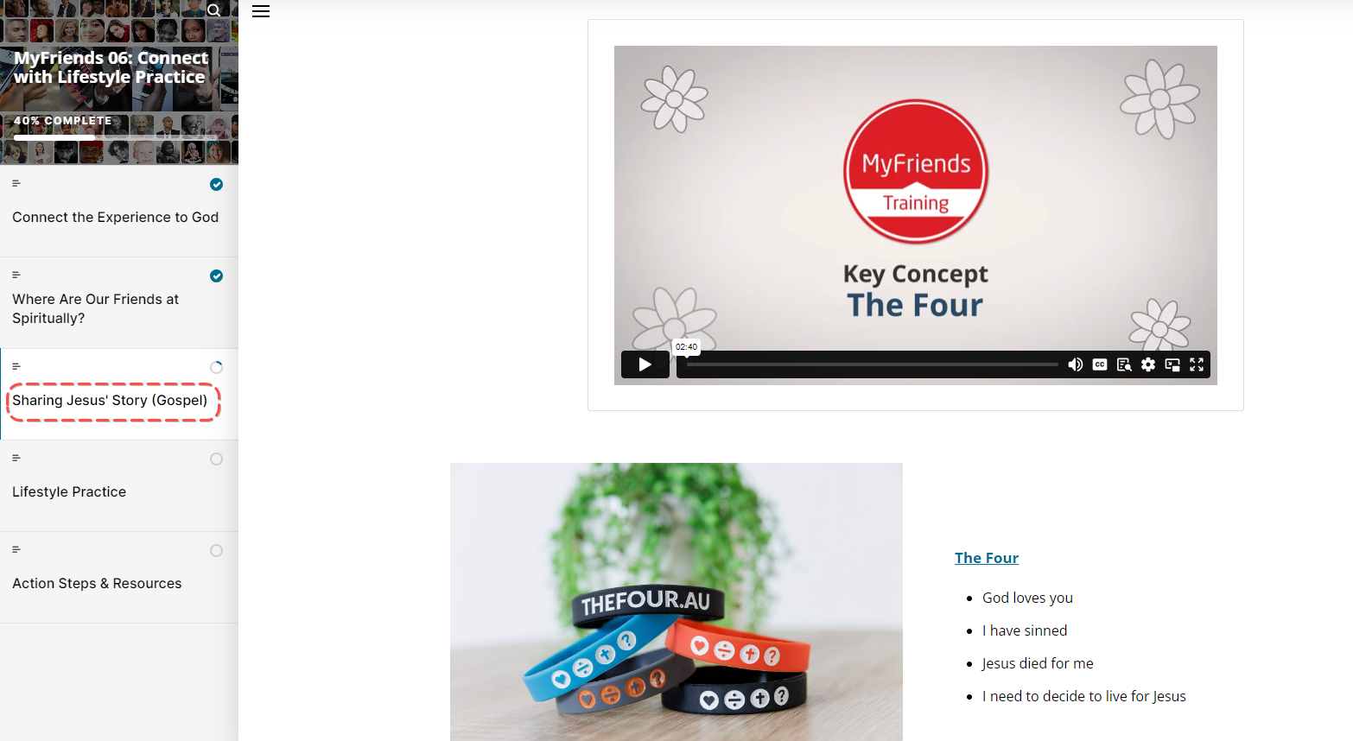
Walk through the site and ask the participants to choose a person to go through TheFour with.

Hand around the four bracelets to each participant so they can look at it as you run through it!

Let’s go through each element of the Four together.
God loves me – ask a participant to read the God loves me section including the two Bible verses and the two questions.
Pause and ask everyone to practice ‘God loves me’ using their bracelet with a partner.

I have sinned – ask a participant to read the I have Sinned section aloud including the two verses and the two questions.
Pause and ask everyone to practice ‘I have sinned’ using their bracelet with a partner.
Jesus Died for me – ask a participant to read the Jesus died for me section including the two verses and the 3 questions.
Pause and ask participants to practice the Jesus died for me section with a partner.

I need to decide to live for Jesus – ask a participant to read the “I need to decide to live for Jesus” section including the verses and question.
Pause and ask participants to practice the ‘I need to decide to live for Jesus’ section with a partner.

This is such a helpful tool that has been used all over the world and seen many, many people make decisions to follow Jesus.
Ask for a volunteer to practice doing all four with a partner in front of the group, pretending the partner does not yet know Jesus.

On Movement Builders Training Hub there is a course about how to use TheFour.
Creating Connections with Jesus
Ask participants to open up to their daisy chain again.
Let’s revisit our daisy chains now and ask God who He may want you to share Jesus’ story with over the next few weeks.
Let’s put up their names in our social media group so we can all be praying and asking how we’re going!

Lifestyle Practice
Explain the Lifestyle Practice for the coming week – This is preparing your 30 second testimony – what your life was like before you met Jesus, how you met Jesus and now that you know Jesus. We will share these next time we meet.
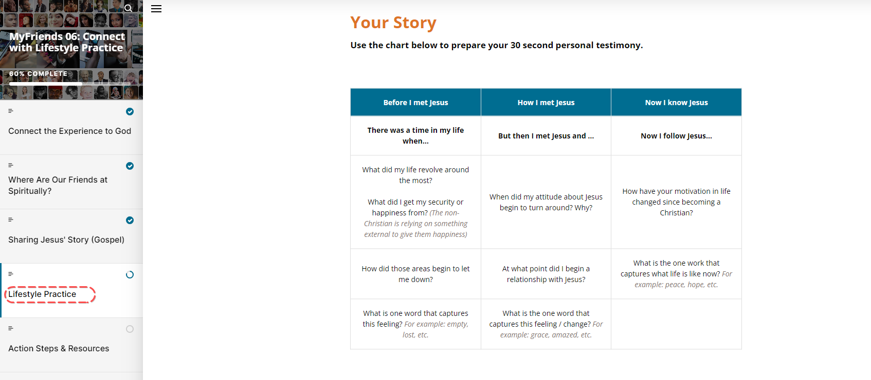

Give time now for everyone to complete the ‘MyFriends – How are you going’ google doc. This provides an opportunity for everyone to be held accountable and for your wider church community to see the impact that MyFriends is having.
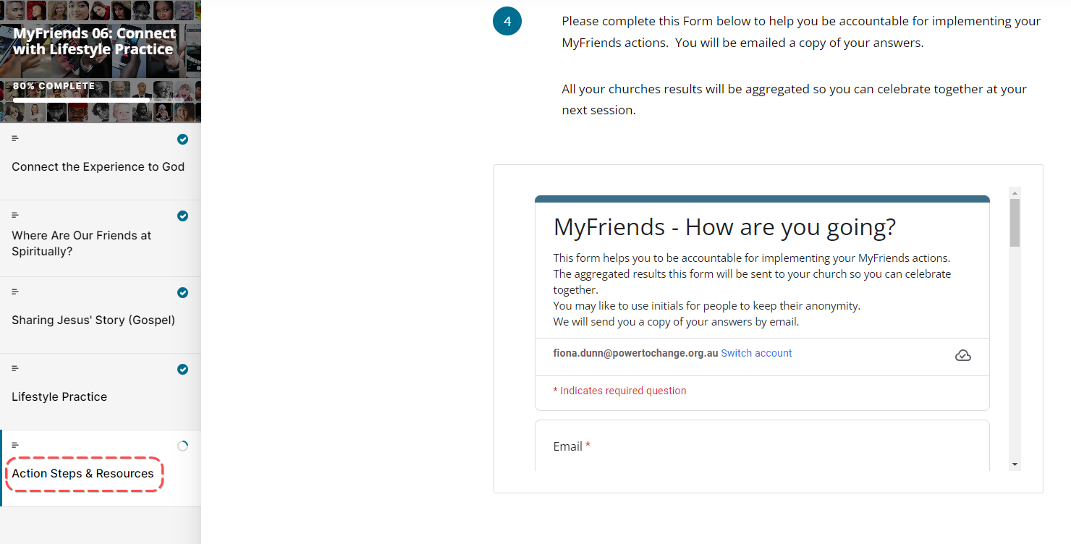

Close in Prayer
Ask someone to pray for the group and for opportunities in the coming week to share Jesus’ story with others.

Week 6 Facilitator Follow up.

Social Media follow up
- Put a short prayer in your social media group after your session
  - Dear Lord, I thank you for encouraging this amazing group of people to attend MyFriends. Lord help them pray with and care for their friends on their daisy chain. Help us connect our friends with Jesus. Amen
  - Role model praying with and caring for your friends on your daisy chain – e.g. Lord I ask you to be with me while I “XXX Caring action” for my friend.
  - Send a link to the course content – if you go to the page for the “scorm” package this is a unique URL to that particular module. Ask a question like – What part of the module “Connect” did you like the best – Here is a link to the module if you would like to review it again. Link
  - Share on our private social group where God has worked in your life – have a practice here in a safe space before sharing it with someone on your daisy chain.
  - Share how God has worked in your life this week and who you have shared it with.
  - Our “home play” this week was to develop your own testimony. Here is a link to the module – link. What stood out to you?
  - Is there anyone in your daisy chain that the holy spirit is prompting you to share your story to?
  - Have you looked at your daisy chain and identified who is “Green” and spiritually open to discover more about God’s story? What are you going to do?
  - How are you going with your daisy chain? Who are you praying with and caring for?
  - Looking forward to seeing you in our next session. The link to the content is (link) and the zoom link is (link)

Facilitator email MyFriends Module 6 – Connect

Dear @@USER:username@@,
This week in the MyFriends programme we looked at how we can help our friends that experience God to help them to connect that experience to God.
Reflect on the content of this week’s MyFriends session:
- As you have lived out a lifestyle of love, prayer, and care, and taken opportunities to share your experience of Jesus with others, they may experience Him too. Are there any experiences that you need to help your friends connect to God?
- Have you practiced sharing the gospel in 2 minutes and looked for opportunities with your friends when you see a green light?
- Complete this week's form to help you be accountable for implementing your MyFriends actions. Your responses will be emailed to you and your church results will be aggregated so you can celebrate together.
  - Copy of MyFriends: Connect - How are you going? - Google Forms
- Please review this week’s Lifestyle Practice: My Story (link to the module in moodle) Discover God with Your Friends: My Story (movementbuilders.org.au)

We look forward to seeing you at your next session.
Blessings,

