

Facilitators Guide
Module 7 - Release

Module 7: Release


Module 7 Objectives
This seventh module is about Release and what it looks like to release our friends to God.

The key objectives are:
- As our friends share their experiences in their social networks, whole groups of people may be interested in learning more.
- How to take a stand against the enemy.
- Review the vision to see reproducible movements everywhere.


Tools
As a facilitator you will need the tools that you used in previous weeks.

Facilitator Guide: Module 7: Release


Introduction (10 mins)
Welcome to week 7! Spend some time sharing stories from the past week, making sure to ask if anyone had opportunities to share ‘The Four’.

Lets review last week's Lifestyle Practice of telling your own story in 30 seconds. what your life was like before you met Jesus, how you met Jesus and now that you know Jesus.
Share your own story and share going round the room.
Give constructive coaching feedback as you go.


Open in a short prayer giving the course and time to God.

This week we are looking at ‘Release’ and understanding what to do if whole groups of people show an interest in learning more about Jesus. We will also look at how to stand against the enemy.


Play Video – Introduction Release
https://vimeo.com/showcase/10517460/video/841120049 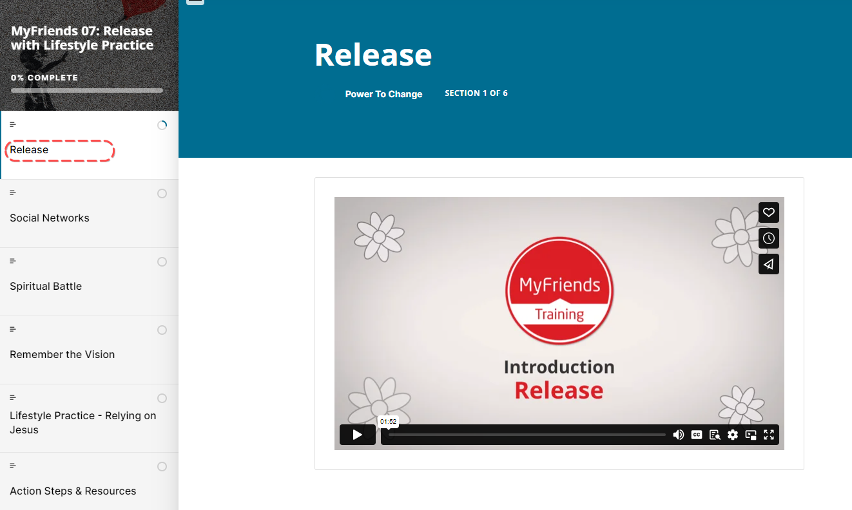



Read Mark 5:18-20, 8:1-10

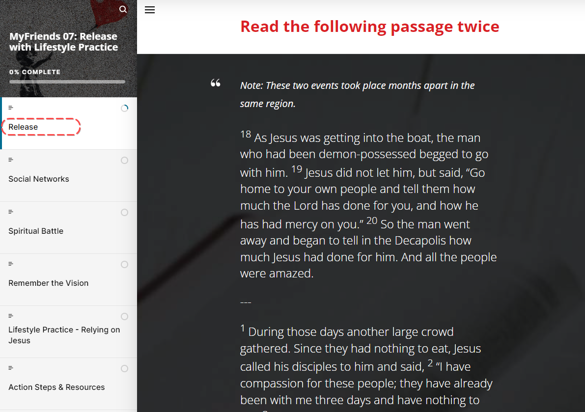
Ask for a volunteer
- What stands out to you in this passage?
- What do you learn about God or people?
- What principle of mission did you discover that you can apply today?

Social Networks
What kind of social network do your friends have? When they share their experiences within their social network, whole groups of people may get interested in getting to know Jesus. Let’s read about how this happened in Acts 10:19-24 and Acts 16:12-15.

Ask a participant to read Acts 10: 19-24 and then Acts 16:12-15
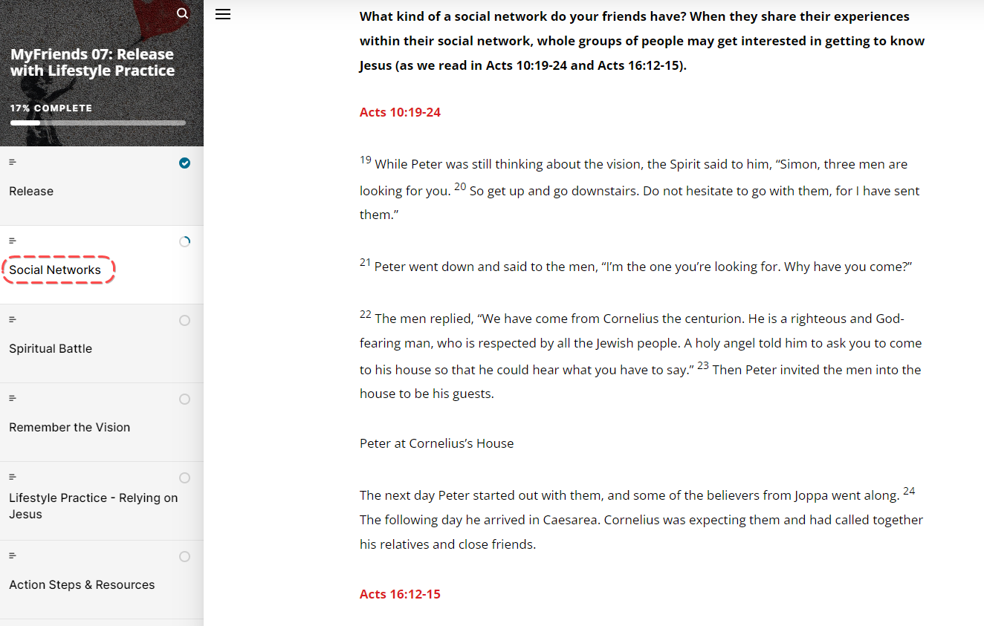

Like these stories from Acts, we pray we will see entire households come to know Jesus as we ‘release’ our friends. But what does it mean to ‘release’ our friends? Read along on Movement Builders.
- We encourage them to share their experiences of God with their friends and family across their social spaces.
- We encourage them to pray with their friends, colleagues, family and neighbours so they may experience God’s love as well.
- We invite them to connect with Jesus or Discover the Basics of God’s story with their friends.
Why is it important to release our friends to process their experience with others?

Spiritual Battle
When someone first experiences God it’s an incredibly exciting time but it’s important to be aware that the enemy will often seek to attack us or our people steal from us or distract us from what God is doing. He uses the weapons of lies, fear and confusion.
Remember that God has “not given us a spirit of fear and timidity, but of power, love and self discipline” (2 Timothy 1:7 NLT). Jesus said, He is our shepherd and the enemy has no right or authority to do this to us when we are following Jesus (John 10:27-30). We encourage you to stand strong by praying the Word of God, focusing on His love and constant presence with you.
When the enemy attacks you or your people, “Be on your guard, stand firm in the faith, be courageous, be strong. Do everything in love.” (1 Cor 16:13-14 NIV)

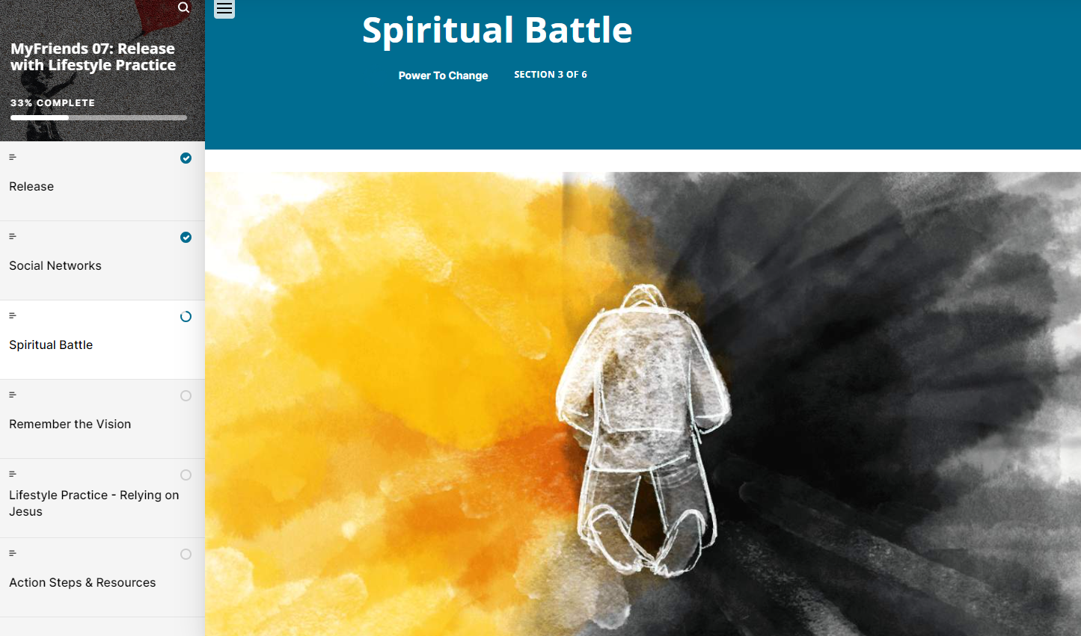
We have talked about experiencing God in our lives – but what about the Enemy – how do we experience “Spiritual Warfare” in our lives”
What does spiritual attack often look like in your life?
How can we take a stand against the enemy?

Remember the Vision


Group discussion
Remember the Challenge
We know that Aussies are interested in spiritual things, but not often interested in going to church. So how will they get to know Jesus?
- Through our social spaces – not necessarily moving people from their spaces and bring them to church – but meeting them in their spaces – help them experience Jesus as they discover God in their own community
- To enable everyone know the heart of God – his love for you, your family and community

Our Prayer is that we all are motivated by God’s heart – to develop a disciple making lifestyle that connects people in their relational circles to Jesus and to help others to do the same ….

Play ‘This is Discipleship’
https://www.youtube.com/watch?v=rk8ERxqCZqQ
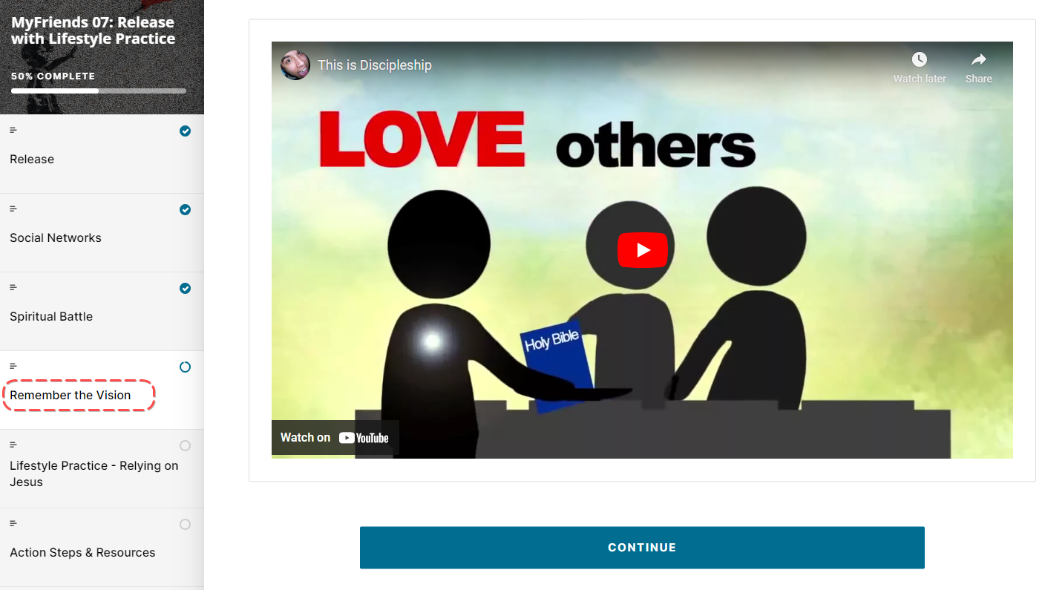

Ask the group to share their responses to the video and what parts of this video are new or different for them.

Lifestyle Practice
Explain the Lifestyle Practice for the coming week.
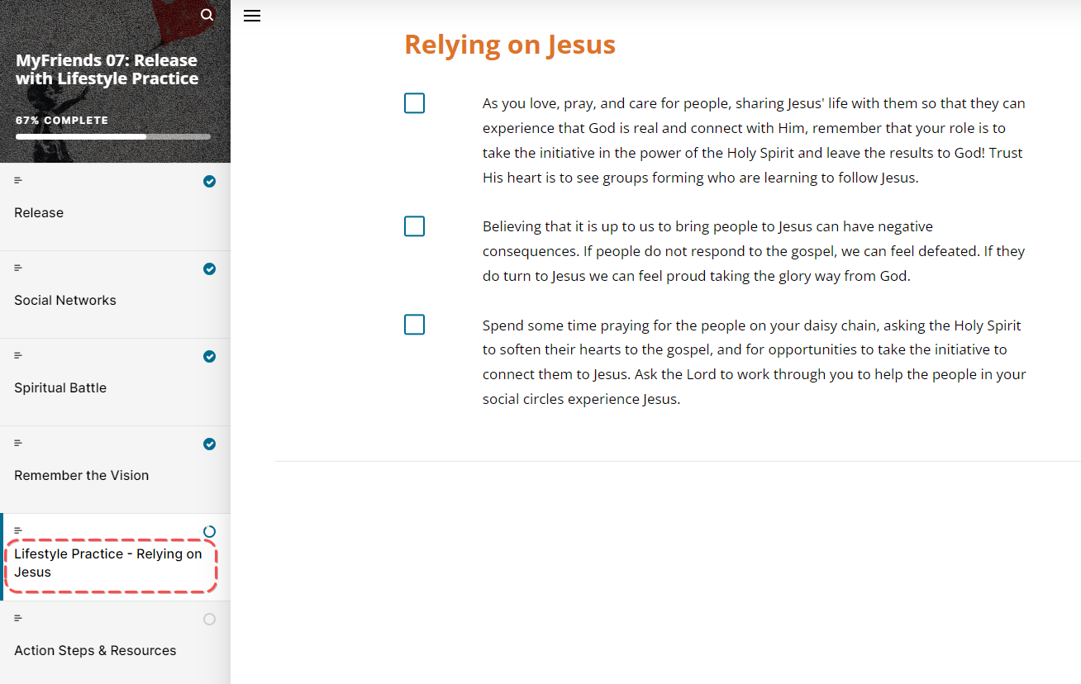

- Look back over the week
  - How have you experienced God at work and through your life?
  - What did you learn about God, yourself, or others this week?
  - What points from the last MyFriends Training challenged you or prompted questions?
  - What keeps us from relying fully on Jesus
- Look Up
  - Read John 15:1-5
  - How do you rely on Jesus?
- Look Forward
  - How is the Holy Spirit prompting you to grow in your reliance on Jesus?
  - What practical steps will you take to get there?

Actions Steps and Resources
Give time now for everyone to complete the ‘MyFriends – How are you going’ google doc. This provides an opportunity for everyone to be held accountable and for your wider church community to see the impact that MyFriends is having.
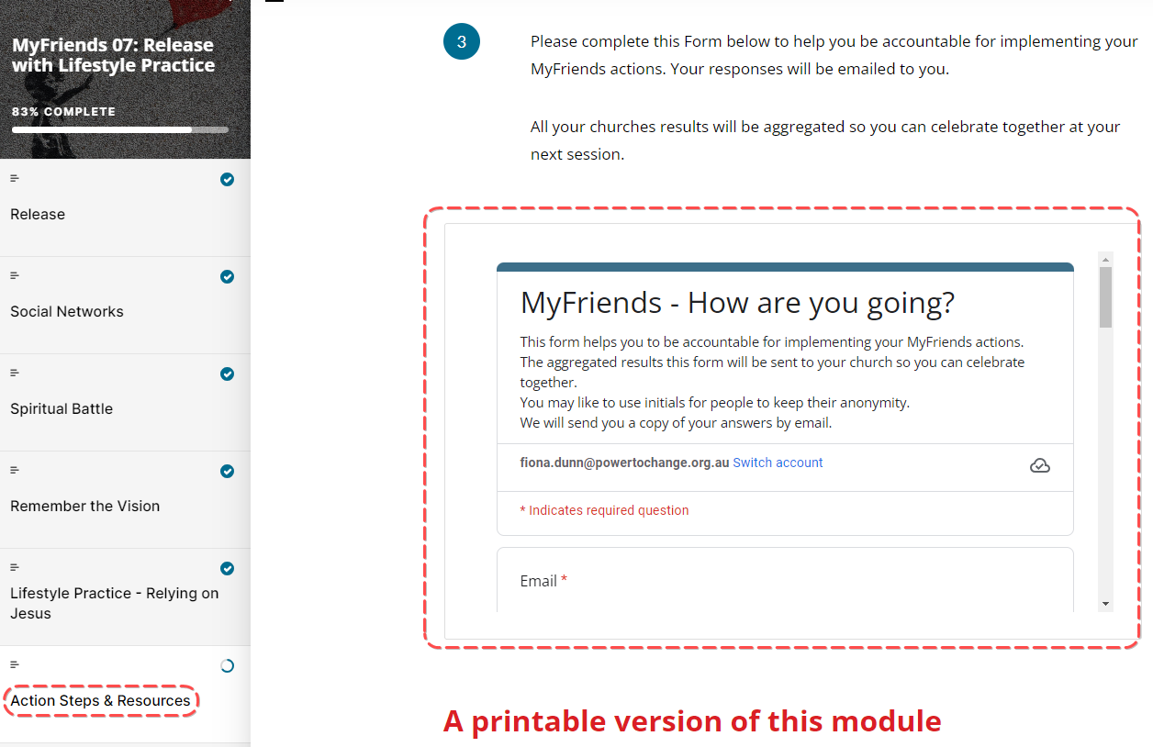

Ask a participant to close in prayer.

Week 7 Facilitator Follow up

Social Media follow up
- Put a short prayer in your social media group after your session
  - Dear Lord, I thank you for encouraging this amazing group of people to attend MyFriends. Lord help them pray with and care for their friends on their daisy chain. Help us connect our friends with Jesus. Amen
  - Role model praying with and caring for your friends on your daisy chain – e.g. Lord I ask you to be with me while I “XXX Caring action” for my friend.
  - Send a link to the course content – if you go to the page for the “scorm” package this is a unique URL to that particular module. Ask a question like – What part of the module did you like the best – Here is a link to the module if you would like to review it again. Link
  - Share on our private social group where God has worked in your life – have a practice here in a safe space before sharing it with someone on your daisy chain.
  - Share how God has worked in your life this week and who you have shared it with.
  - How do you rely on God?
  - Our “home play” this week was to develop your own testimony. Here is a link to the module – link. What stood out to you?
  - Is there anyone in your daisy chain that the holy spirit is prompting you to share your story to?
  - How are you going with your daisy chain? Who are you praying with and caring for?
  - Looking forward to seeing you in our next session. The link to the content is (link) and the zoom link is (link)
MyFriends: Release our Friends to God


Facilitator email MyFriends Module 7 – Connect
Dear @@USER:username@@,
This week in the MyFriends programme we looked at what it looks like to release our friends to God.
Reflect on the content of this week’s MyFriends session:
- Look at your daisy chain. Where do you see SHARE, EXPERIENCE, CONNECT, RELEASE happening? What is your next step?
- Ask God who He wants you to share your story or Jesus’ story with over the next few weeks. Share this in your social messaging group and start praying for opportunities to connect these people to Jesus.
- Please complete this Form below to help you be accountable for implementing your MyFriends actions. Your responses will be emailed to you. - All your results will be aggregated so you can celebrate together at your next session. MyFriends: Release - How are you going? - Google Forms
- Please review this week’s Lifestyle Practice: Relying on Jesus (link to the module in moodle)
We look forward to seeing you at your next session.
Blessings,
MyFriends Team

