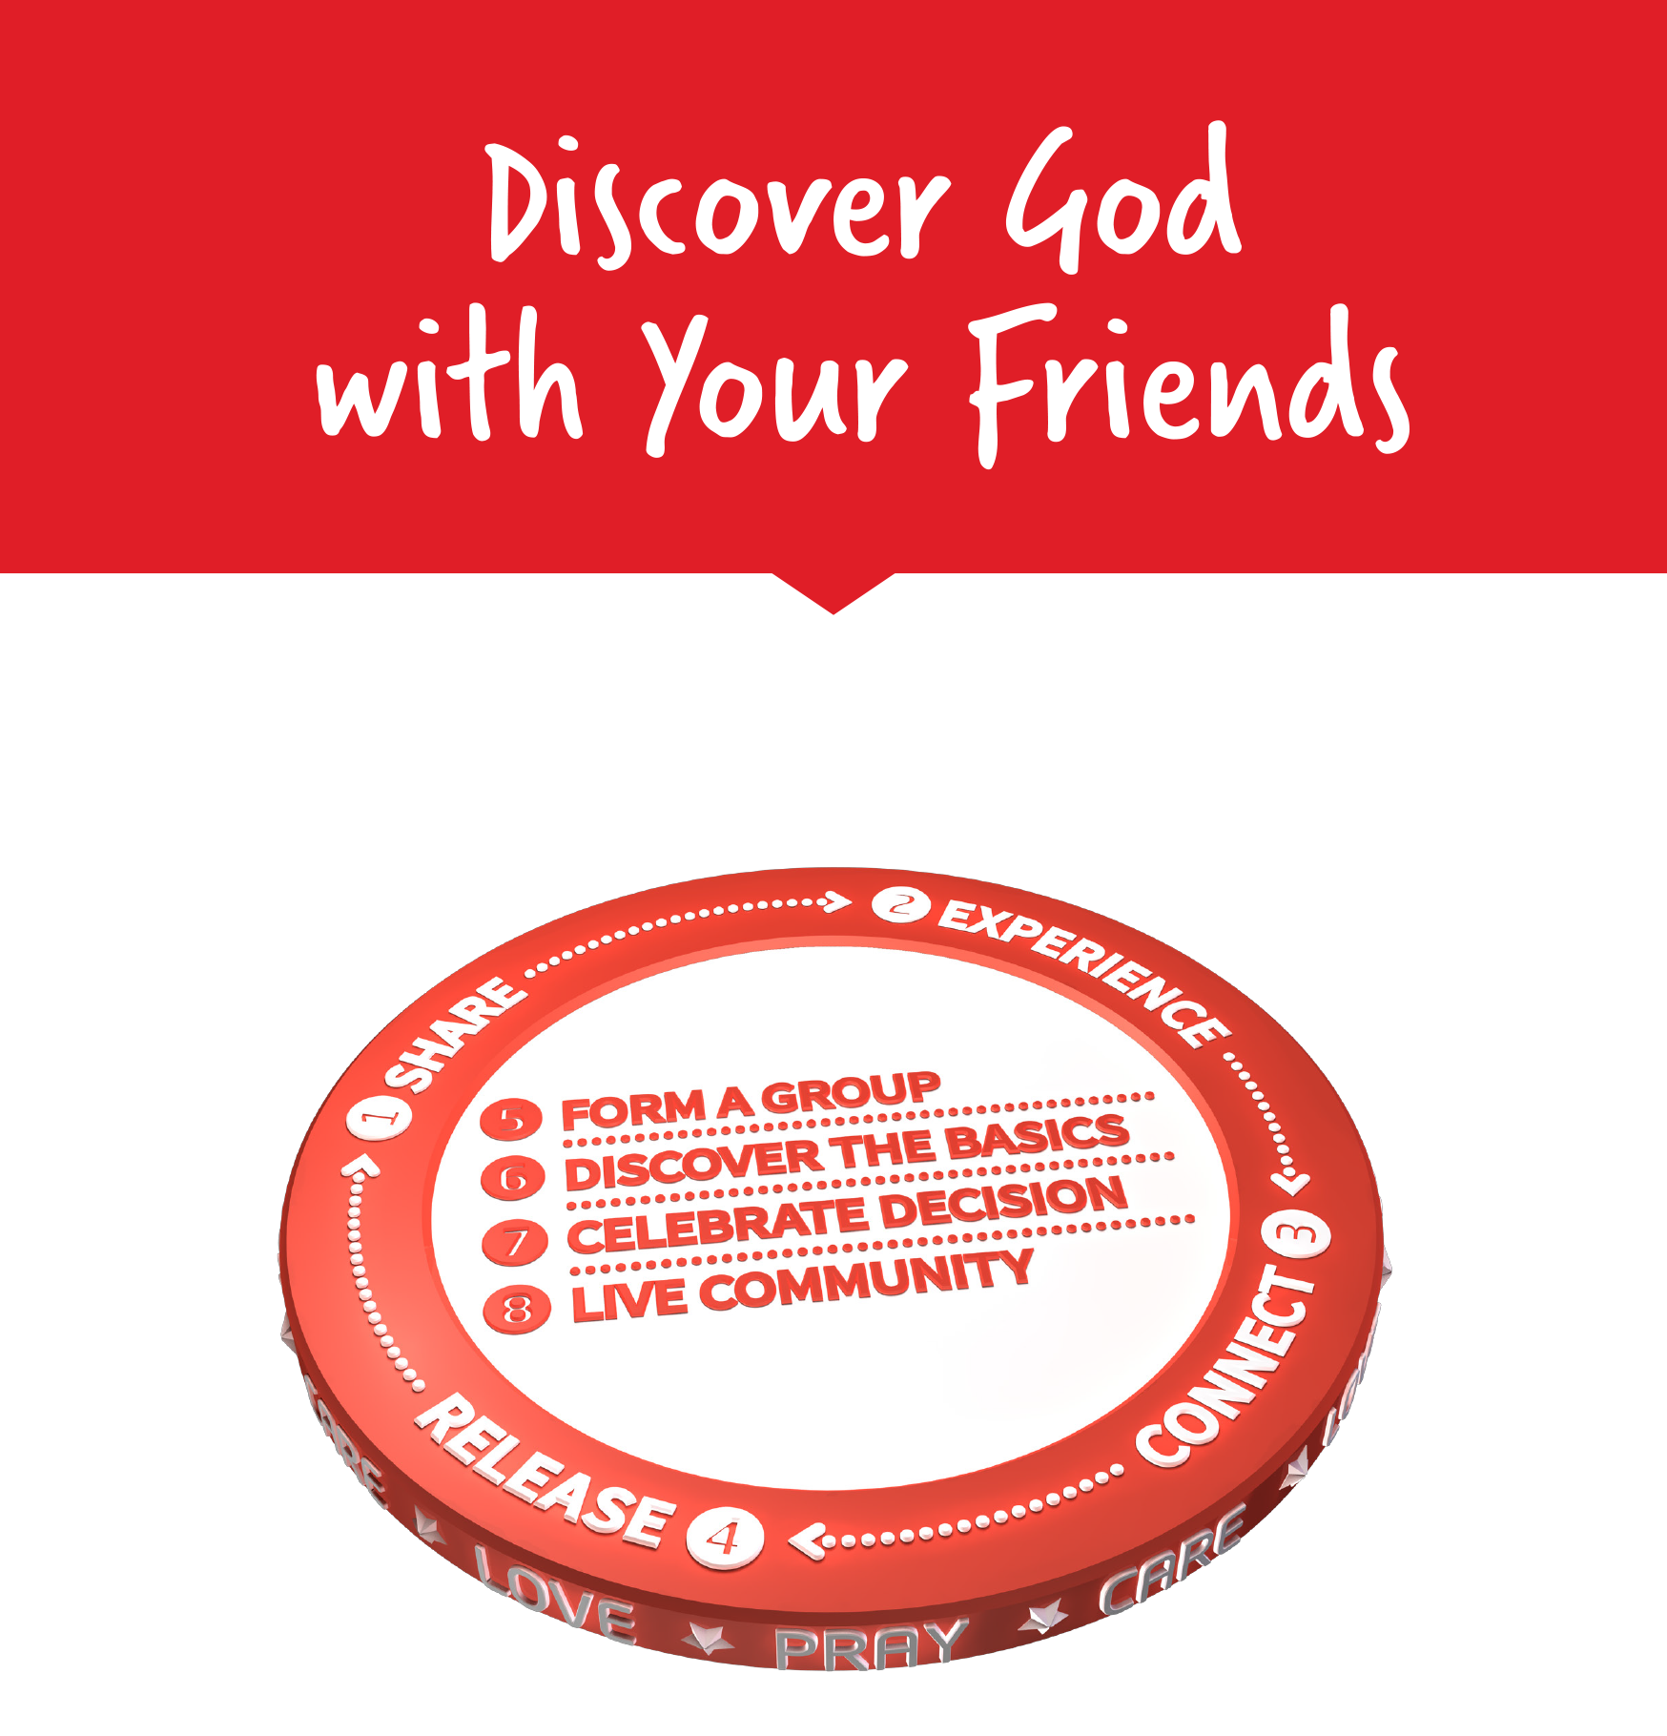

Facilitators Guide
Module 8 – Form a Group and Discover the Basics

Module 8: Form a Group and Discover the Basics


Module 8 Objectives
This eighth module covers Forming a Group and Discovering the Basics. These two sessions look at how to engage the spiritually interested as we help them towards a decision.

The key objectives are:
- God's heart is for communities and encouraging those in our daisy chain to share their experiences with others who might be interested in connecting with Jesus around God's story.
- Learn ways that we can bridge our conversation to intentionally invite our friends and family to engage through Bible Discovery.
- The Bible Discovery Process is an intentional group discipleship process to see people come to know Jesus. It is a powerful, reproducible, and obedience-based discipleship model to see individuals and families reached, who learn a model that can be replicated in seeing a movement of multiplying disciples.
- Bible stories used in the Discovery Process are modelled and replicated as each new generational chain is formed.


Tools
As a facilitator you will need the tools that you used in previous weeks.

Facilitator Guide: Module 8: Form a Group and Discover the Basics


Introduction (10 mins)
Welcome to week 8! Invite people to share stories from their week, particularly updates about their friends they’ve been praying for and sharing Jesus with!

Review last week and Lifestyle Practice – Relying on Jesus
Some starter Questions are:
- How have you experienced God this week?
- What is challenging you about MyFriends training and lifestyle?
- How did you go relying on Jesus?
- What are your next steps?


Open in a short prayer giving the course and time to God.

This week is broken into two topics – the first is to form a group and the second is to discover the basics. We have a lot to cover so we will have to move quite quickly through the content. In this first module, form a group, we will explore ways we can bridge our conversation to intentionally invite our friends and family to engage in Bible Discovery.


Play Video: Introduction Form a Group
https://vimeo.com/showcase/10517460/video/841121149
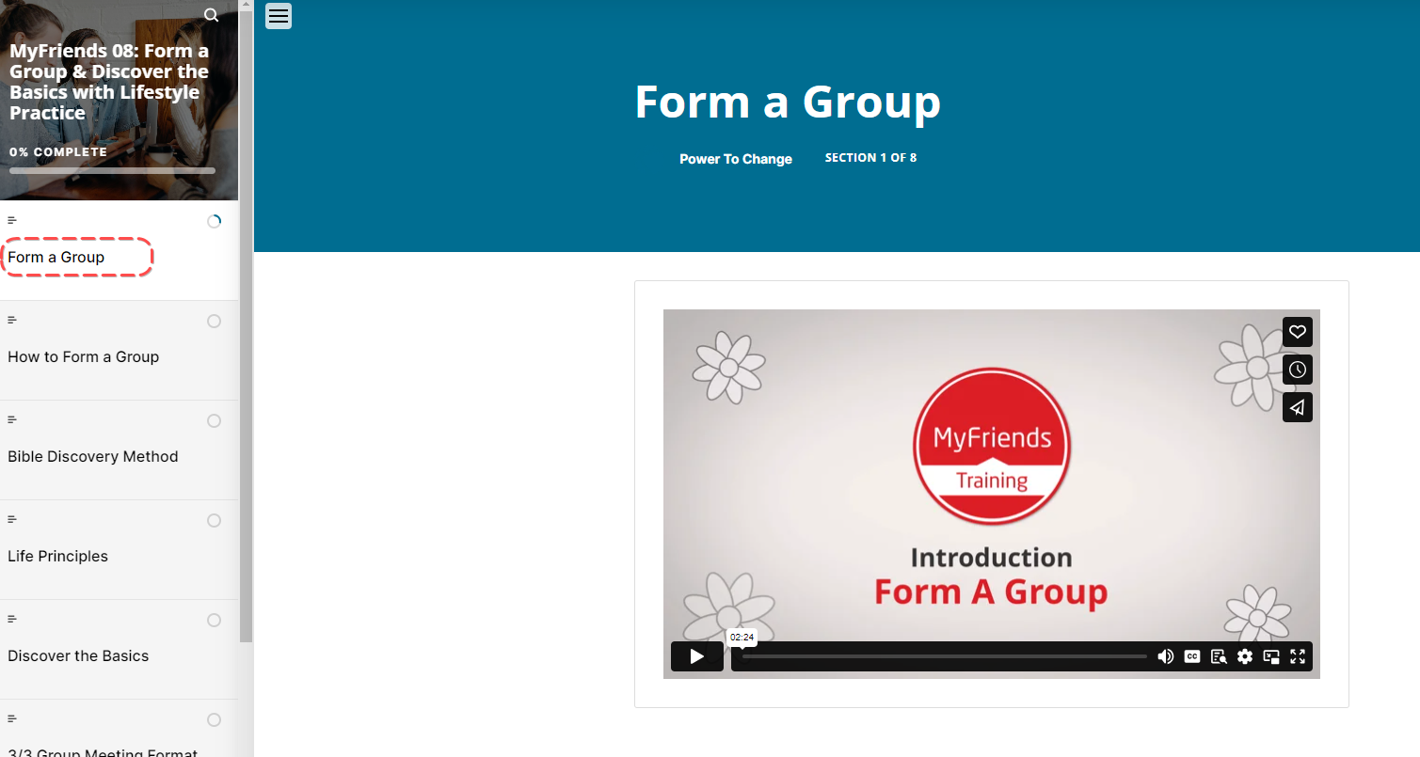

Form a Group
Let’s start off in the Bible. We’re going to read from Acts 14:21-28. Here we meet Paul and Barnabas at a point in their journey where they have prayed and shared with people in Iconium, Lystra, Derbe and Antioch, seeing people connected with Jesus and each other, learning to follow Him.


Read: Ask a participant to read Acts 14:21-28
Then ask someone else to read it again (a different translation is often helpful!)
Then ask someone to retell the story – help them out if they get stuck!
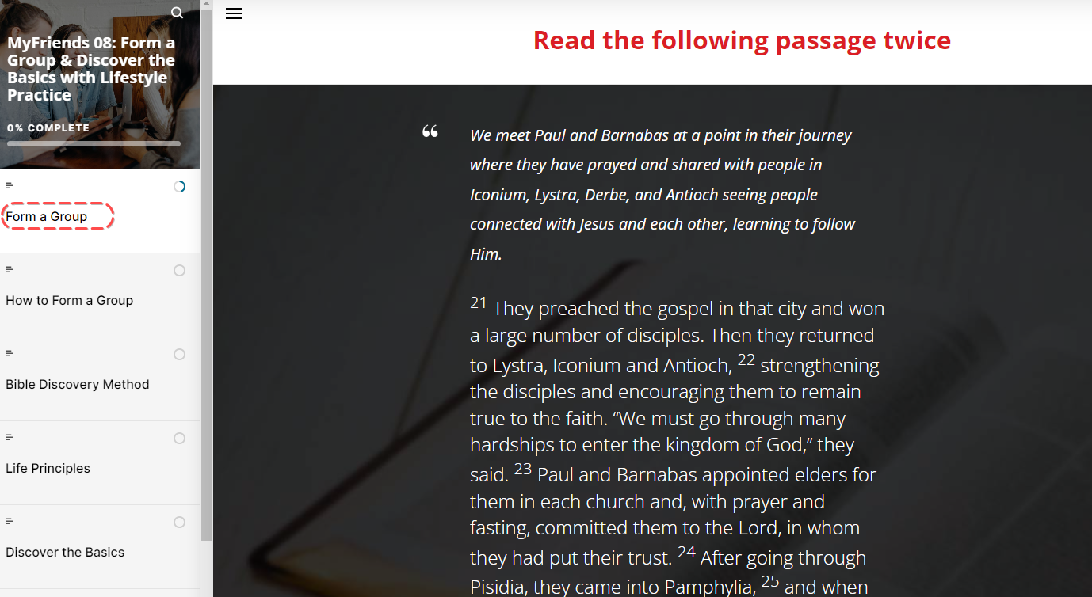
In pairs, get participants to discuss the following questions.
- What stands out to you in this passage?
- What do you learn about God or people?
- What principle of mission did you discover that you can apply today?
Bring the group back together and ask everyone to share their responses to the questions

How to Form a Group
So how do we know when to form a group? If we have one or two people who have experienced Jesus and connected with or want to discover more about Him, then the next step is to form a group.
If you or someone in the group has an example of forming a group, then share that now.

Discuss the following questions together as a group:
- How do you think you know when to form a group?
- Can you think of some ways you can invite your friends to discover God’s story together?

Challenge Who on your Daisy Chain could be ready to join a group – this could be a super small group of two people.
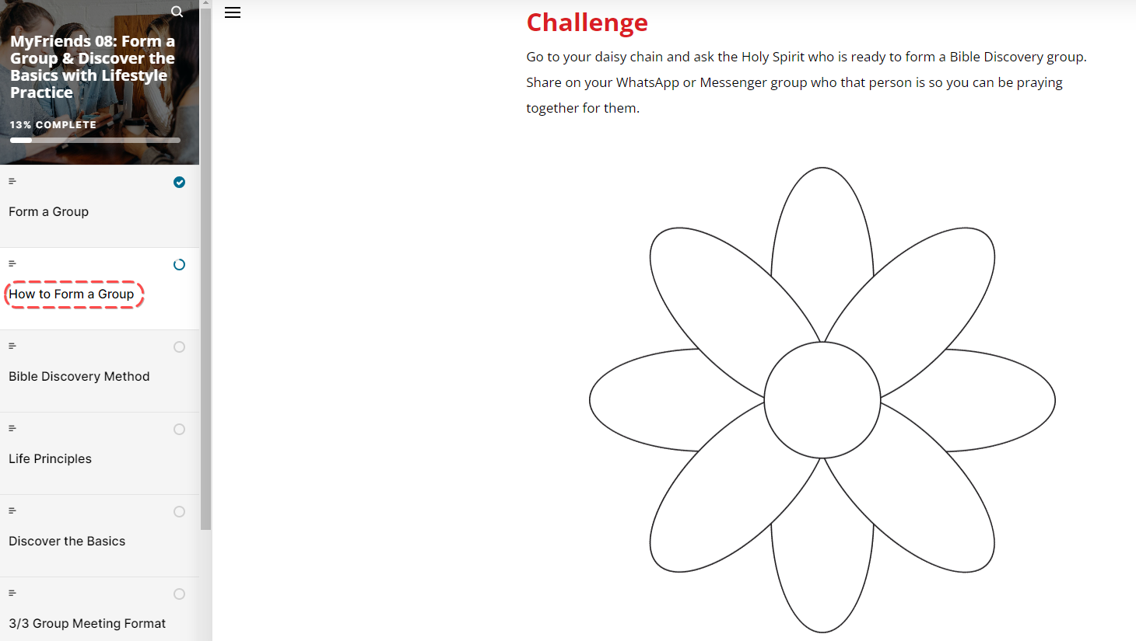

Bible Discovery Method

Play Video: Key Concept Bible Discovery
https://vimeo.com/showcase/10517460/video/841190639
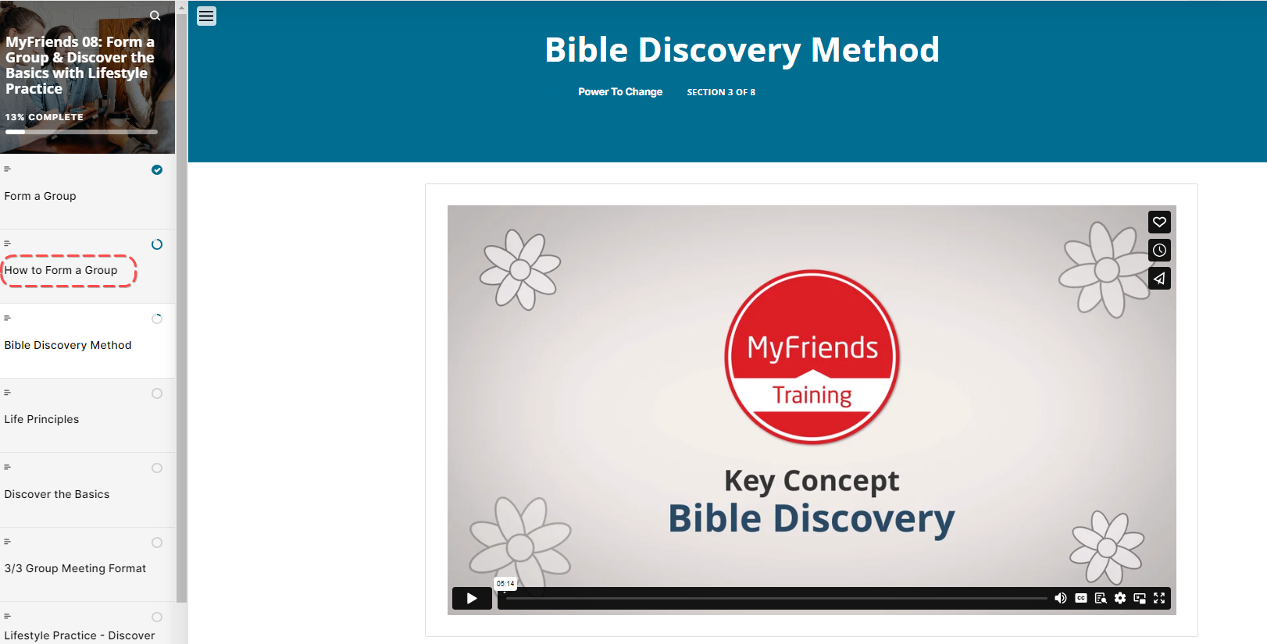



But what exactly is a Bible Discovery Group?

Ask the group if anyone has been part of a Bible Discovery Group and to share their experiences.
Ask a participant to read the section on moodle titled What is a Bible Discovery Group?
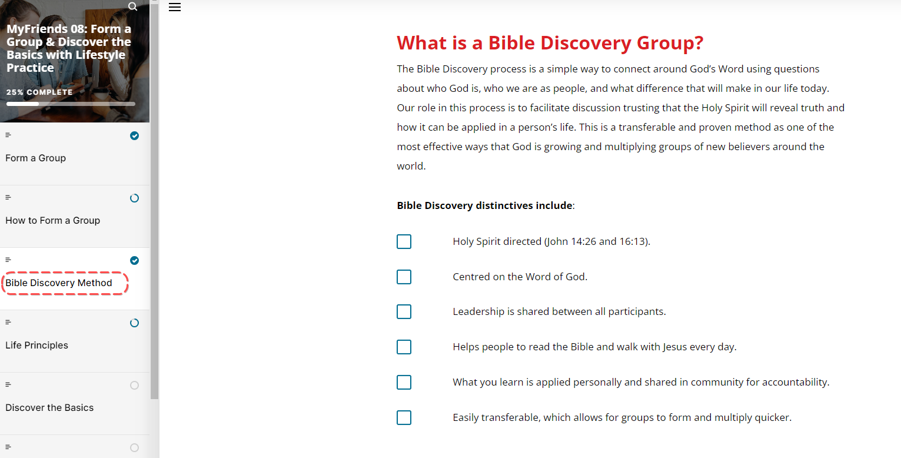
Then look together with your group at the Bible Discovery distinctives. After pressing Start, ask a participant to read
Step 1 – Holy Spirit Directed
Step 2 - Centred on the Word of God
Step 3 – Leadership is shared between all participants
Step 4 – Helps people to read the Bible and walk with Jesus every day
Step 5 – What you learn is applied personally and shared in community for accountability
Step 6 – Easily transferable, which allows for groups to form and multiply quicker. It is simple enough that a child can facilitate.
Summary – Once someone has finished reading through this – ask what they notice about it (Hint: it’s the format we’ve been using!)

Ask your group why do they think this format has been so successful at helping people connect with Jesus and grow in their relationship with Him?

There are some excellent Conversation Tips here in moodle that you can run through in your own time if you are running your own Bible Discovery (if you know someone that is doing this from your group, talk specifically about them here)
Ask participants to go to their daisy chain again and spend a moment asking the Holy Spirit if there’s anyone ready to form a Bible Discovery group. Share this with the wider group.

Life Principles and The Basics
As you have got to build strong relationships with your friends you will know what questions they have about Christianity. Some people question Christian Life Principles and others question Jesus’ story. Depending on the needs of your friends there are group study materials available for you.
You may find that you start with one study material and someone has a question that prompts you to look at a different stream next time you meet.

Life Principles

Life Principles are topical studies that help those exploring the Bible to see the practical impact in the daily issues that we face. These studies are designed for 1:1 or 1:many Bible Discovery groups.

Go to the MyFriends.network web app and look at the topics that are covered.
Take some time to look at myfriends.network web app and get everyone to pin it to their home screen.
Show the group two different types of groups – life principles and the basics.
Both life principles and the basics use the Bible Discovery method. Life Principles is designed for the person who is interested in what Jesus has to say about life. Discover the Basics is for when your friend is ready to discover God's story over ten gatherings. Remember to encourage the people you’re meeting with to identify friends and family in their networks who are on a spiritual journey and would like to connect together around God’s story. Remember our verse from Acts 2:39 – “The Promise is for you and your children and for all who are far off- for all whom the Lord our God will call.”
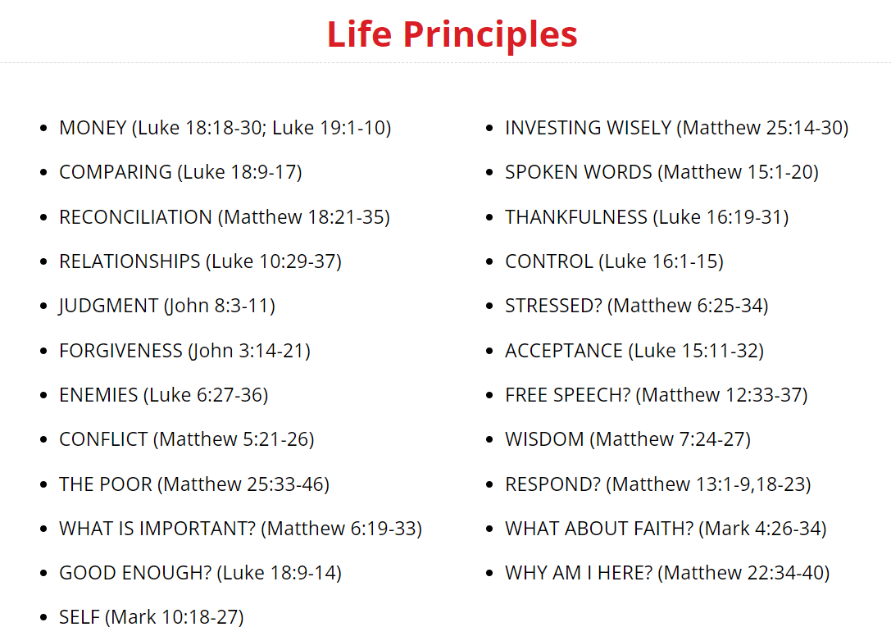

Discover the Basics

The Basics takes you on a journey through the story of the Bible from creation to Christ.
If you have a few seekers that are interested in going on a 10-week journey exploring Christianity taking you from creation to the Cross, then we encourage you to take the group through The Basics.
Again these can be found on the MyFriends.network app.

Take 5 mins to review what is covered in each section either in Movement Builders course module or by going into the MyFriends.network

Split into groups and review the content and think about who would benefit from each content area.

3/3 Group Meeting Format
The three thirds format is called this because your group meeting is split into three parts
1 Look Back
2 Look Up
3 Look Forward
Let’s look together at our materials for the explanation of each third.
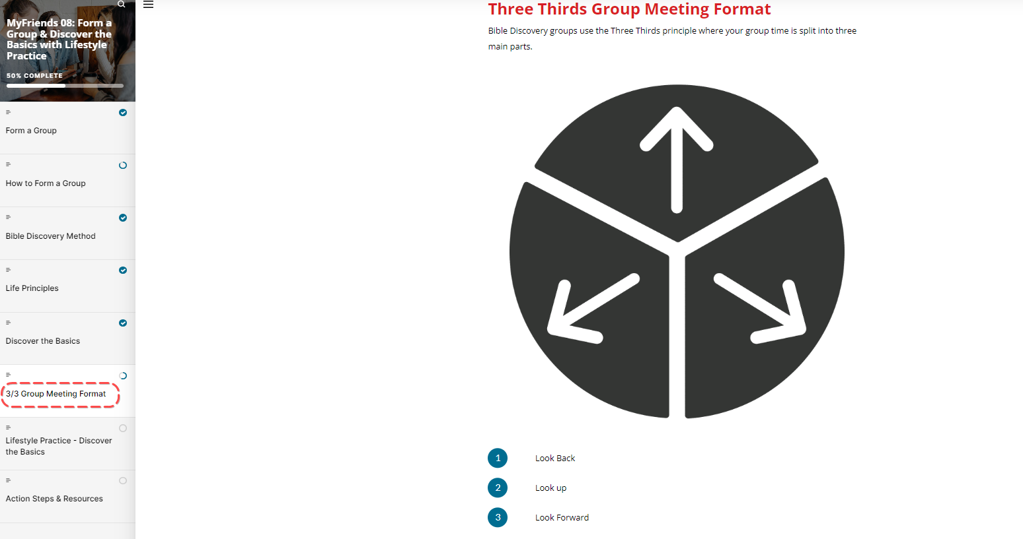

Ask a participant to read Step 1 – Look Back.
Ask the group – Why do you think this step is important?

Ask a participant to read Step 2 – Look Up
Ask a participant to read Step 3 – Look Forward
Ask the group – Why do you think this step is important?

Split into Groups of 3 – and choose a topic from either The Basics or Life Principles and go through the materials together.
We are going to do this fast – a normal group would take 45 minutes to 60 minutes together – let's take 10 minutes to feel how the 3/3 format works.

Challenge
Time to reflect again! Turn to your daisy chain and ask the Holy Spirit the following questions as you review the people on it.
- Who can you add?
- Who are you prompted to pray for?
- Who can you care for?
- Who can you share your experience of God in your life?
- Who can you connect with Jesus’ story?
- Who can you invite to connect with Jesus or Discover the Basics of God’s story with their friends?

Remember you are not doing this on your own – make sure you put in our social media group the people you are praying for or meeting with so we can all support you!

Spend time completing the Google Doc form for accountability

Lifestyle Practice.
Explain the lifestyle practice for the coming week
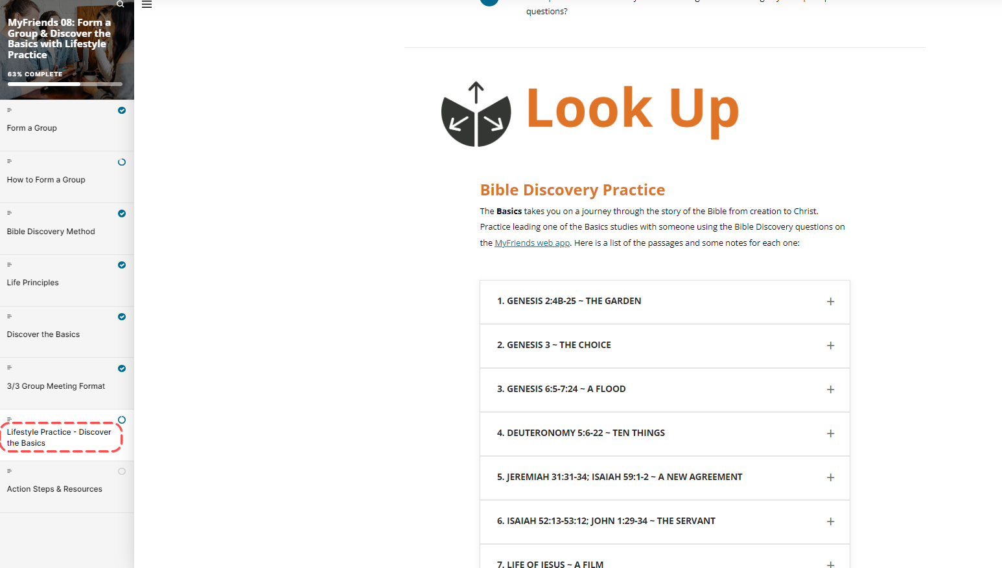

Action Steps
Take some time to complete the Action Steps
- Practice a Bible Discovery Group with some friends – you might like to find a buddy in this group.
- Who from your daisy chain can you invite to start a group – that might be one on one? When will you do it?
- Complete the MyFriends How are you going form.
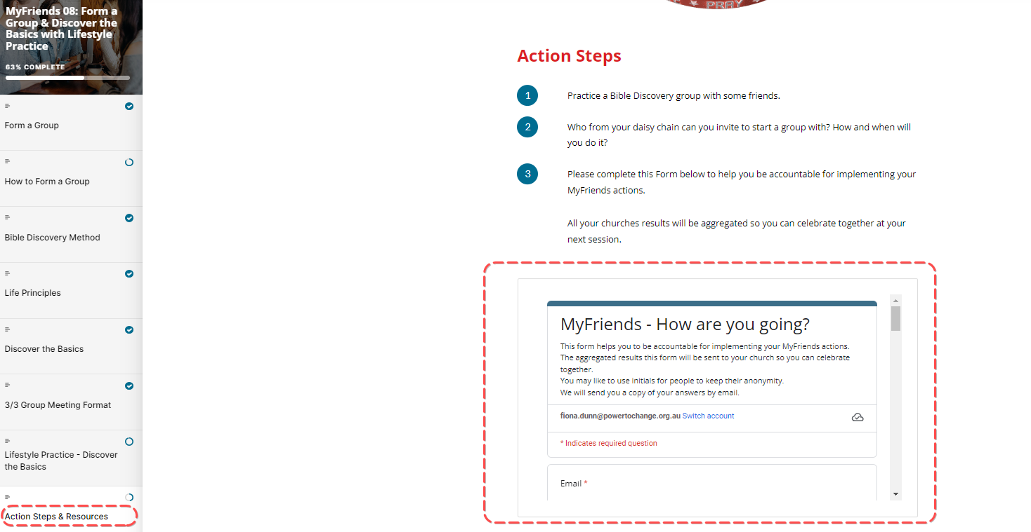
Ask a participant to close in prayer.

Week 8 Facilitator Follow up.

Social Media follow up
- Put a short prayer in your social media group after your session
  - Dear Lord, I thank you for encouraging this amazing group of people to attend MyFriends. Lord help them pray with and care for their friends on their daisy chain. Help us connect our friends with Jesus. Amen
  - Role model praying with and caring for your friends on your daisy chain – e.g. Lord I ask you to be with me while I “XXX Caring action” for my friend.
  - Send a link to the course content – if you go to the page for the “scorm” package this is a unique URL to that particular module. Ask a question like – What part of the module “Connect” did you like the best – Here is a link to the module if you would like to review it again. Link
  - Share on our private social group where God has worked in your life – have a practice here in a safe space before sharing it with someone on your daisy chain.
  - Share how God has worked in your life this week and who you have shared it with.
  - Our “home play” this week was to practice running a group with one or more people – Have you scheduled this in?
  - Is there anyone in your daisy chain that the holy spirit is prompting you to ask to join you to discover God’s story in a group or one on one?
  - How are you going with your daisy chain? Who are you praying with and caring for?
  - Please complete this Form below to help you be accountable for implementing your MyFriends actions. Your responses will be emailed to you. - All your results will be aggregated so you can celebrate together at your next session. MyFriends: The Basics - How are you going? - Google Forms
  - Looking forward to seeing you in our next session. The link to the content is (link) and the zoom link is (link)

Facilitator email MyFriends Module 8 – Form a Group and Discover the Basics

Dear @@USER:username@@,
This week in the MyFriends programme we looked at forming a group and discovering the basics of the bible in a Bible Discovery Process.
Reflect on the content of this week’s MyFriends session:
- Have you practiced a Bible Discovery group with some friends?
- Who in your daisy chain can you invite to start a group with? How and when will you do it?
- Please complete this Form below to help you be accountable for implementing your MyFriends actions. Your responses will be emailed to you. - All your results will be aggregated so you can celebrate together at your next session. MyFriends: The Basics - How are you going? - Google Forms
- Please review this week’s Lifestyle Practice: Discover the Basics (link to the module in moodle)
We look forward to seeing you at your next session.
Blessings,

