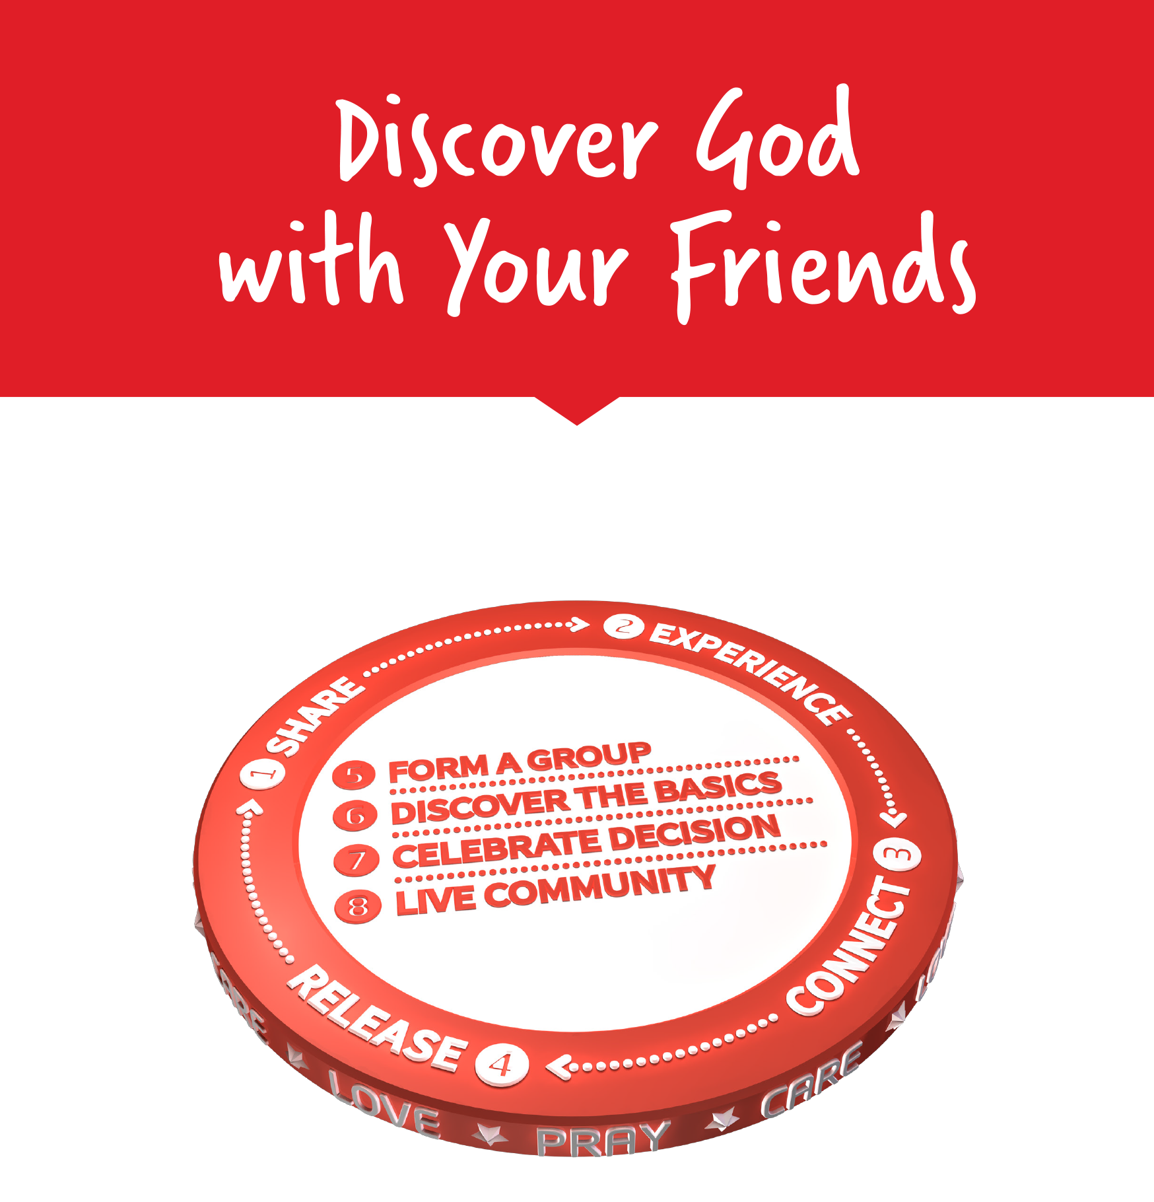

Facilitators Guide
Module 9 – Celebrate and Live in Community

Module 9: Celebrate & Live Community


Module 9 Objectives
In this last module we will look at Celebrating Decisions and Living in Community. The focus is on developing a culture and mindset of multiplication.

The key objectives are:
- To explain how Baptism is a physical and spiritual act that declares that you are no longer living for yourself but that your life belongs to God (in Christ) and you now live for Him as part of His family.
- To recognise the celebration of baptism as an opportunity to challenge those who are far from God to join the journey of discovering Jesus for themselves.
- To dream of joining friends and getting to see God work through you to reach several generations so that we see disciples who make disciples who make disciples …
- To be able to cast a vision for being intentional in following Jesus in the 'MyFriends' journey by forming group, multiplying those groups, and mobilising leaders.
- To identify who can you help train to walk this journey with you?


Tools
As a facilitator you will need the tools that you used in previous weeks.

Facilitator Guide: Module 9: Celebrate and Live Community


Introduction (10 mins)
Welcome to Session 9 – our final training session together!

Share stories from the week and how you’ve seen God at work. Have there been any groups form? Who has been able to begin a Discover Bible group?

What an incredible journey it has been. To finish up tonight we have two modules to complete –celebrate and live community. So let’s jump right in!


Open in a short prayer giving the course and time to God.

Introduction
This week is broken into two topics and that is to celebrate someone’s decision and living in community.

Play – MyFriends Celebrate and Live Community

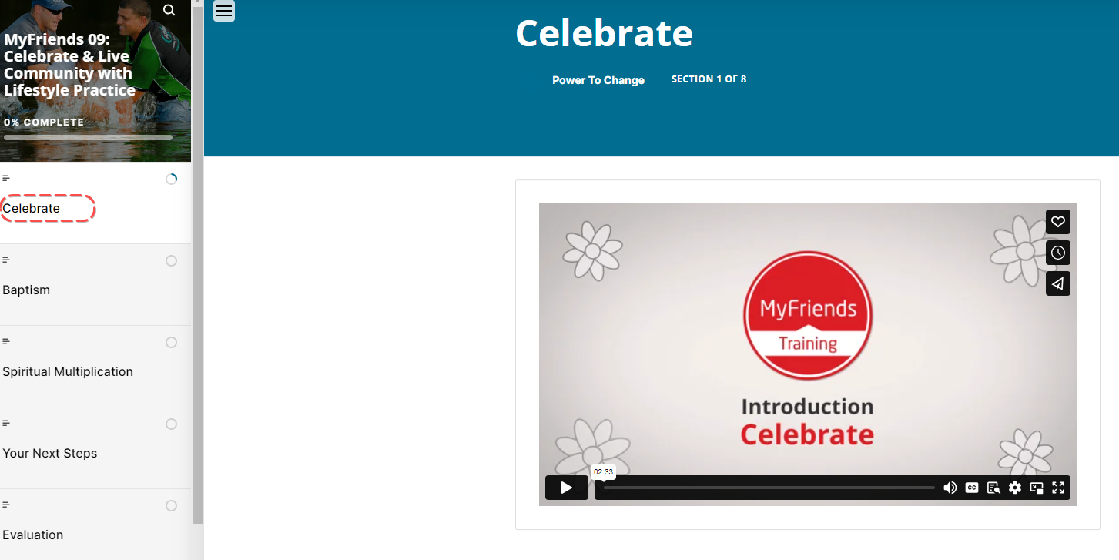

Ask a participant to read Acts 16:25-34
Then ask someone else to read it again (a different translation is often helpful!)
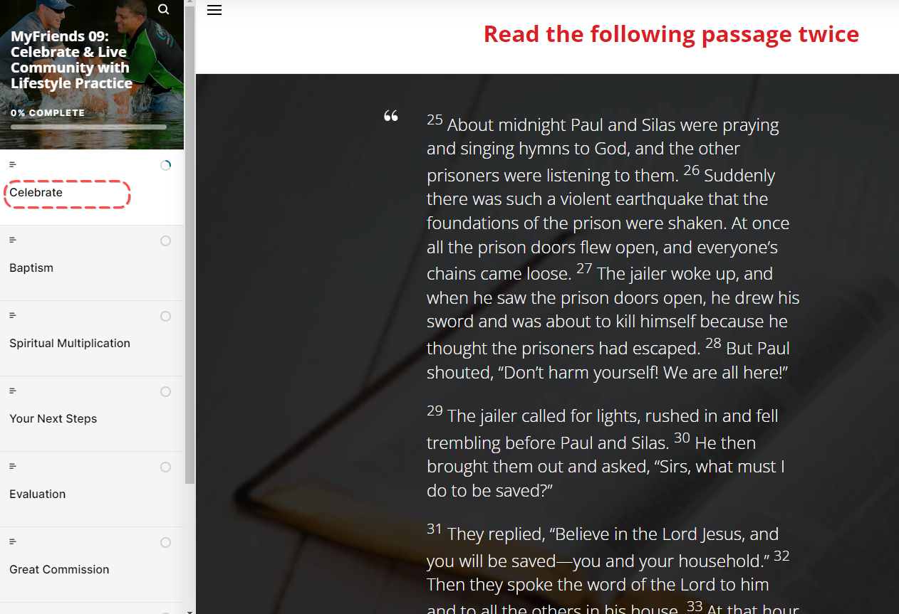
Then ask someone to retell the story – help them out if they get stuck!

Have a group discussion about the following three questions
What stands out to you from this passage?
What do you learn about God or people?
What principle of mission did you discover that you can apply today?


Baptism
Ask a participant to read the section with the heading ‘Baptism’
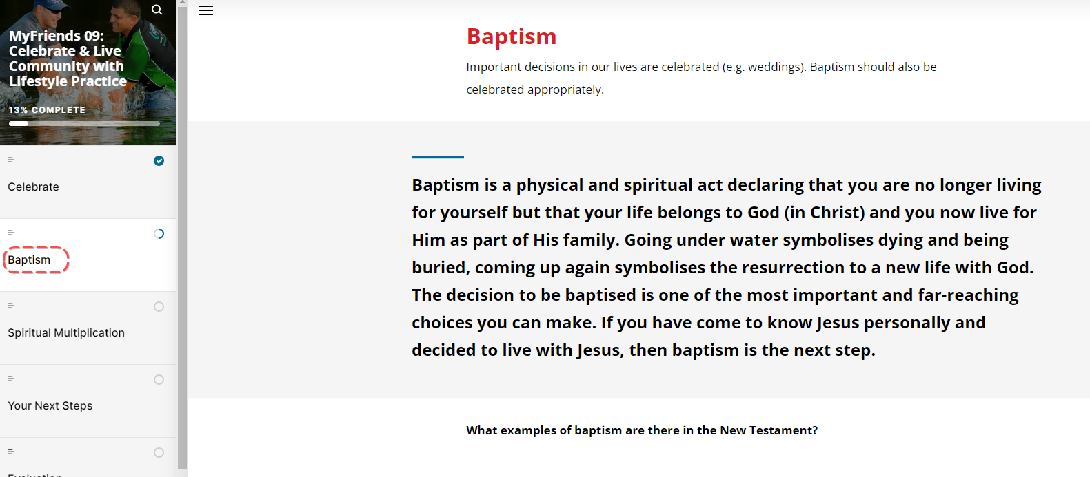
On a whiteboard, brainstorm together what examples of baptism you can think of in the New Testament – make a list of who it is that baptises in each case. Let your group know that anyone can baptise!
- John the Baptist
- Jesus

Ask a participant to read the section starting ‘Important decisions…’

Ask the group – Has anyone ever baptised someone before?
If anyone has, invite them to share their story or share one of yours if you have done it before!

Ask anyone who has been baptised what they remember the person baptising them saying. Then ask a participant to read the ‘How to Baptise’ section.

- Do you confess Jesus is Lord and Saviour? (Romans 10:9)
- Do you commit to follow Him all your life as part of His family?

I baptise you in the Name of the Father, Son, and Holy Spirit (Matthew 28:18-20)

If you have time practice baptising each other! Get the person being baptised to sit sideways on a chair and the person baptising them to stand beside them and tip them gently backwards when it’s time to baptise! Practice what you would say as you baptise and then swap it over.

(note: different Christian denominations have different ways to celebrate baptism – from an exciting full immersion to a cross of holy water on the forehead. Discuss the baptism traditions of the context that you are running MyFriends in.)
Let’s go back to our daisy chain again. Dream for a moment about what it would be like to baptise someone on your daisy – what a thrill that would be!

Break Take a moment to grab a drink and stretch your legs!

Spiritual Multiplication
Play Video - https://vimeo.com/178454883
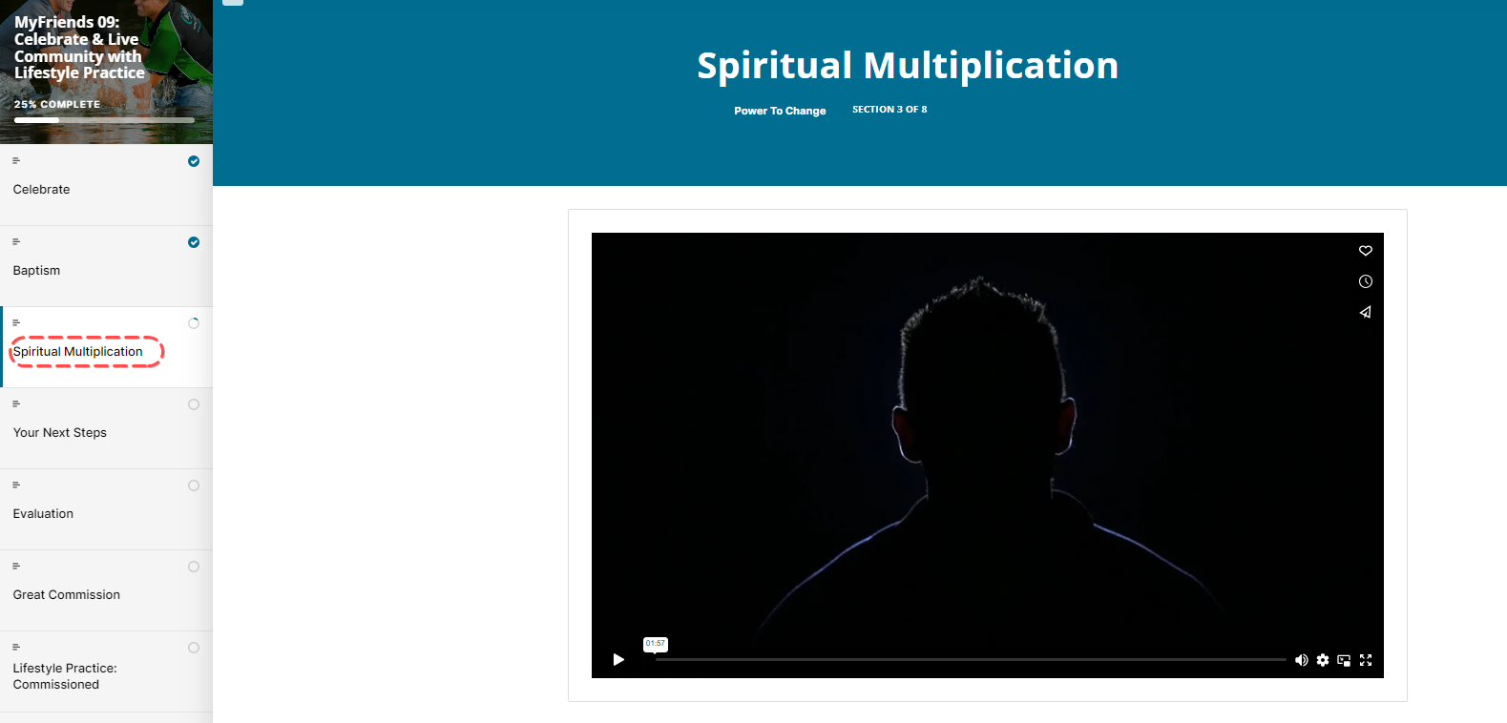
Which would you prefer to be – the Super Evangelist or the Disciple Maker?

Which bears the most fruit for God’s Kingdom?
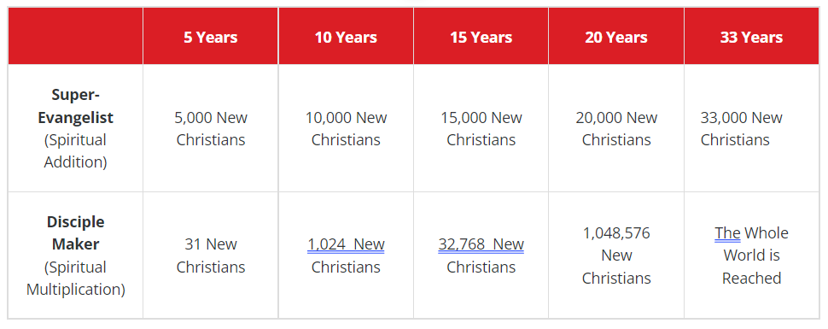

How does the MyFriends Lifestyle help grow God’s Kingdom?

Your Next Steps
This section is about how to live in community and reflecting on your MyFriends journey and identifying the next steps–whether it’s form a group, multiply or mobilise.
Play the video: Key Concept Next Steps
https://vimeo.com/showcase/10517460/video/843809702
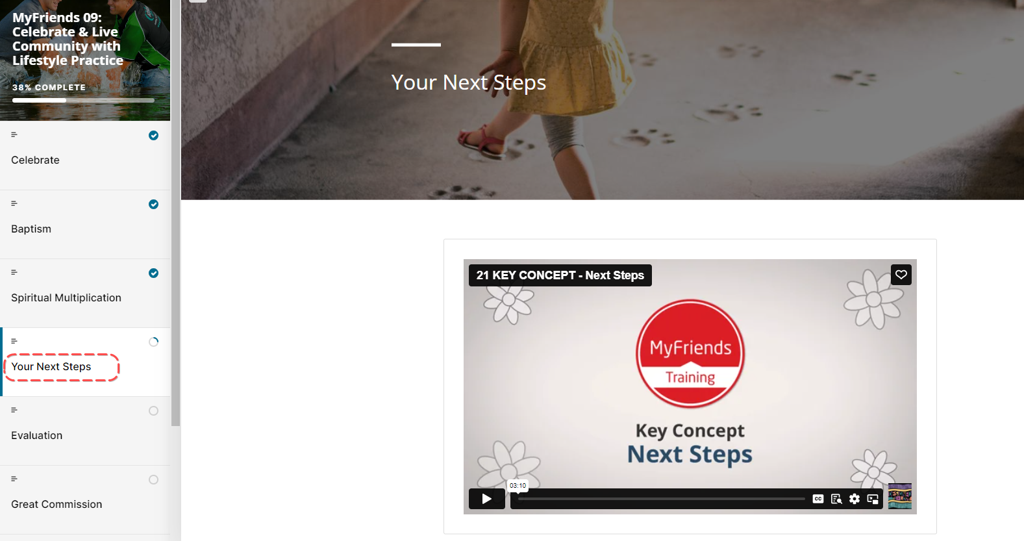

What are your personal next steps?
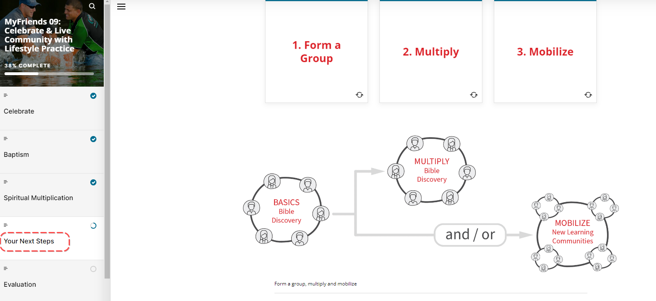

Read Your next steps and get participants to flick through the 3 steps. Ask the group if anyone has thought of who they know anyone ready for the third step – Mobilise. Specifically, do they know anyone ready to be part of a MyFriends journey and learn to make disciples like Jesus?

- Still Working on the Process?
Register your interest in our periodic zooms which explore the common sticking points in the MyFriends process.
- Are you Ready to Start Multiplying Your Group?
OurGenerations
Join with multiplying peers in a coaching group where together you can explore how to best equip and send people from your group to connect their own friends with Jesus, forming their own groups who are learning to follow Him.
- Would you like to run a MyFriends training course?
MyFriends
We'd love to join you in the process and help equip you to bring the MyFriends training to your local community. We want to help set you up for success!
- Want to Know Where This Fits into the Larger Disciple Making Picture?
SHIFTm2M
Join leadership peers to explore a disciplemaking framework centred on a case study of Jesus' ministry focusing on His movement building principles. Shift groups are coordinated by trained facilitators who will help you wrestle with the realities of implementing what you discover about movement building in your own life and ministry context.
How do we want to keep our own group going .. and ensure that we make this our lifestyle to be part of the Great Commission?

Evaluation
Give people 5 minutes to pray about their next steps and complete the Evaluation form.
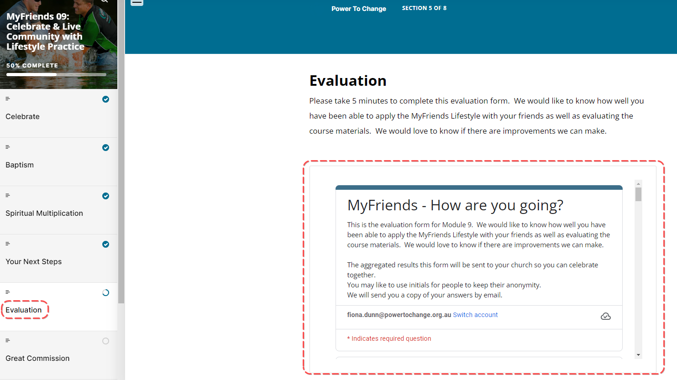

The Great Commission
Play our final Video; Wrap Up
https://vimeo.com/showcase/10517460/video/841124143
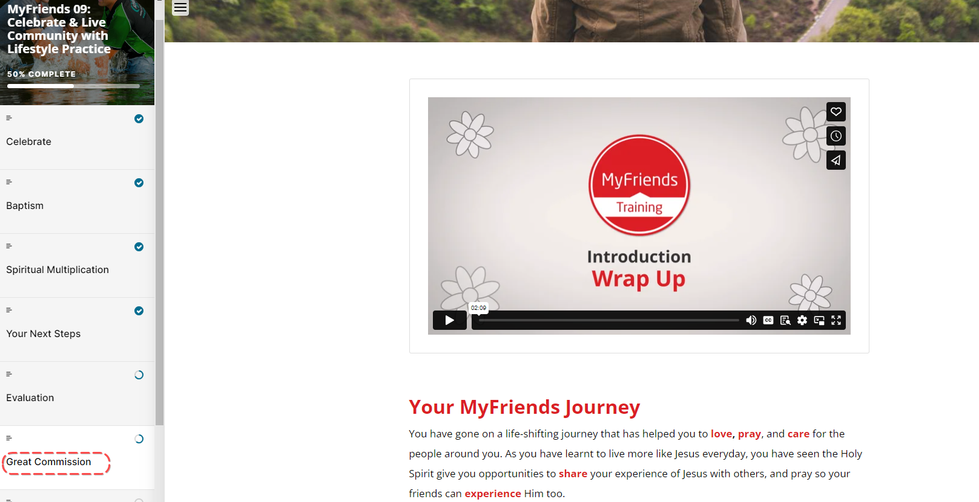

If you have time watch the Rick Warren and Ying Kai – Why Every Disciple is a Disciplemaker Video
Pray for each other
We’re going to take time now to pray and listen to what God puts on our minds as potential next steps on your MyFriends journey – this includes those on your daisy chain and our MyFriends Group here – what might God be saying to us as a group about our next steps? Break off into pairs now to pray and listen.

Ask the pairs to share any insights with the wider group.

Spend some time as a group reflecting on the highlights of your MyFriends journey. Remind the group that the MyFriends lifestyle does not end now! It continues on as we love, pray, care and share with those around us.

Lifestyle Practice
This is just the beginning – you have been Commissioned. Our prayer is that you keep this going. We have one more lifestyle practice for you and then we will send you weekly Devotions based on the MyFriends content and the MyFriends.network app.
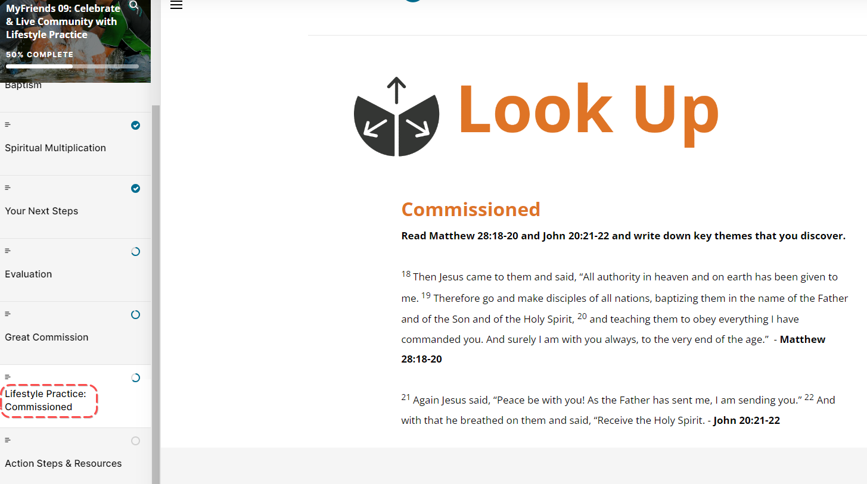

Close in prayer thanking God for all He has done and will do as a result of this MyFriends journey.

