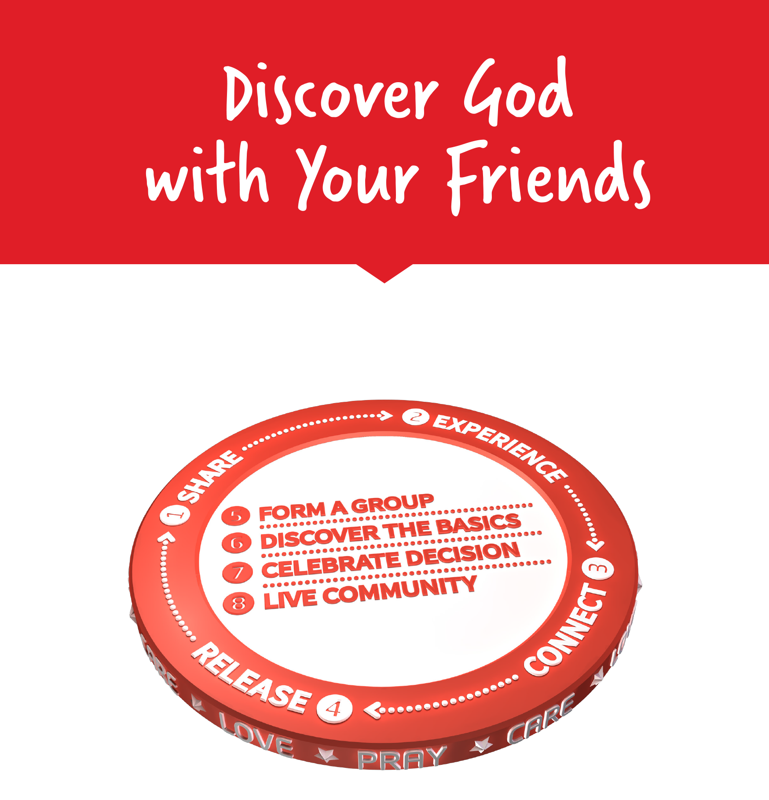

Facilitators Guide
Section 1: Setting your Training up for Success

Thank you for Leading MyFriends

Congratulations for stepping up to run MyFriends for your group. You probably have been through this program before - but if not, please take extra time to read the content and the Leaders notes for each module. This will help you be well prepared and help your MyFriends group be as successful as possible.
We are passionate about giving Australians the opportunity to know Jesus personally. Many Aussies are interested in spiritual things but have little desire to visit a church. So how can they get to know Jesus?
MyFriends helps everyday Christians develop a lifestyle that creates opportunities for their friends and family to discover God’s story together.
We are a community that intentionally loves, prays, cares, and shares Jesus with our non-churched friends, family, and colleagues. We’re trusting that Australians will experience Jesus and be ready to discover God’s story together, in their own communities.
We’re very excited that you are partnering with Power to Change to see your community experience and know Jesus and participate in this adventure. Let’s see every community across Australia know Jesus!

The MyFriends Team


Setting Up Your MyFriends Lifestyle Course for Success

These are some things to think about before you start your MyFriends Lifestyle program.

Your facilitation team
Are you running the program on your own or as a team? It's great to have others work with you. This way you can split the roles such as having someone look after the logistics (this is great if you are doing it on-line and someone can look after the chat function), room set up and facilitate group discussions. You might take alternating sections of the content. A team helps mitigate the risk of having to cancel the course due to illness. Discuss with your team before the course starts how you are all going to work together and what roles each of you will do.

Logistics
How are you running your MyFriends course? Are you running it online or face-to-face? Make sure that rooms are booked if needed, zoom or online conferencing is set up and participants have all the details before the start of the course. Set up a WhatsApp or Social Media group for participants to support each other in prayer or other ways throughout your course. (Ask Power to Change for your participant list a week before your course.)

Advertising
Do all your potential participants know about the course? Ask Power to Change for a promotion pack that includes a promotional video, PowerPoint slides, sample newsletter promotion article, social media sample campaign as well as link to MovementBuilders.org.au and a specific link to your course so that people can register for your course. If you are doing this with a small group, make sure that they have the registration link and have registered for your course.
You can use this Video for Promotion - https://vimeo.com/843812001
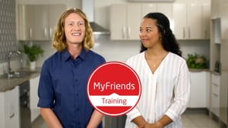

Get to know the materials
You may have gone through the content before and are living the MyFriends Lifestyle practice which is fantastic - it's great to have a role model and this will help you have amazing stories to share which will help the content be even more meaningful. To prepare for the sessions go through the materials at least twice to get to know them well. You might like to take your own notes of what you will do. If you are working as a team, please do this together - perhaps at the end of the previous session.

Get to know your "WHY"
We are all called to be part of The Great Commission and help our friends know Jesus. Why is your group or church running MyFriends? You might like to talk to your pastor or minister about why they are encouraging people to live the MyFriends Lifestyle?
One church ran MyFriends for their evening congregation and in 12 months they had doubled in size.
Another church wanted to be more community focused and felt that the Love, Pray and Care philosophy would enable them to be "a light on the hill" and serve their local area better.
What is your WHY?

Introducing MyFriends to your Church
MyFriends helps everyday Christians develop a lifestyle that creates opportunities for their friends and family to discover God’s story together.
We are a community that intentionally loves, prays, cares, and shares Jesus with our non-churched friends, family, and colleagues. We’re trusting that Australians will experience Jesus and be ready to discover God’s story together, in their own communities.
When you are introducing MyFriends to your church you might like to think about some of the following change management strategies:
- Run a session for your leadership team about MyFriends – this may be your ministers and lay leaders as well as your Governance group. (Contact Power to Change to run a session for you)
- Invite key members to join a Power to Change run virtual course and then discuss how it could be used in your context. (Contact Power to Change and we can provide a FREE course for them to experience)
- Pilot MyFriends with a smaller group of people that have a heart for outreach and evangelism and share their experience.
- Link MyFriends with your existing outreach programs as a way to engage the community with the fantastic things you are already doing.
- Run a sermon series on key messages from MyFriends.
- Share, share, share what is happening so others can pray for you and get excited by what you are doing!

The Materials

The materials are available online for each participant and are designed to work with a facilitator leading participants through the content, having great discussions and sharing their experiences and ideas. This course is not designed to be an e-learning self-paced course.
Participant materials are available on the Movement Builders Training Hub and have been written so that they resize to all devices – laptop, tablet, or mobile phone.
In the Resource section of each module there is a PDF that can be downloaded if you have participants that like a paper copy or find accessing online materials challenging.

Accessing the course materials
Your course will be set up in Movement Builders training hub and the name of your course and can be found under the MyFriends course category. You will also be given a unique URL for your course - this is the URL you can give out to potential participants. It can be accessed on any digital device through a browser. Participants will need to register for a free MovementBuilders.org.au account before they can register for your course.
If you have participants that are accessing online materials using a mobile device (smartphone or tablet) they can do so using a browser, however, they will have a much better user experience if they download the "Moodle" app.
- Go to where you get your apps from (Apple store or Google Play)
- Download "Moodle" (Moodle is the Learning Management System that Power to Change uses)
- When you install Moodle the app will ask you for a domain name - MovementBuilders.org.au
- Then put in your Username and Password you have used to create your MovementBuilders account and go to your courses.
The Moodle app also has an offline capability so your participants can download the course to their mobile device over Wifi and not use all their mobile data or need connectivity.
In your first session you might like to check that everyone has access to the materials, and they are working on their device. Please contact us through the "Contact Us" page on MovementBuilders.org.au if anyone is having big issues - we are here to help.

Displaying videos and materials
The Videos are embedded in your materials. They are also available in the MyFriends Training - https://vimeo.com/showcase/10517460
You can share your screen to display the materials using a projector, TV or on Zoom. This helps participants work together with you and find their place in the materials. Please check your audio-visual equipment before your session to check what is the best way to show materials.
When sharing the videos don't forget to click the "full screen" button in the bottom right to get the best learner experience.
If you are running the course in a place where there is minimal internet, please download the videos and your modules onto your computer.

Other Leader Materials
The MyFriends - Mobiliser Training / Facilitator Training course has been set up for you with additional support materials. This online content is FREE for all MyFriends leaders, facilitators and mobilisers.
There is a word version of the leader guide, PowerPoint slides (useful if you don't have access to the internet), promotion pack and other resources available to you.
- Go to MyFriends - Mobiliser Training / Facilitator Training course.
- Use the Enrolment Key PTCMyFriends
We are constantly adding to and improving the support we provide you and love to hear your suggestions and feedback. Please email.
fiona.dunn@powertochange.org.au.

MyFriends Format
We’ve found that learning the MyFriends Lifestyle is best done over several weeks. This is to ensure that it’s not just information that we acquire but becomes part of how we live our lives. The most effective way we have found to do this is by splitting the content into two key components: Training and Lifestyle Practice.
We have put the training into a 9-session format. We have provided a step-by-step outline of each week to make it as easy as possible for you to know how to run each session. This includes suggested timings for each part. For each week there is also a box that has additional leaders notes for the session. Make sure you read this, and the outline before the session so you are completely prepared.
The Lifestyle Practice can be implemented by your small group participants (and you!) during the week in their own time – almost like home-play!!

The table below is an overview of each training session in a small group format.
Training session | Training Topic | Lifestyle Practice Topic
 | MyFriends Introduction  Love | The Father’s Love Letter
 | Pray | Hearing God’s Voice
 | Care | Holy Spirit
 | Holy Spirit | Sent like Jesus
 | Share  Experience | Person of Peace
 | Connect | My Story
 | Release | Relying on Jesus
 | Form a Group  Basics | Discover the Basics
 | Celebrate  Live Community | Commissioned

How do you Care for your Participants?

Love, pray and care for your participants as they are now your friends too! We want to role model the MyFriends Lifestyle throughout the course to show what is possible when we live like Jesus.

Love, Pray and Care for your Participants.

Love each participant
Get to know each participant personally. What is their background? What do they want out of the course? How can you support them on their MyFriends journey? A team really helps when you have a larger group.

Pray for your participants.
Add your group to your prayers. Are there any specific people that the Holy Spirit is putting on your heart? Encourage your group to pray for each other throughout the course and beyond.

Care for your participants
What can you do to make things easier for your participants?
It might be as simple as a bit of catering - who doesn't feel cared for with a nice muffin? This helps people that may come to your course straight from work.
How is your room set up? Does your room help people feel nurtured and encourage them to be part of the conversation? Sitting round tables or in a circle help people connect rather than classroom style.
Does everyone know each other well? You may like to do more icebreaker activities to help people get to know each other and build trust and psychological safety in the group.
Think about the content and how to explain it for your group - think about other examples you can use to explain key concepts if you think someone hasn't quite grasped an idea.
You might like to connect with people with a quick phone call throughout the week. Think about calling 2 people per week and through out the course you will have contacted everyone.
What other things can you do to care for your group?

Creating Psychological Safety
Creating psychological safety is really important when you are facilitating your MyFriends program. We want participants to feel cared for and to feel safe to be themselves, be able to speak up, make mistakes and take risks. Learning something new can always feel a bit risky - and we want to minimize this for people.
We can create psychological safety by:
- Setting the stage well: creating a nurturing environment in your room, explain that the full group will be learning together and it's OK to try new ideas and even make mistakes - this helps us learn better. This includes you as a facilitator; ask for feedback along the way so you can serve the group better too.
- Get to know each other: by building relationships with participants and helping them know each other better helps create a safe space for people to share what they have done and the results they got - even if it wasn't what they intended. Using Icebreakers is a good way to start building relationships.
- Use positive reinforcement: When asking questions use positive reinforcement and expand if someone doesn't quite cover all you need. If someone goes off on a tangent gently bring the conversation back on track. If someone doesn't quite get the answer let them know that they have an interesting view and redirect the answer.
- Model constructive behaviour: Model what you would like people to do. A good way to do this is to ask for feedback, contribute ideas, to speak up, to ask questions, to share your mistakes. You don't have to be the perfect facilitator - if things don't quite go to plan - admit when things don't go quite right - this includes your MyFriends lifestyle practice. Modelling builds safety, safety leads to more learning actions, more actions create more models, which builds more safety.
- Monitor your response: Notice how you respond, if you are asking people to ask questions - you need to be excited when they suggest something. If you are asking for feedback - even if it is negative, it should be treated like a gift (after all, you can't change something if you don't know about it).

Icebreaker Ideas
Ice breakers are a fantastic way to make people feel comfortable and to get to know each other better! Choose an ice breaker for each week that you think will fit with your group or find your own online! Icebreaker can be used with face-to-face groups as well as virtual ones – you may need to be a little more creative about how you use them using zoom.

Two truths and a lie
Each person takes it in turn to tell the group 2 truths and a lie. The rest of the group then have to guess which one is the lie! Encourage participants to keep each statement short.
E.g., I can juggle, I have been to New York City, I don’t like bananas.

M&M mixer
Each person takes it in turn to choose an M&M from a bowl (with their eyes closed!). They then have to answer a question assigned to the colour M&M they pull out. For example, Yellow M&Ms must share their most embarrassing moment. Make up your own question for each colour or follow this link for some suggestions.

“Minute to Win It” games.
There was a TV show called Minute to Win It where contestants had to complete a task using household items in less than a minute to move on to the next challenge and ultimately win money.
People now play “minute to win it” games just like simple party games – sometimes actually having the minute time limit and other times just playing them as quick and easy party games. Ideas include:
- Face the Cookie: Put a cookie on someone’s forehead and they can only use their face muscles to get the biscuit into their mouth!
- Defying Gravity: Give each player three balloons. They have to keep all three balloons up in the air for a minute.
- Bottle to Bottle: Fill one 2-liter bottle with something (Lucky Charms, Jellybeans, etc.) then tape to another 2-liter bottle – players have to transfer all from one bottle to the other.
- Wrap It Up: A two player game where one person has to wrap the other person in streamers, toilet paper, or something else.
- Backwards ABC's: Have participants recite the alphabet backwards one at a time. If they make any mistakes, they have to start over. Whoever does it the fastest wins. For a tiebreaker or extra challenge, pick a random letter to start with rather than Z, and have participants work their way back to the original letter.
Google Minute to Win It games and you will find lots more!

Ice breaker bingo
This works best with 5+ people. Each person is given a sheet and moves round the room with the aim of getting a name in every box. Here is a site with some great starter ideas.
This is a great one for Module 3 - Care.
Do you have other Icebreakers you like to use? We would love to hear them - please email fiona.dunn@powertochange.org.au.

Evaluation and Tracking Progress

From module 5 there is a form for participants to fill in each week. This form helps people to be more accountable for their actions and intentionally look for opportunities to share how God has been working in their lives and to make connections for their friends.
As a church or ministry, it’s always good to see how many Gospel presentations people have made so you can coach them and follow up.
As participants work with their friends, they may create small groups so that their friends can learn more about Jesus. Again, it’s important to know who is creating groups so that you can support them – or encourage them to join a OurGenerations course.
We also ask participants to track people that have made a decision for Christ and become a Christian.
In the final week the form also asks about how we can make the course better – what they like about it and the things that could be improved. This helps us improve the course.

Power to Change won a grant to create the Movement Builders Training Hub and create the digital course materials so that you can run them and multiply the impact that Power to Change could do on its own. As part of the Grant, and to access the next year's funding, we would like to know the impact that you have been making. This not only helps us with funding and keeping the cost of this course low – it also helps us know how to improve the course and support you in the future. Please encourage your participants to take the time to fill in the weekly forms.

